**This is a sample Software Validation/UAT Protocol. Castor makes no guarantees about the accuracy. The user of this sample is responsible for ensuring that it conforms to the requirements of study in question.**

- PURPOSE
The purpose of this test protocol is to define the requirements for verifying and validating that the Castor Electronic Data Capture (EDC) Software meets all of the requirements for use in <<<SPONSOR NAME>>> sponsored clinical investigations, serve as UAT – User Acceptance Testing and validate that the instructions are adequate for Users (sites) to appropriately input data into the electronic case report forms (eCRFs) within the EDC.

- SCOPE
This test protocol applies to the Castor Electronic Data Capture (EDC) Software (Castor version <<<v2020.2.11>>>, <<<STUDY NAME>>> <<<Study version>>>) and will test all functions the software will perform as it relates to <<< SPONSOR NAME>>> clinical investigations. This software verification and validation will consist of functional testing including confirmation of 21 CFR Part 11 compliance.

- BACKGROUND
- REFERENCE DOCUMENTS
- RESPONSIBILITIES
Castor EDC is responsible for:
• Providing verified and validated EDC software.

Testers are responsible for:
• Training to this test protocol prior to execution.
• Performing testing per the test cases defined within this test protocol.
• Providing completed datasheets to Quality upon completion of testing.

Quality is responsible for:
• Drafting this test protocol and the subsequent test report(s).

- REQUIREMENTS

  - Test Flow
Test set-up per Section 7.0 below must be completed by the administrator (Quality) prior to execution of test cases. All test cases should be performed by the Testers in sequential order. Each Tester may perform testing simultaneously on a separate computer. Test results will be documented in Castor EDC Software Verification and Validation User Datasheets (Appendix 4). Any deviations to this test protocol will be documented, including investigation results and action plan (where deemed necessary), in corresponding test report(s).
  - Test Facility
Software verification and validation testing will be performed at <<<Site>>> located in <<<Hoboken, NJ, USA>>> by trained personnel.
  - Equipment and Materials
• No physical test samples will be required for this software verification and validation study.
• A minimum of three (3) computers with internet access will be required for this study.
• All testing will be performed in the “Test Environment”.
  - Training Requirements
All personnel involved in the testing of the EDC Software will be trained prior to execution of this test protocol. A copy of applicable training record(s) will be provided in the corresponding Test Report(s).
  - Statistical Methods
No statistical analysis will be required for this software verification and validation study.

- TEST SET-UP
The Admin (Verifier) will utilize the instructions below to complete Appendix 3, Castor EDC Software Verification and Validation Set-Up Datasheet to set-up Testers for executing the EDC software verification and validation test cases.

Test Set-up Prerequisites:
• Completed training to this test protocol
• Computer with internet access
• Study admin Castor EDC account set up

Test Set-up Instructions:

STEP | ACTION
1 | Open web browser and input www.castoredc.com then click on “User login”.
2 | Input email and password and ensure country is set to United States.  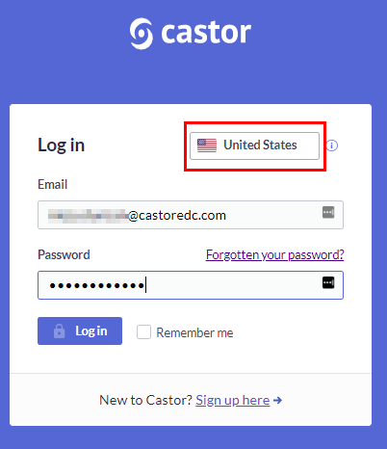
3 | Click on “Study” then click “Users”.  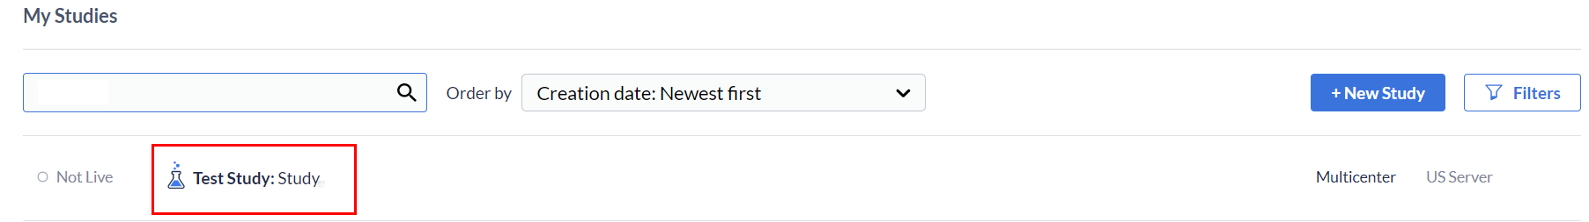  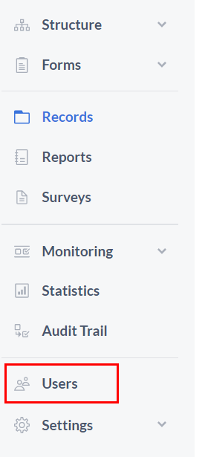
4 | Click on “+ Add user”.  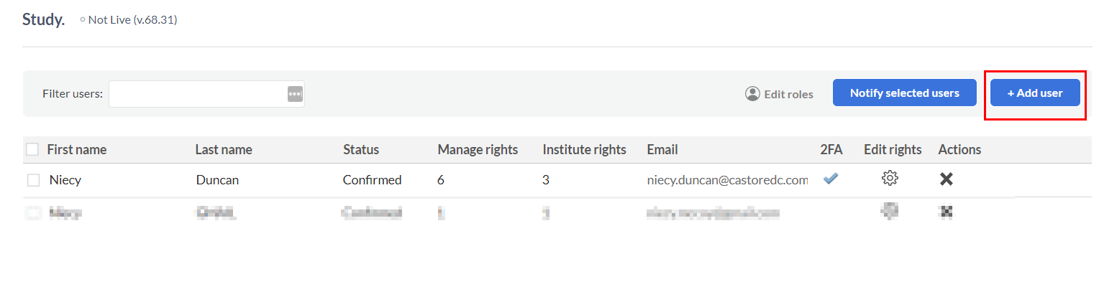
5 | Input one (1) of the email addresses listed above (Step 4) then click “Add User” and verify that the following error message is received then click “OK”. Record results on Appendix 3, Castor EDC Software Verification and Validation Set-Up Datasheet.  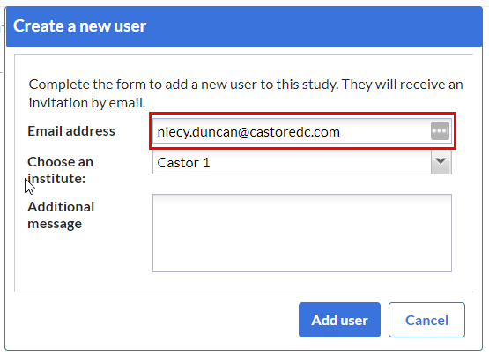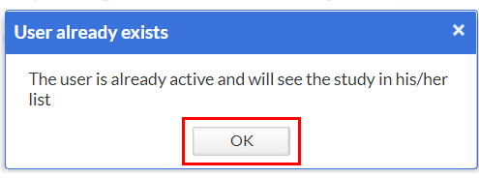
6 | Input the email addresses of the new User (Tester), select Test Institute, type “sample user study invitation” and click on “Add user”.  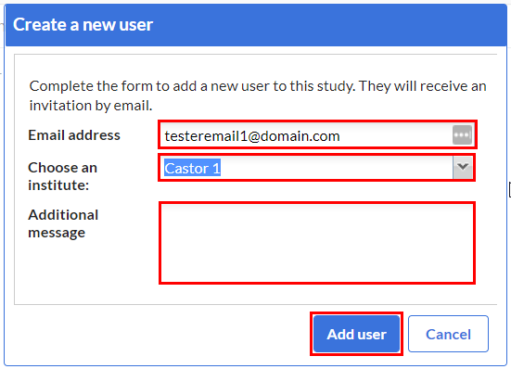
7 | Click the cogwheel to the right of one of the new users. Select the user role to provide rights for the user and click on “Save.”  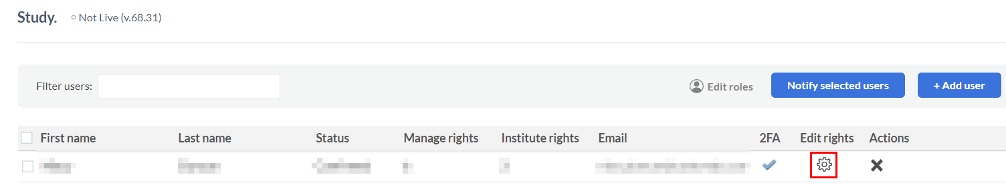  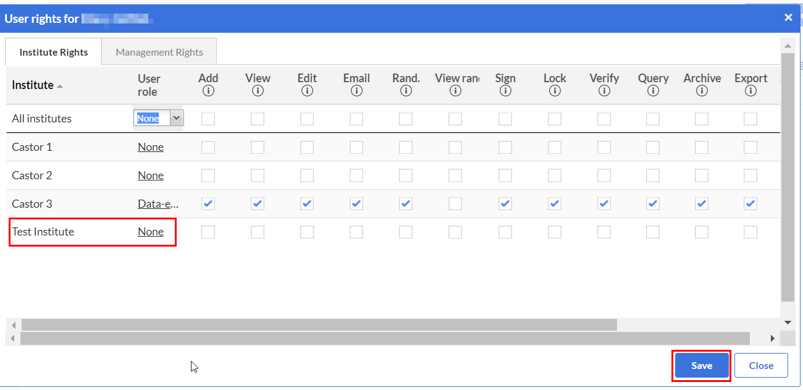
8 | Repeat Steps 6 and 7 until all new Users (Testers) have been added. Record each User (Tester) on Appendix 3, Castor EDC Software Verification and Validation Set-Up Datasheet.
9 | Upon completion of the set-up activities listed above, Testers may begin test cases laid out in Section 9.0.

- TEST PROCEDURE
The electronic Case Report Form is broken into five (5) phases as seen in the table below. Each Phase has the following steps. Each step with the addition of set up and back end verifications will undergo testing per test cases provided in the next section.

Phase | Phase Steps Descriptions
1. Screening | Demographics
 | Inclusion Criteria
 | Exclusion Criteria
 | Informed Consent
 | Randomization
2. Baseline | Baseline Visit Date
 | Evaluations
 | Laboratory Tests
 | Adverse Events
 | Drug Distribution
3. Day 30 | Day 30 Visit Date
 | Evaluations
 | Laboratory Tests
 | Adverse Events
 | Drug Compliance
4. Day 60 | Day 60 Visit Date
 | Evaluations
 | Laboratory Tests
 | Adverse Events
 | Drug Collection
5. End of Study | End of Study

  - TEST CASES
A minimum of three (3) Testers will be utilized for this software verification and validation study. Each testers will complete the following 29 test cases (TC) listed in the table below.
Test Case (TC) ID | Test Case Description | Test Case (TC) ID | Test Case Description
TC-A* | Logging into the EDC | TC-11* | Day 30, 11. Day 30 Visit
TC-B* | Lock out | TC-12 | Day 30, 12. Evaluations Completed
TC-C* | Time out | TC-13 | Day 30, 13. Laboratory Tests
TC-D* | Creating a new record | TC-14 | Day 30, 14. Adverse Events
TC-1* | Screening, 1. Demographics | TC-15 | Day 30, 15. Drug Compliance
TC-2* | Screening, 2. Inclusion Criteria | TC-16 | Day 60, 16. Day 60 Visit
TC-3 | Screening, 3. Exclusion Criteria | TC-17 | Day 60, 17. Evaluations Completed
TC-4 | Screening, 4. Informed Consent | TC-18 | Day 60, 18. Laboratory Tests
TC-5 | Screening, 5. Randomization | TC-19 | Day 60, 19. Adverse Events
TC-6 | Baseline, 6. Baseline Visit | TC-20 | Day 60, 20. Drug Collection
TC-7 | Baseline, 7. Evaluations Completed | TC-21 | End of Study, 21. End of Study
TC-8 | Baseline, 8. Laboratory Tests | TC-E* | GCP Compliance
TC-9 | Baseline, 9. Adverse Events | TC-F* | Monitoring
TC-10 | Baseline, 10. Drug Distributions | TC-G* | PI Sign off
 |  | TC-H | Audit Trail
*Test Method included in template

- TEST CASES
Testers to utilize test cases below to complete Appendix 4, Castor EDC Software Verification and Validation User Datasheets recording results during execution of each test case. Expected Results / Acceptance Criteria column steps correspond to test case step descriptions as seen in test method tables below. If anomalies are observed or comments need to be documented, record information on Appendix 5, Anomaly / Comment Log providing adequate details for observed event, comments, etc.

TC-A: Logging into the EDC Software

Test Purpose:
To ensure that the Castor EDC software requires unique IDs and passwords to allow for ease in maintaining appropriate audit trails and other 21 CFR Part 11 compliance requirements.

Test Prerequisite:
• Completed training to this test protocol
• Computer with internet access
• User email addresses provided to Admin (Verifier)

Test Method:
TC-A, Logging into EDC
Step Description |  | Expected Results / Acceptance Criteria (Pass/Fail)
1 | Check email provided to Admin to obtain access to Castor EDC. | Email from “no-reply@castoredc.com” entitled, “You were invited to join ‘Study’ on Castor EDC”.  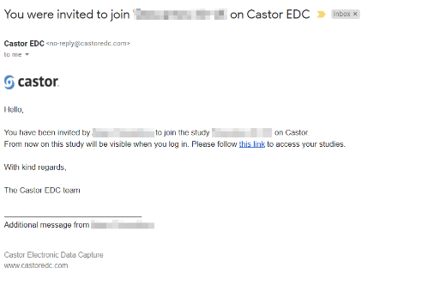
2 | Open email from Castor EDC then click on “this link” in email to complete account registration. | 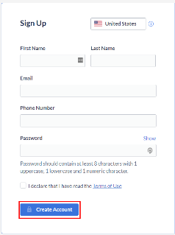  The following window appears for account creation.
3 | Input required information using provided email to complete the registration process then click “Create Account”. | The following appears displaying “Study” screen.  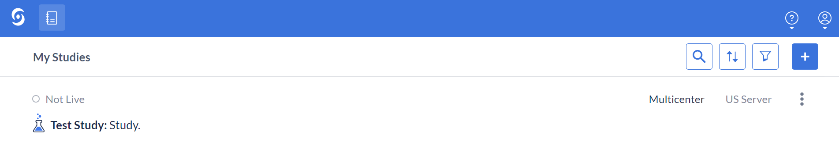
4 | Hover mouse over account “Account” then click “Log out”. | Logged out of Castor EDC software and back to log in page.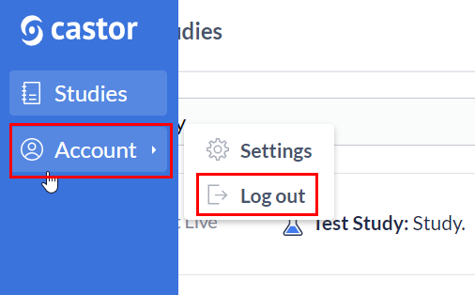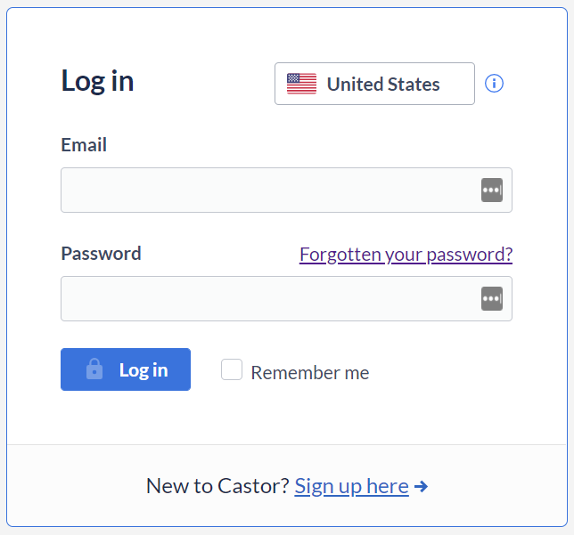

TC-B: Lock Out

Test Purpose:
To ensure that the Castor EDC software appropriately locks a User out of the Castor EDC software after 10 incorrect password entries to demonstrate compliance with 21 CFR Part 11 requirements.

Test Prerequisite:
• Active Castor EDC User account
• Computer with internet access

Test Method:
NOTE: Steps shown in RED below are to be performed by the Admin.

TC-B, Lock out
Step Description |  | Expected Results / Acceptance Criteria (Pass/Fail)
1 | Open web browser and input www.castoredc.com then click on “User login”. | Castor EDC homepage appears.
2 | Ensure country is set to United States then input the following until you reach 10 incorrect log in attempts:  - Input incorrect email and correct password  - Input correct email and incorrect password  - Input both incorrect email and password | Log in screen appears. Invalid username or lock out error appears.  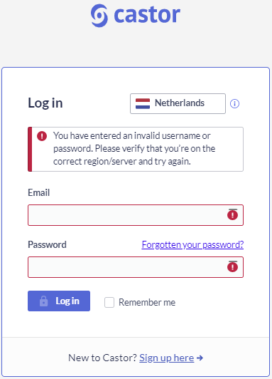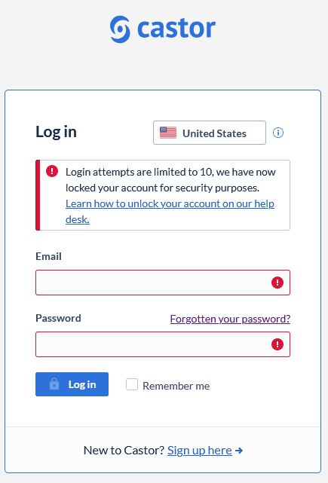
3 | Notify Admin to unlock account. | N/A
4 | Admin to open web browser and input www.castoredc.com  then click on “User login”. | Castor EDC homepage appears.
5 | Admin logs into Castor EDC ensuring country is set to “United States”, Admin clicks on “Study” then click “Users”.
6 | Admin clicks on padlock icon “” in Action column then clicks “Yes” to unlock Tester’s account then “OK”. | 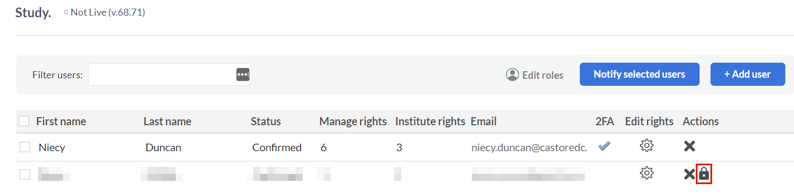  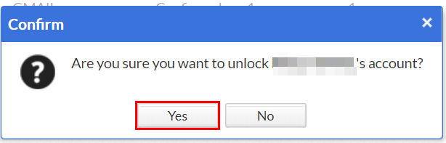
7 | Hover mouse over account “Account” then click “Log out”. Tester is ready to resume test case.
8 | Repeat Step 1, ensure country is set to United States then input correct email and correct password.  Then click “Log in” | Log in screen appears. Main home screen appears with “Study”.

TC-C: Time Out

Test Purpose:
To ensure that the Castor EDC software appropriately logs a User off of the Castor EDC software after 20 minutes of inactivity to demonstrate compliance with 21 CFR Part 11 requirements.

Test Prerequisite:
• Active Castor EDC User account
• Computer with internet access

Test Method:
TC-C, Time out
Step Description |  | Expected Results / Acceptance Criteria (Pass/Fail)
1 | If not already logged in, open web browser and input www.castoredc.com then click on “User login”. | Castor EDC homepage appears.
2 | Ensure country is set to United States then input email and password.  Then click “Log in”. | Log in screen appears. Main home screen appears with “Study”.
3 | Record start time on datasheet in Appendix 4 then step away from computer for a minimum of 20 minutes.  - After a minimum of 20 minutes, record end time on datasheet in Appendix 4. | Castor EDC logs out and displays “Your session has expired”.  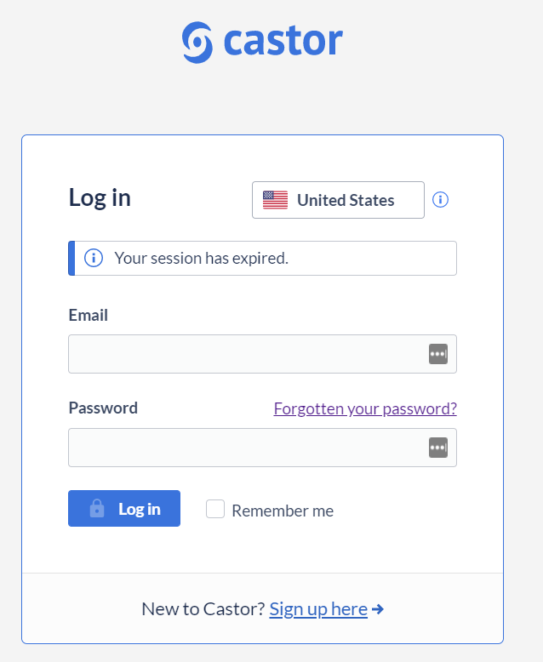

TC-D: Creating a New Record

Test Purpose:
To ensure that the Castor EDC software appropriately auto-numbers records.

Test Prerequisite:
• Active Castor EDC User account
• Computer with internet access
• On Castor EDC website

Test Method:
TC-D, Creating a record
Step Description |  | Expected Results / Acceptance Criteria (Pass/Fail)
1 | Ensure country is set to United States then input email and password.  Then click “Log in”. | Log in screen appears. Main home screen appears with “Study”.
2 | Click on “Records” then click “Create Record”  -OR-  Click “+New” | If this is the first record created, verify the new record details window appears.  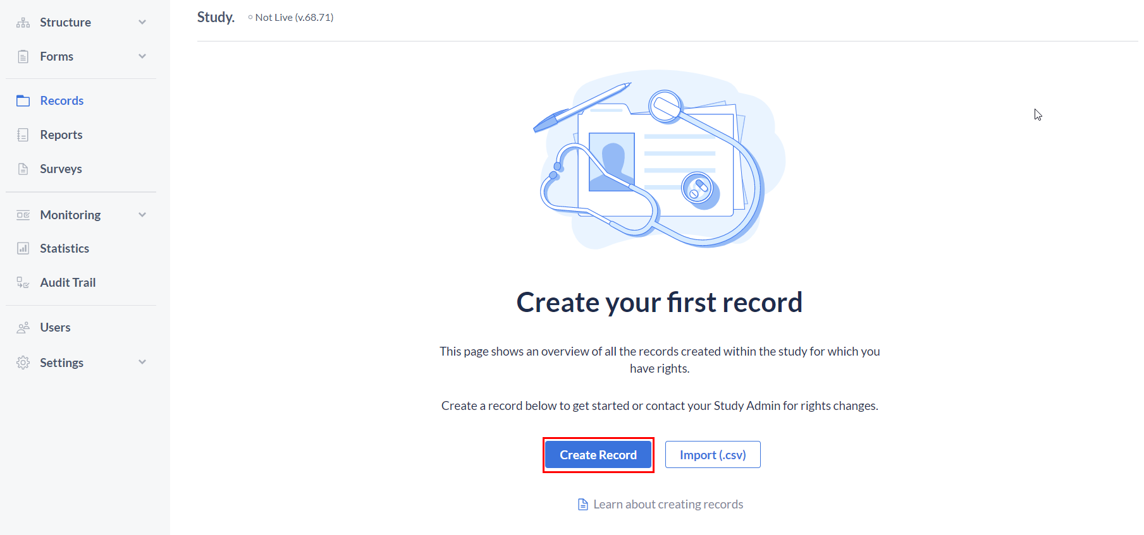  -OR-  If this is not the first record, verify the Record tab window appears.  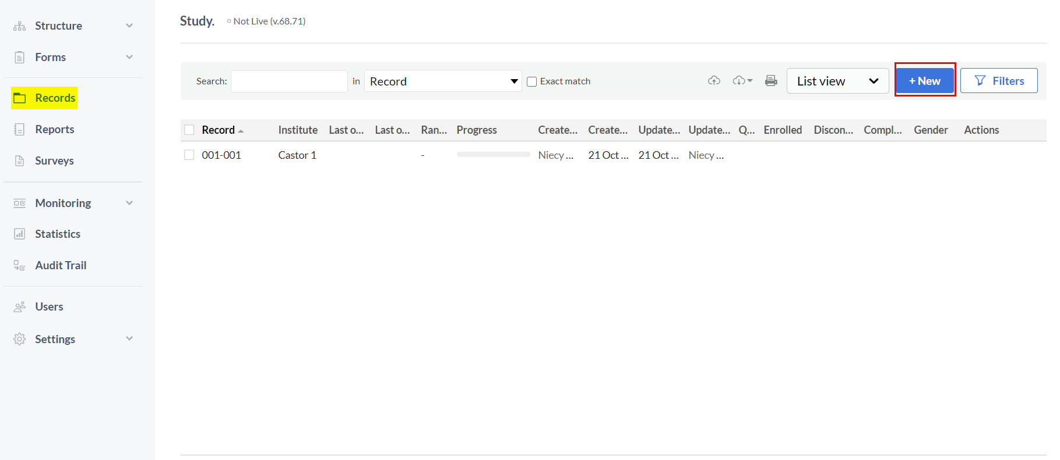
3 | Click the down arrow to display the pre-loaded institutes and click on “Test Institute” then click “Next”. | Verify the record number is auto-generated with Institute Code (000) then sequential number (XXX).  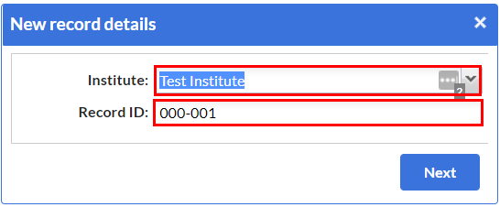

TC-01: Screening, Demographics Test

Purpose:
To ensure that the Castor EDC software appropriately allows User to input screening information related to the subject’s demographics as intended including triggering of warnings, where applicable.

Test Prerequisite:
• Active Castor EDC User account
• Computer with internet access
• On Castor EDC website and logged into Castor EDC account

Test Method:
TC-01, Screening, Demographics
Step Description |  | Expected Results / Acceptance Criteria (Pass/Fail)
1 | Click on “Records” then click on the record created in TC-D. | Verify the new record details window appears and that the record created in TC-D is listed. Verify the Screening, 1. Demographics screen appears.  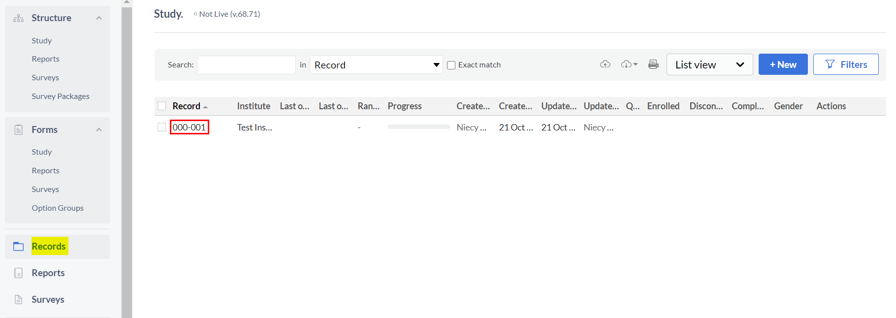  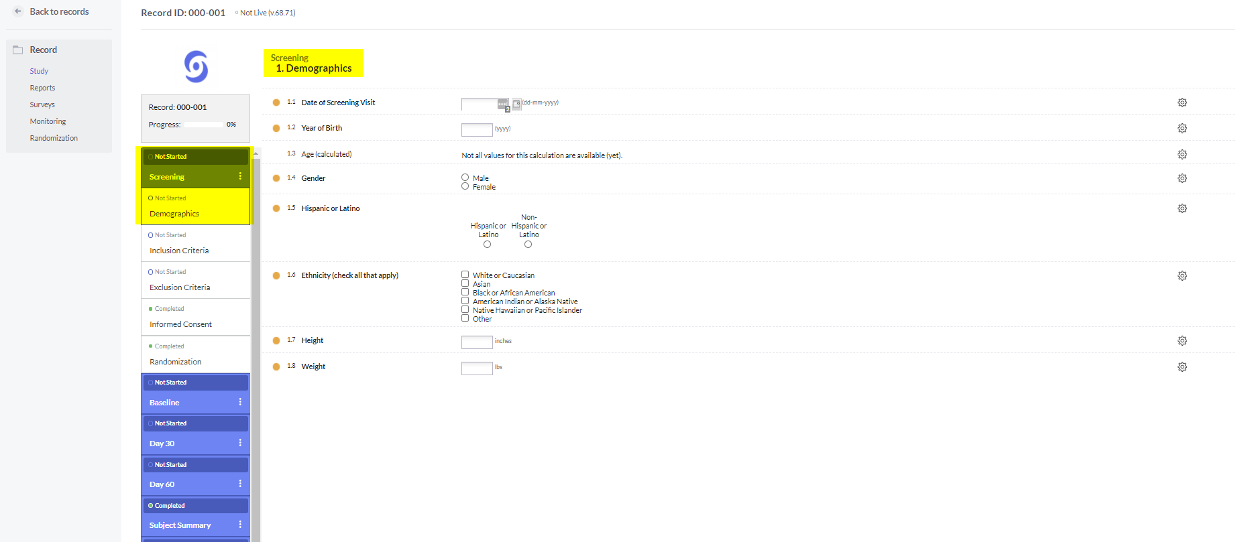
2 | Input a future date then input today’s date. | Verify the following warning is received then verify warning disappears.  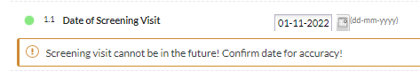
3 | Input a year that would calculate the age as:  - less than 18  -Over 65  -between the ages of 18 and 65 | Verify the following warnings are received then verify warnings disappear  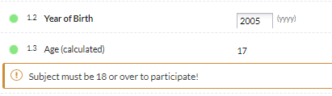  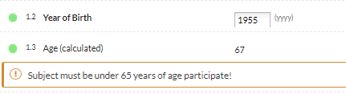
4 | Click “Male”. | Verify selection appears
5 | Click “Non- Hispanic or Latino”. | Verify selection appears
6 | Select all checkboxes then unselect “Other”. | Verify all selections appear and field 1.6.1 appears when “Other” is checked and field 1.6.1 disappears if “Other” is not selected.  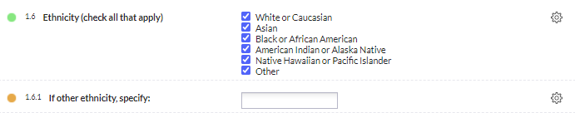
7 | Type “test” in other ethnicity field, then de-select “Other”. | Verify the following pop-up appears and click “Continue”. Confirm field 1.6.1 has disappeared.  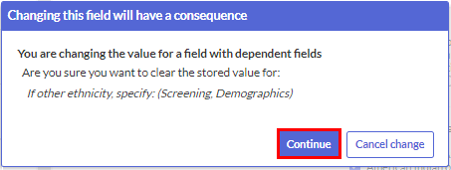
8 | Enter “91” then enter “90”. | Verify the following warning is received then verify warning disappears  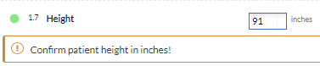
9 | Enter “301” then enter “300”. | Verify the following warning is received then verify warning disappears  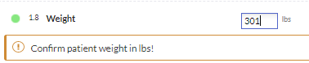
10 | After completion of fields 1.1 through 1.8, click “Next” | Verify section 2. Inclusion Criteria screen appears  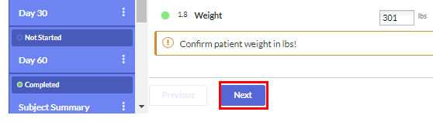  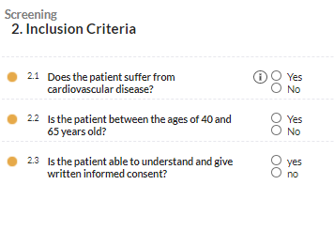

TC-02: Screening, Inclusion Test

Purpose:
To ensure that the Castor EDC software appropriately allows User to input screening information related to the inclusion criteria as intended including triggering of warnings, where applicable.

Test Prerequisite:
• Active Castor EDC User account
• Computer with internet access
• On Castor EDC website and logged into Castor EDC account

Test Method:
TC-02: Screening, Inclusion
Step Description |  | Expected Results / Acceptance Criteria (Pass/Fail)
1 | Click “No” then click “Yes”. | Verify the following warning is received and data entry is not allowed.  Then verify warning disappears and data entry is allowed.
2 | Click “No” then click “Yes”. | Verify the following warning is received and data entry is not allowed.  Then verify warning disappears and data entry is allowed.
3 | Click “No” then click “Yes”. | Verify the following warning is received and data entry is not allowed.  Then verify warning disappears and data entry is allowed.  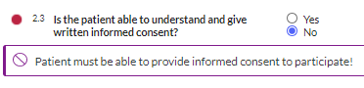
4 | After completion of fields 2.1 through 2.3, click “Next”. | Verify section 3. Exclusion Criteria screen appears  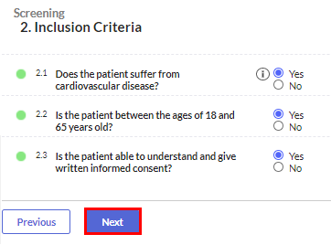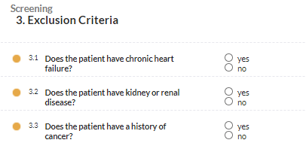

TC-11: Day 30, Visit

Purpose:
To ensure that the Castor EDC software appropriately allows User to input visit information related to the visit 30 days following baseline as intended including triggering of warnings, where applicable.

Test Prerequisite:
• Active Castor EDC User account
• Computer with internet access
• On Castor EDC website and logged into Castor EDC account

Test Method:
TC-11: Day 30, Visit
Step Description |  | Expected Results / Acceptance Criteria (Pass/Fail)
1 | Click “No” then click “Yes”. | Ensure that the following remark appears and disappears  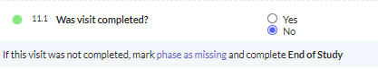
2 | Enter visit date that is:  -less than 28 days after date entered in TC-6  -more than 32 days after date entered in TC-6  -between 28 and 32 days | Verify the following warnings and deviation report button appears and disappears.  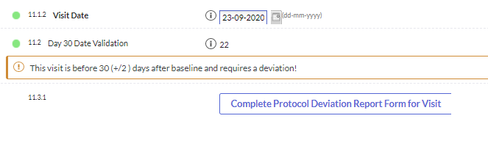  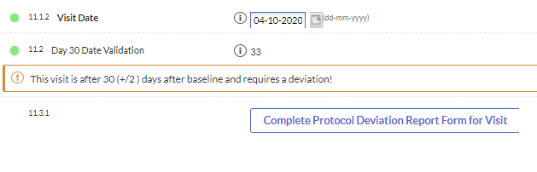
3 | After completion of 11.1 through 11.2, click “Next”. | Verify section 12. Evaluations screen appears  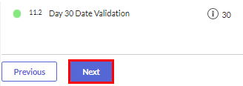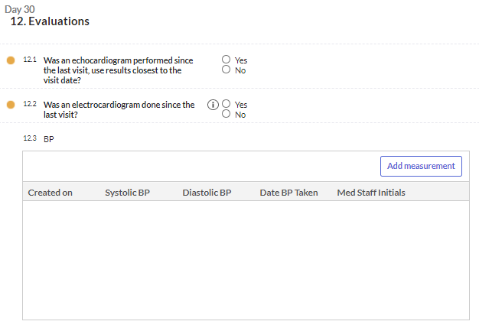

TC-E: GCP Compliance

Test Purpose:
To ensure that the Castor EDC software requires an explanation if an edit is made to a record to support demonstration of compliance with Good Clinical Practices (GCP).

Test Prerequisite:
• Active Castor EDC Admin account
• Computer with internet access
• On Castor EDC website and logged into Castor EDC account

Test Method:
TC-E: GCP Compliance
Step Description |  | Expected Results / Acceptance Criteria (Pass/Fail)
1 | Click on “Records” then click on the record created in TC-D. | Verify the Screening, 1. Informed Consent / Demographics screen appears.  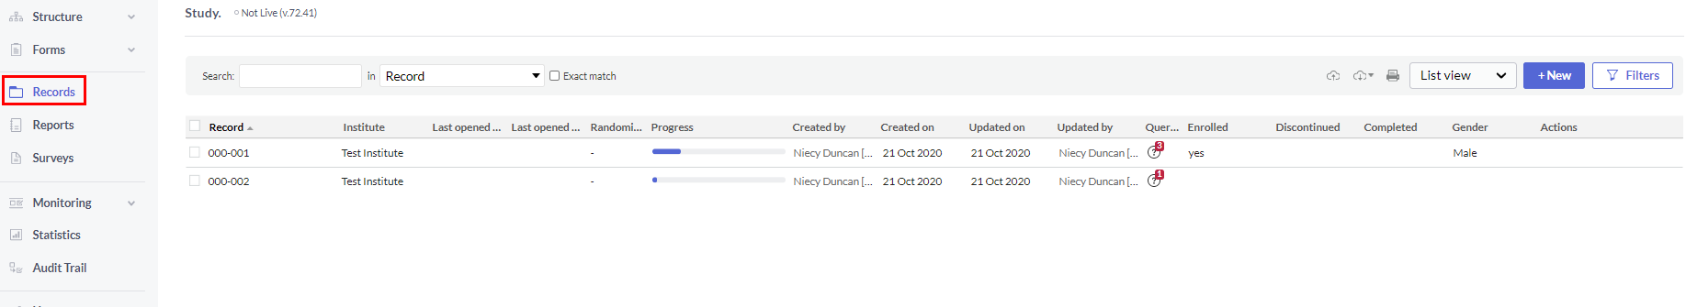  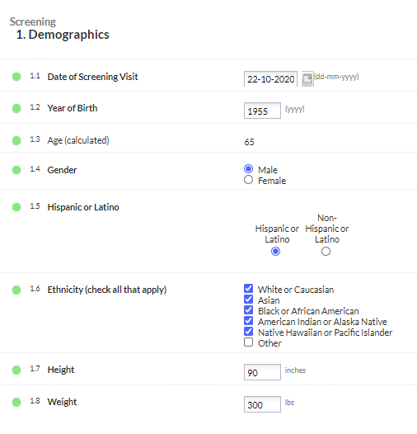
2 | Attempt to input a different date.  - Input “1”  Click “Continue”. | Verify the following GCP Compliance warning is received then verify warning disappears.  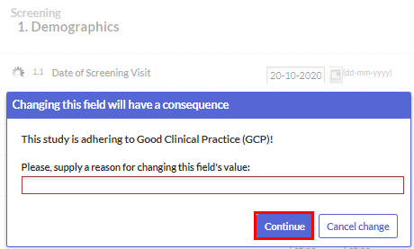
3 | Attempt to change the year of birth to a different year.  - Input “1”  Click “Continue”. | Verify the following GCP Compliance warning is received then verify warning disappears.  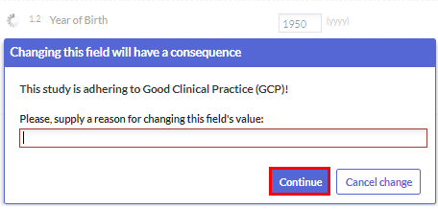
4 | Attempt to de-select one of the ethnic options.  - Input “1”  Click “Continue”. | Verify the following GCP Compliance warning is received then verify warning disappears.  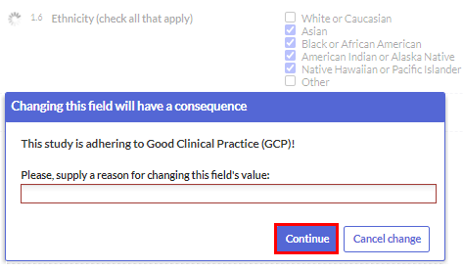

TC-F: Monitoring

Test Purpose:
To ensure that the Castor EDC software appropriately notifies Monitor that a Phase has been completed and is ready for monitoring and to allow the Monitor to indicate source data verification (SDV) has been completed with appropriate audit trail.

Test Prerequisite:
• Active Castor EDC Admin account
• Computer with internet access
• On Castor EDC website and logged into Castor EDC account

Test Method:
NOTE: To be performed by Admin.

TC-F: Monitoring
Step Description |  | Expected Results / Acceptance Criteria (Pass/Fail)
1 | Click “Study”. | Verify main screen with Study link appears. Verify that there are 10 queries. NOTE: Depending upon number of Testers, query quantity may vary; however, there should be 10 queries created per Tester.  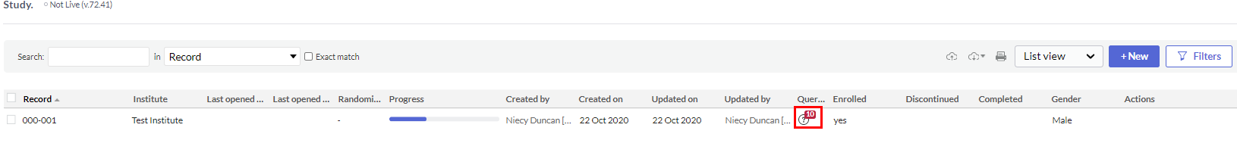
2 | Double click open query icon“” . | Verify End of Study screen appears.
3 | Click on query icon  “ ”. | Verify “Queries for field Has the subject completed their participa…” pop-up appears.  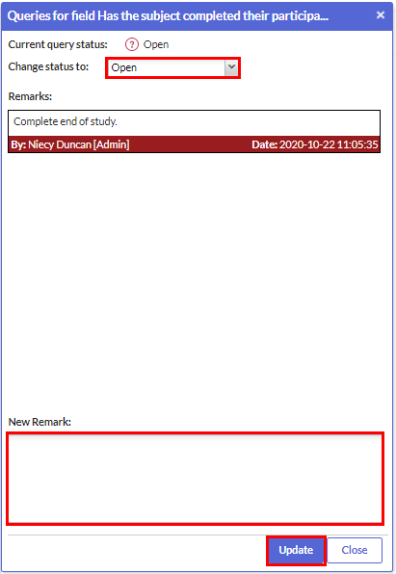
4 | Click down arrow then select “Closed”.  Input “This Phase has successfully completed Source Data Verification.”  Click “Update”. | Verify color changes from orange to green and red question mark changes to green checkmark.
5 | Click “Back to records”. | Verify that quantity of queries has decreased by 1.  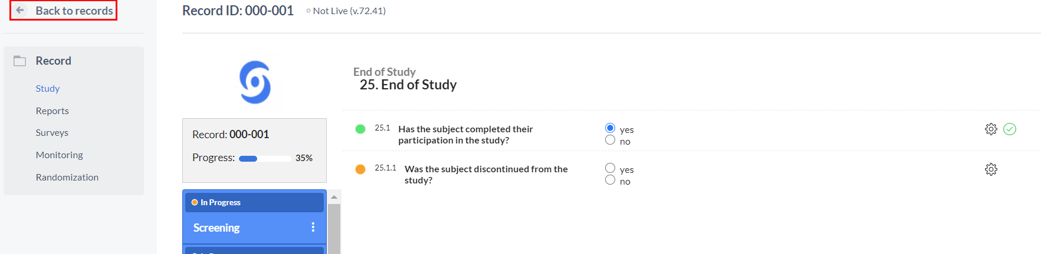  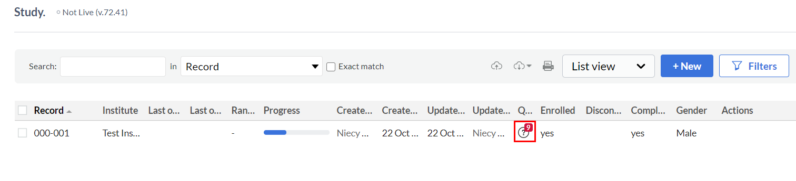
6 | Repeat Steps 2 – 5 until all queries are completed.  Click “Back to records”. | Verify Progress bar is green and has reach 100%. Verify Progress bar on records page is green and at 100% and that there are no Queries.  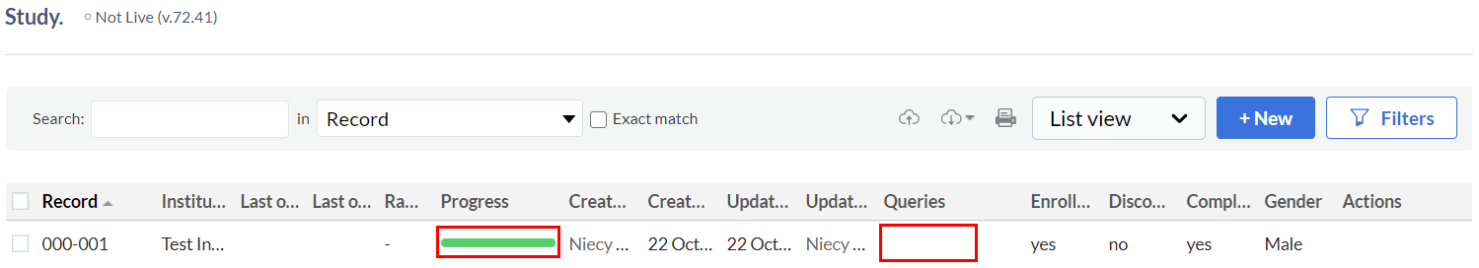

TC-G: Principal Investigator (PI) Sign Off

Test Purpose:
To ensure that the Castor EDC software appropriately allows the Principal Investigator (PI) to sign off the completed electronic Case Report Form (eCRF) with appropriate audit trail.

Test Prerequisite:
• Active Castor EDC Admin account
• Computer with internet access
• On Castor EDC website and logged into Castor EDC account

Test Method:
NOTE: To be performed by Admin.
TC-F: Principal Investigator (PI) Sign Off
Step Description |  | Expected Results / Acceptance Criteria (Pass/Fail)
1 | Click “Study”. | Verify main screen with Study link appears.  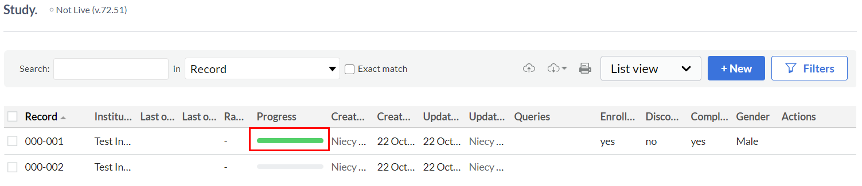
2 | Double click on completed record. | Verify record opens.  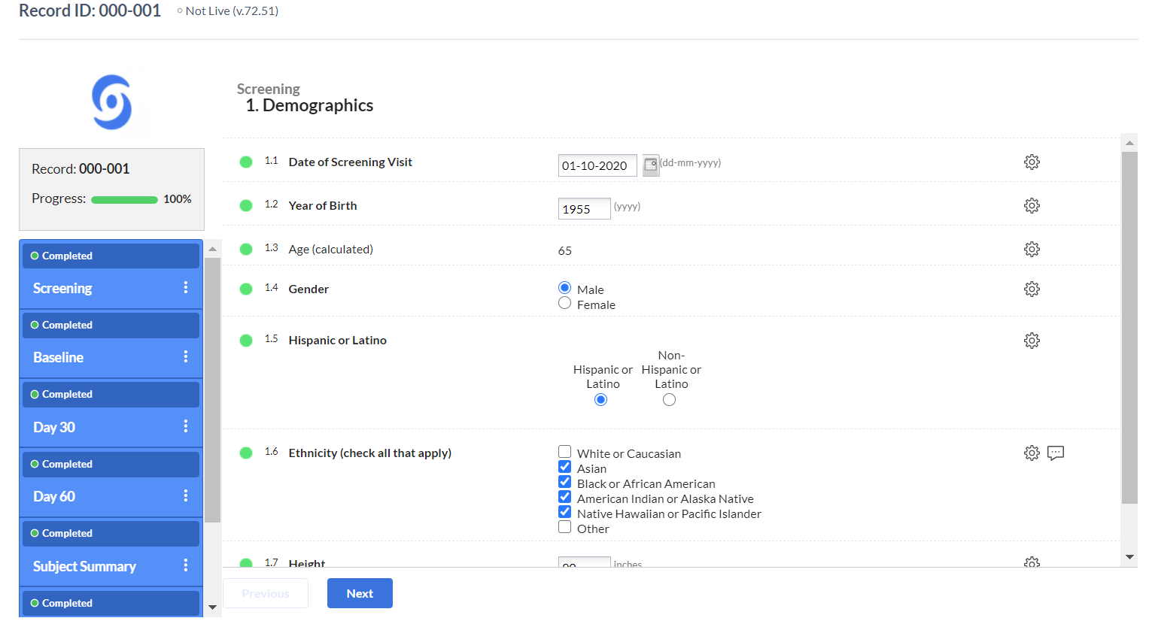
3 | Click on ellipses “ ” on Screening bar then select “Sign this Phase”. | Verify drop box list appears.  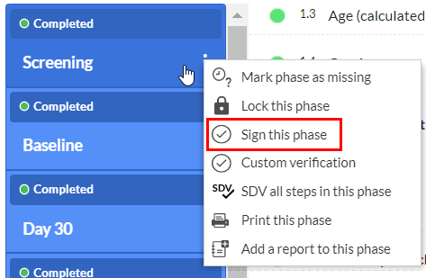
4 | Enter email address and password then click “Sign”. | Verify username and password window appears (first signature during session).  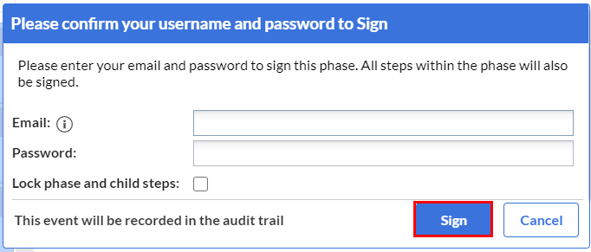  -OR-  Verify PI signature window appears (additional signatures during session).  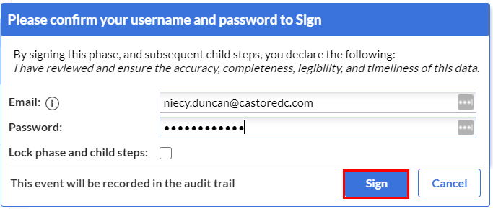
5 | Repeat Steps 3 – 5 until all Phases have been signed off | Verify purple signature icon “ ” appears next to all steps. Verify signature banner appears at the top of all steps.  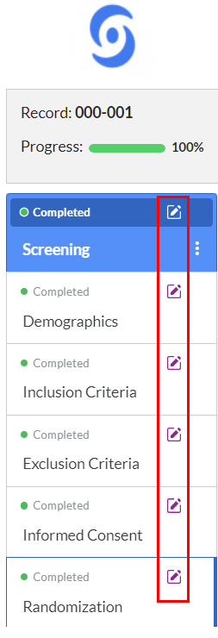
6 | Click “Back to records”.  Double Click to open next completed record. | Verify return to Record Overview. Verify record opens.  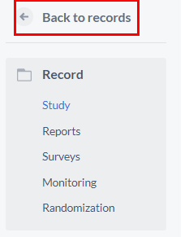  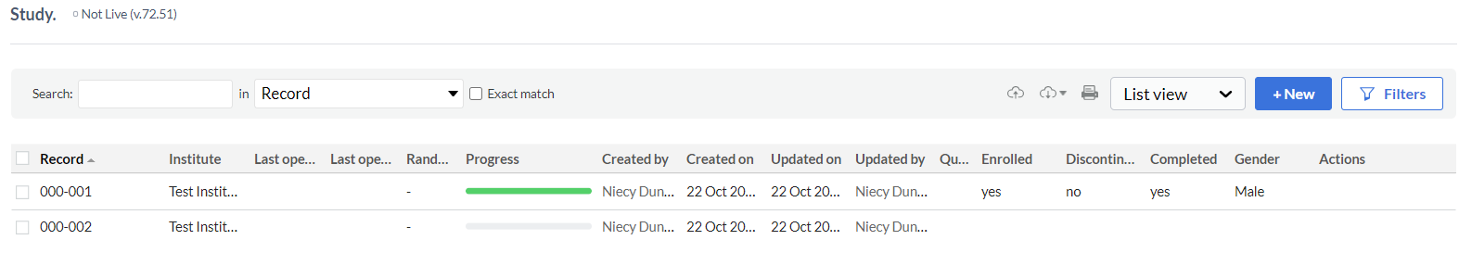
7 | Repeat steps 1-6 until all records and all phases are signed.  Click “Back to records”.  Select “Step view” from the dropdown list. | Verify signature icon “ ” appears for all steps on all records.

Appendix 3: Castor EDC Software Verification and Validation Set-Up Datasheet (Page 1 of 1)

□ Admin verified receipt of error message when attempting to add existing User Admin Initial/Date: __________________

Name  (Print) | Role  (check one) | Email | Signature | Initials | Date
□ Admin (Verifier)
□ User (Tester)
□ Admin (Verifier)
□ User (Tester)
□ Admin (Verifier)
□ User (Tester)
□ Admin (Verifier)
□ User (Tester)
□ Admin (Verifier)
□ User (Tester)
□ Admin (Verifier)
□ User (Tester)
□ Admin (Verifier)
□ User (Tester)
□ Admin (Verifier)
□ User (Tester)
□ Admin (Verifier)
□ User (Tester)
□ Admin (Verifier)
□ User (Tester)
□ Admin (Verifier)
□ User (Tester)
□ Admin (Verifier)
□ User (Tester)
□ Admin (Verifier)
□ User (Tester)
□ Admin (Verifier)
□ User (Tester)
□ Admin (Verifier)
□ User (Tester)
Appendix 4: Castor EDC Software Verification and Validation User Datasheets (Page 1 of 4)

Software Version: ____________ Tester Name: ______________________________ Verifier Name: ______________________________

Test Case (TC) ID | Test Name | Expected Results / Acceptance Criteria |  | Actual Results |  | P= Pass /  F= Fail | Performed By (Initial/Date) | Verified By (Initial/Date)
TC-A | Logging into EDC | 1 | Email received to join Castor EDC. | 1
 |  | 2 | Window appears for account creation. | 2
 |  | 3 | Window displaying STUDY. | 3
 |  | 4 | Logged out of Castor EDC software and back to log in page. | 4
TC-B | Lock out | 1 | Castor EDC homepage appears. | 1
 |  | 2 | Log in screen appears. Lock out error appears. | 2
 |  | 3 | N/A | 3 | N/A | N/A
 |  | 4 | N/A | 4 | N/A | N/A
 |  | 5 | N/A | 5 | N/A | N/A
 |  | 6 | N/A | 6 | N/A | N/A
 |  | 7 | N/A | 7 | N/A | N/A
 |  | 8 | Log in screen appears. Main home screen appears with “Study”. | 8

Appendix 4: Castor EDC Software Verification and Validation User Datasheets (Page 2 of 4)

Test Case (TC) ID | Test Name | Expected Results / Acceptance Criteria |  | Actual Results |  | P= Pass /  F= Fail | Performed By (Initial/Date) | Verified By (Initial/Date)
TC-C | Time out | 1 | Castor EDC homepage appears. | 1
 |  | 2 | Log in screen appears. Main home screen appears with “Study”. | 2 | Start Time: __________  End Time: ___________
 |  | 3 | Castor EDC logs out and displays “Your session has expired”. | 3
TC-D | Creating a record | 1 | Log in screen appears. Main home screen appears with “Study”. | 1
 |  | 2 | Verify new record details window appears. | 2
 |  | 3 | Verify record number is auto-generated with Institute Code (000) then sequential number (XXX). | 3
TC-1 | Screening, Demographics | 1 | Verify new record details window appears. Verify “Screening/ Demographics” screen appears. | 1

Appendix 4: Castor EDC Software Verification and Validation User Datasheets (Page 3 of 4)

Test Case (TC) ID | Test Name | Expected Results / Acceptance Criteria |  | Actual Results |  | P= Pass /  F= Fail | Performed By (Initial/Date) | Verified By (Initial/Date)
TC-1  Cont. | Screening, Demographics | 2 | Verify warning appears then disappears. | 2
 |  | 3 | Verify warnings appear then disappear. | 3
 |  | 4 | Verify selection appears. | 4
 |  | 5 | Verify selection appears. | 5
 |  | 6 | Verify selections and field 1.6.1 appears when “Other” is checked and field 1.6.1 disappears if “Other” is not selected. | 6
 |  | 7 | Verify pop-up appears and field 1.6.1 has disappeared. | 7
 |  | 8 | Verify warning appears then disappears. | 8
 |  | 9 | Verify warning appears then disappears. | 9
 |  | 10 | Verify section 2. Inclusion Criteria screen appears | 10
TC-2 | Screening, Inclusion | 1 | Verify warning appears and data entry not allowed. Verify warning disappears and data entry is allowed. | 1
 |  | 2 | Verify warning appears and data entry not allowed. Verify warning disappears and data entry is allowed. | 2
 |  | 3 | Verify warning appears and data entry not allowed. Verify warning disappears and data entry is allowed. | 3
 |  | 4 | Verify section 3. Exclusion Criteria screen appears. | 4

Appendix 4: Castor EDC Software Verification and Validation User Datasheets (Page 4 of 4)

Test Case (TC) ID | Test Name | Expected Results / Acceptance Criteria |  | Actual Results |  | P= Pass /  F= Fail | Performed By (Initial/Date) | Verified By (Initial/Date)
TC-11 | Day 30, Visit | 1 | Remark field appears and disappears | 1
 |  | 2 | Verify warnings and deviation report button appears and disappears. | 2
 |  | 3 | Verify section 12. Evaluations screen appears | 3

Appendix 5: Anomaly / Comment Log (Page 1 of 1)
Page _____ of ______

Test Case  (TC) ID | Step # (s) | Anomaly / Comment Description (provide as much detail as possible) | Protocol Deviation? | Action Required? | Recorded By (Initial / Date) | Reviewed By (Initial / Date)
 |  |  | □ Yes  □ No | □ Yes  □ No
 |  |  | □ Yes  □ No | □ Yes  □ No
 |  |  | □ Yes  □ No | □ Yes  □ No
 |  |  | □ Yes  □ No | □ Yes  □ No
 |  |  | □ Yes  □ No | □ Yes  □ No
 |  |  | □ Yes  □ No | □ Yes  □ No
 |  |  | □ Yes  □ No | □ Yes  □ No
 |  |  | □ Yes  □ No | □ Yes  □ No

