**SEO Basics for Realtors**

**Step 1:** VERY IMPORTANT- **Search with incognito window**, your cookies will influence your search bias. Yes, it’s true Google profiles you and optimizes search based on your search history when in normal search mode.

**Step 2:** Search your name and your location (test out likely variations),

example Jessica Side Realtor Spokane, WA

Jessica Side Realtor

Jessica Side Realtor Spokane

Jessica Side

Jessica Side Spokane Real Estate

Jessica Side South Hill Realtor

**Step 3:** Find out what people are searching for, what are the popular terms?

Free- Google.com—Start typing in the search and whatever pops up first as a suggestion is the top search term. (don’t forget to be incognito)

Free (limited)- <https://neilpatel.com/ubersuggest/>

Free trial- <https://ahrefs.com/>

Free trial- <https://moz.com/>

**Step 4:** Check out your competition, what is coming up for them? If they have something that looks good on your end use that as an idea to bolster your marketing.

Linked in profile

Bio page on Realtor.com, Zillow, Trulia, etc…

**Step 5:** Find sites that are already pulling your information and tune them up, include areas you have a niche in or any kind of expertise, differentiate yourself.

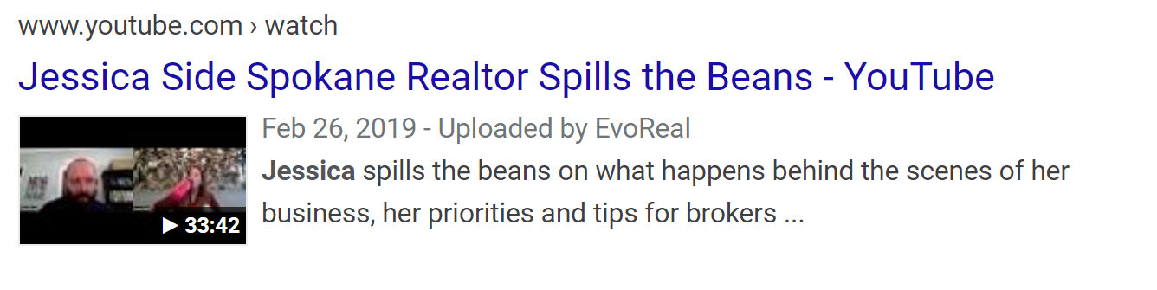**Step 6:** Do this! Start a YouTube channel if you have not yet and upload an introduction video, use your name and ‘Spokane WA Realtor’ in the title. Include a nice description and link back to your agent website in the description.

Why? Google owns YouTube, and if you do this right your image video thumbnail will be right on the first page of the search.

**Step 7: Do this!** Setup a Google Business account completely (verify and add categories), have your clients and friends review you, fill out your business completely and upload photos. Have clients and friends upload photos on your google business via the Google Maps app (they are more linked than you may know). Upload them from your separate Gmail account.

Bonus pts for utilizing the Google Business Posts

**Add a snapshot photo of your business card.**

Add photos from your office, working with clients, showing houses, anything real estate related.

**Step 8: Setup a vanity site-** Setup and manage a vanity site, use your name as the URL or link it to your realty one group agent website.

**Step 9:** Ask your clients for reviews, make the links short and easy (use <https://bitly.com/> to shorten if necessary)! Prioritize your Google business account, followed by sites that pop up on search.

**Step 10:** Check your links, add links to all areas to build consistency and inbound/outbound linking to social media or other featured websites. (have you updated your zONE profile lately?) 😊

**Search yourself on a bi-weekly/monthly basis and adjust your descriptions, blogging, bios etc… as keyword searches change, keep your business photos updated and try to be consistent across channels with your desired messaging.

**Top referring pages for Realtors after Googling our brokers;**

#1. Realty One Group- Update your bio in zONE!

#2. YouTube if you have it- remember key words

#3. Homes.com- create a free profile

#4. Linked in- create your profile (lots of recent changes since Microsoft purchased it)

#5. Realtor.com- fill out your profile and add a photo

#6. Zillow.com- fill out your profile and get reviews

#7. Homesnap.com- setup your account (this should be free with your Realtor association)

#8. Alignable- if you have it fill it out and design around your branding

#9. Facebook- if you are public this should pull up, make it easy for people to find you

#10. Instagram- tip use your name if you want to be found

#11. Blogs and newspaper articles- Spokesman review, business journal, other magazine (outbound links will bolster)