What you need before you add E-Invoice in your Sage-50:
- Sage Exchange/Payment center Username and Password
- Sage Gateway for Sage 50
- Sage 50 2020
- Paya Connect Desktop

STEP # 1:
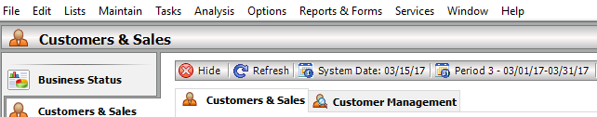

From Services > Click on CREDIT CARD PROCESSING >> Click on ACCOUNT INFO >> Enter Merchant ID and Merchant Key >>
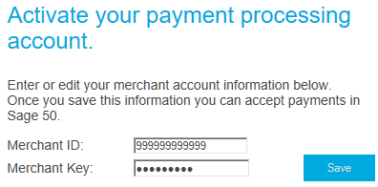

THIS STEP COMPLETES THE ACTIVATING OF CREDIT CARD PROCESSING IN SAGE 50.

STEP # 2:
From your Sage 50, click on Payment Center:

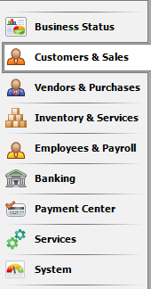

Log in to Payment Center using your Sage Exchange log in credentials: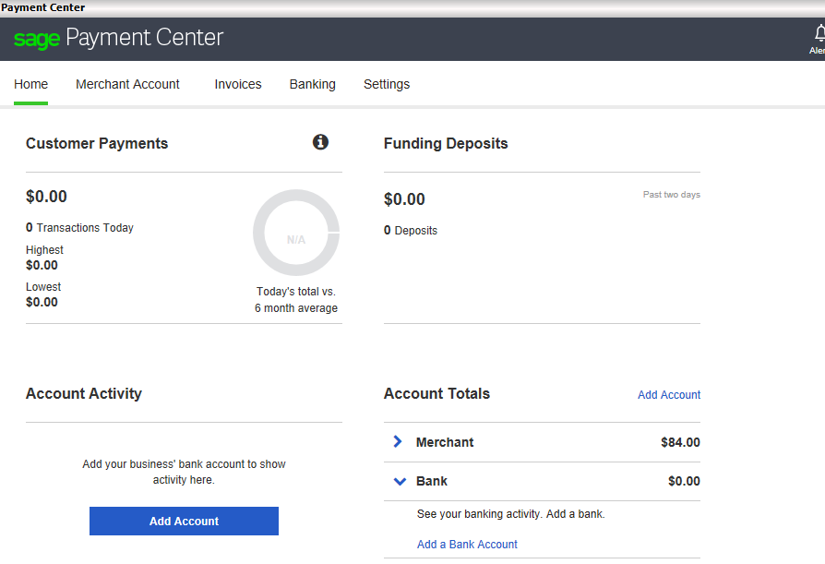

STEP # 3:
Configuring the Sage 50 R20 plug-in for e-invoicing:
Right‐click the PCD icon in the Microsoft Windows system tray then left click Settings to open the Sage Exchange ‐ Settings dialog box.
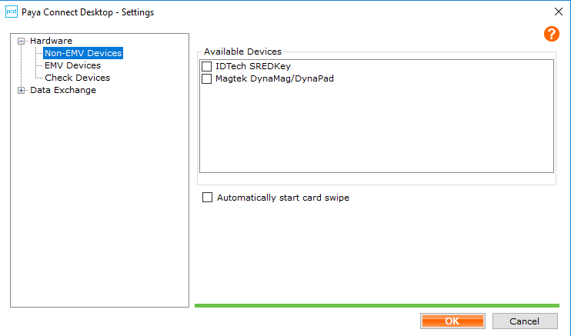
Click on Data Exchange and Register your company.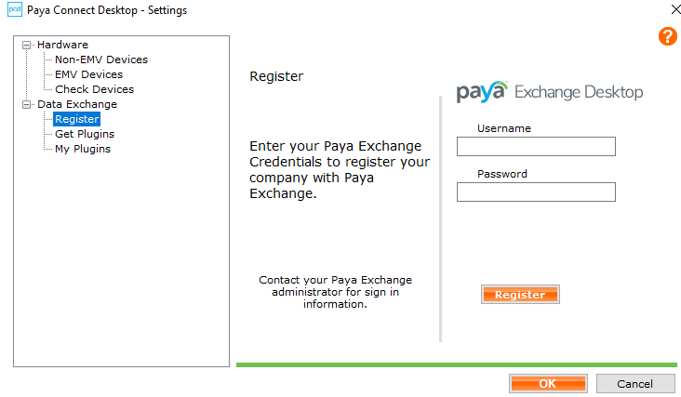

Upon clicking Register, following window will appear:
Use Sage Exchange Login credentials to Register

If you have entered correct Login credentials, the system will accept your registration, and will show this message: Registration Successful

After having registered successfully, it is time to Get Plugin for E-Invoicing (Install and Configure the Sage 50 2017 plugin):
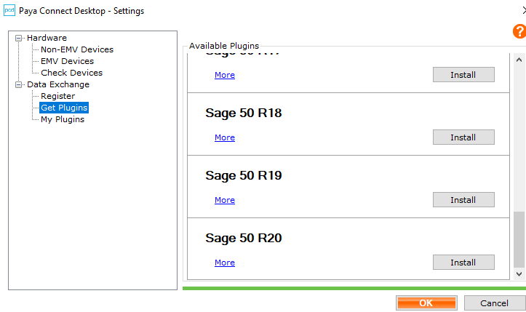
After choosing to Install, you would need to click on YES to enable Plugin: 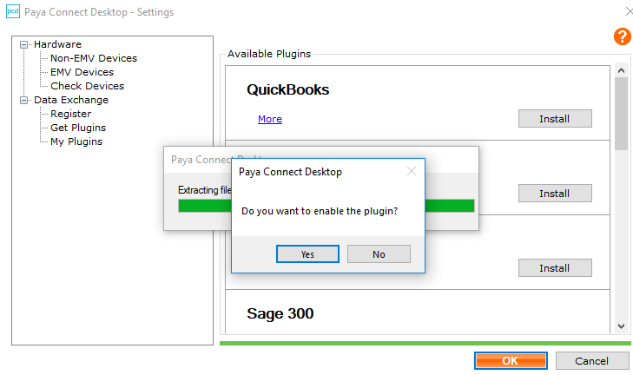

Time to select your Company:

Your available companies will pop-up in this window. Select the desired company and click OK:
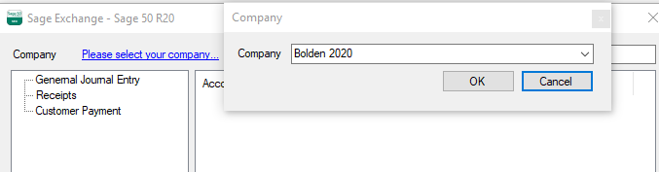
Click OK to exit the Sage Exchange - Sage 50 R20 dialogue box.
If this is your first time enabling a plugin, you will see an error after clicking OK. This is not unusual. Click OK on the error dialogue box.
“””””At this point, you must log out of Sage 50 and Log back in to Sage 50.”””””

Close Sage 50. Re-Open the same company in Sage 50, and you’ll see this pop-up:
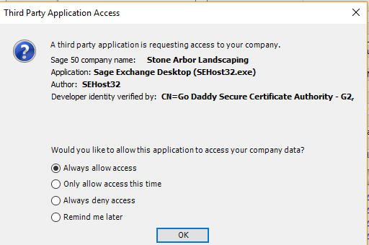
Always Allow access

Right-click the PCD icon in your system tray and choose Settings, Data Exchange, My Plugins and click ENABLE. There are three categories in this screen. General Journal Entry, Receipts, and Customer Payment.

Step 1: Leave General Journal Entry as is. Do not select any Account under this category:

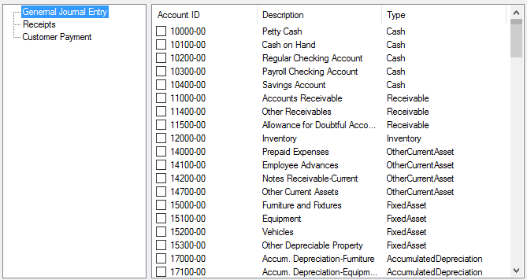

Step 2: Under the category “Receipts”, please select the GL account that you would you’re your Paid Invoices to be sent :

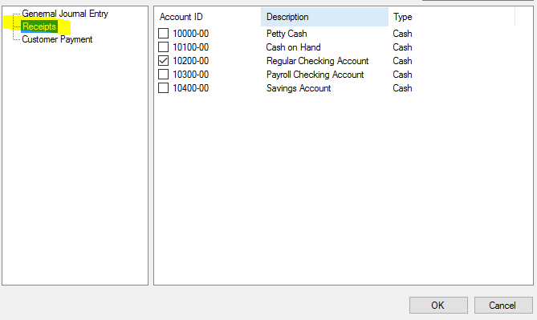

Step 3: Under “Customer Payment”, please select an account.
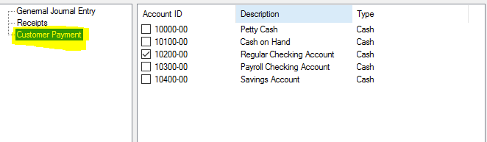
After selecting accounts, click Ok.

Step # 4:
In Sage 50, click Payment Center, then click on INVOICES:
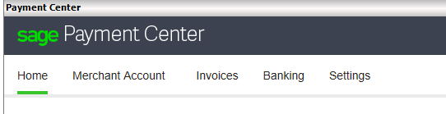
You will see this message. Click RECONNECT INVOICES:
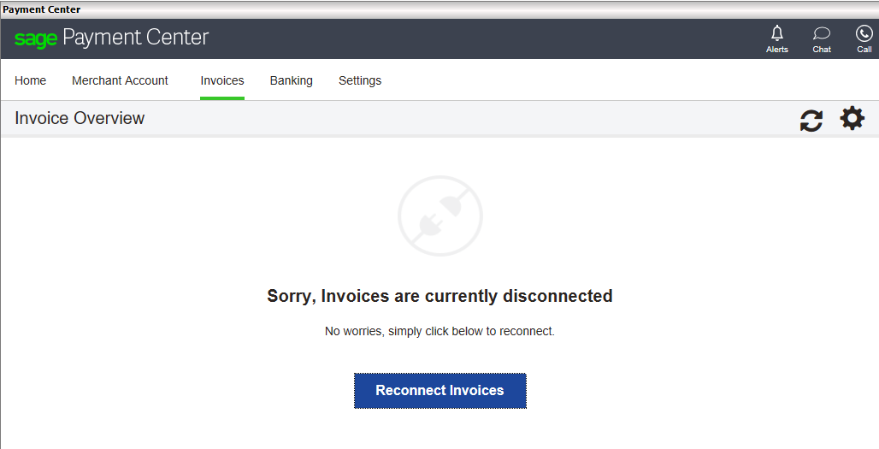

Select the account you want the Invoices to be posted and Save: (For example, this account has chosen Checking). Click SAVE.

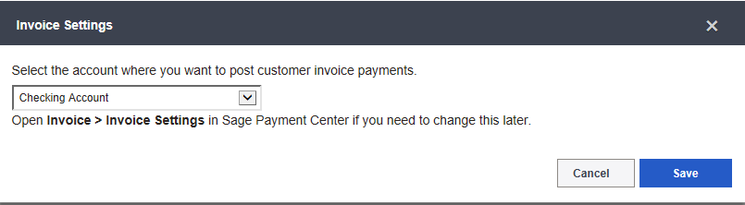

Upon successful connection, you will have following screen displayed:
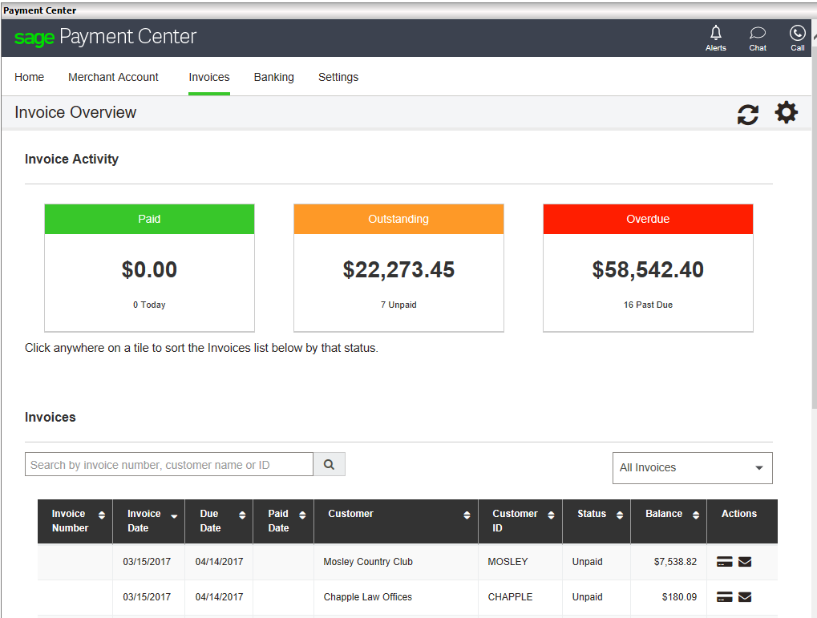
You have successfully activated your E-Invoice feature within your Sage 50 Software.

