Process Document for Encrypt
CSV file & upload to SFTP Site

Introduction

Purpose
This document captures the steps to be followed for encrypting and upload the csv file to SFTP Server.

Intended Audience
This document is intended for technical team of merchants of Rev.IO.

Software required
- File zila (https://filezilla-project.org/)
- Open PGP (https://www.goanywhere.com/openpgp-studio/download)

File Zilla

Go to URL (https://filezilla-project.org/)

Download the installation file, i.e. click on Download File Zila Client.
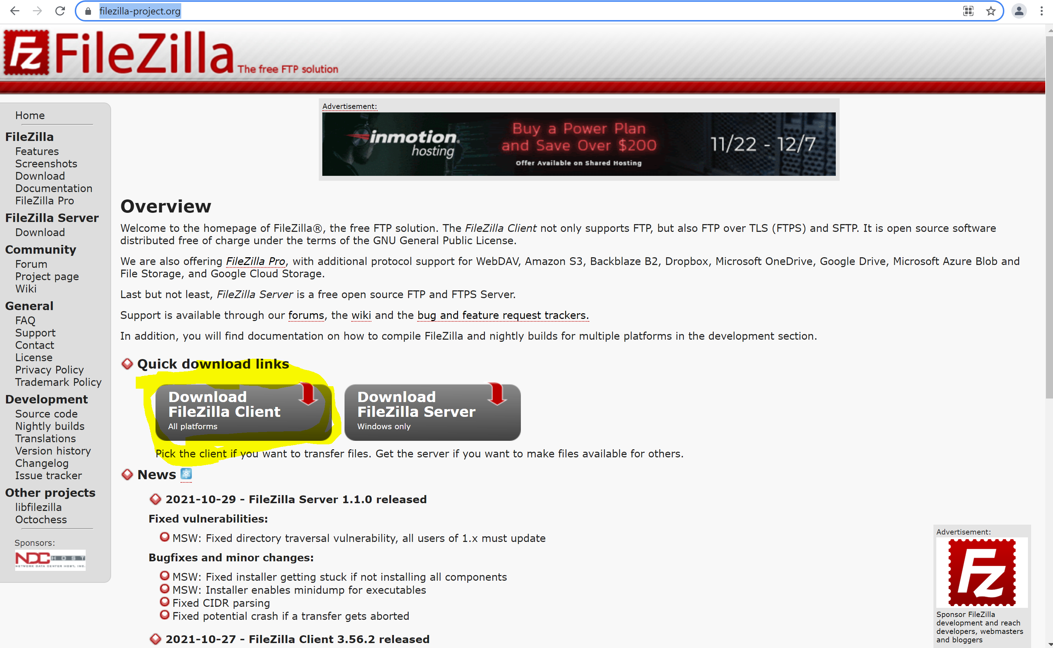

Will get below screen
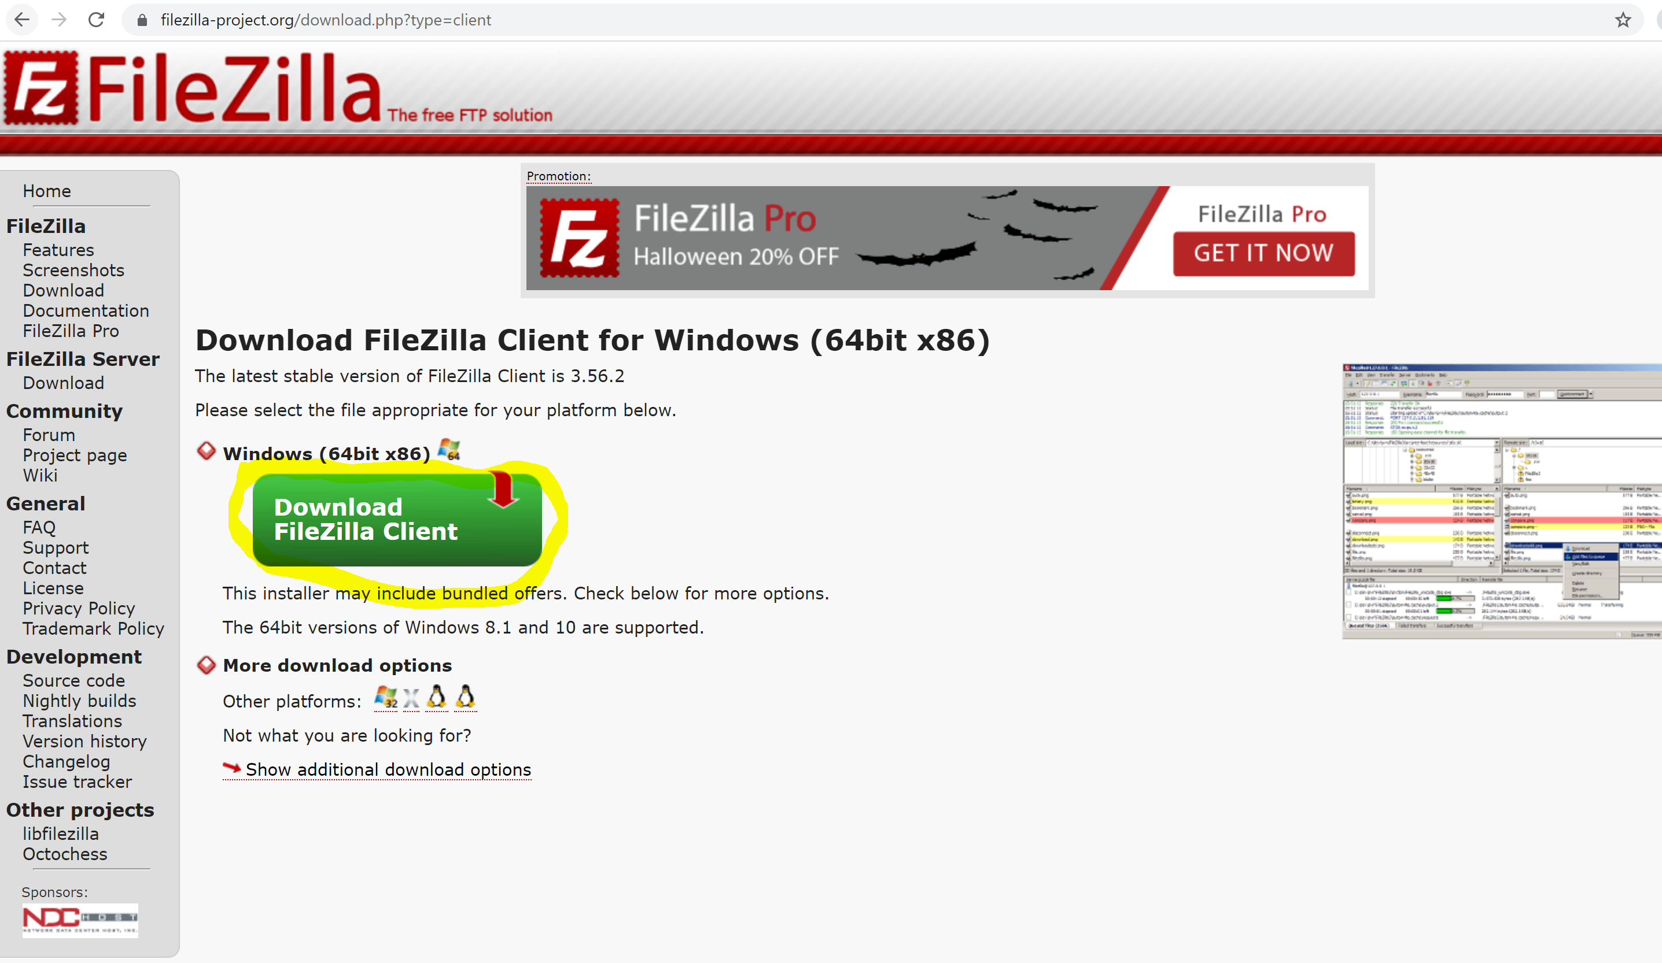

Click on Download File Zila Client, will get below screen
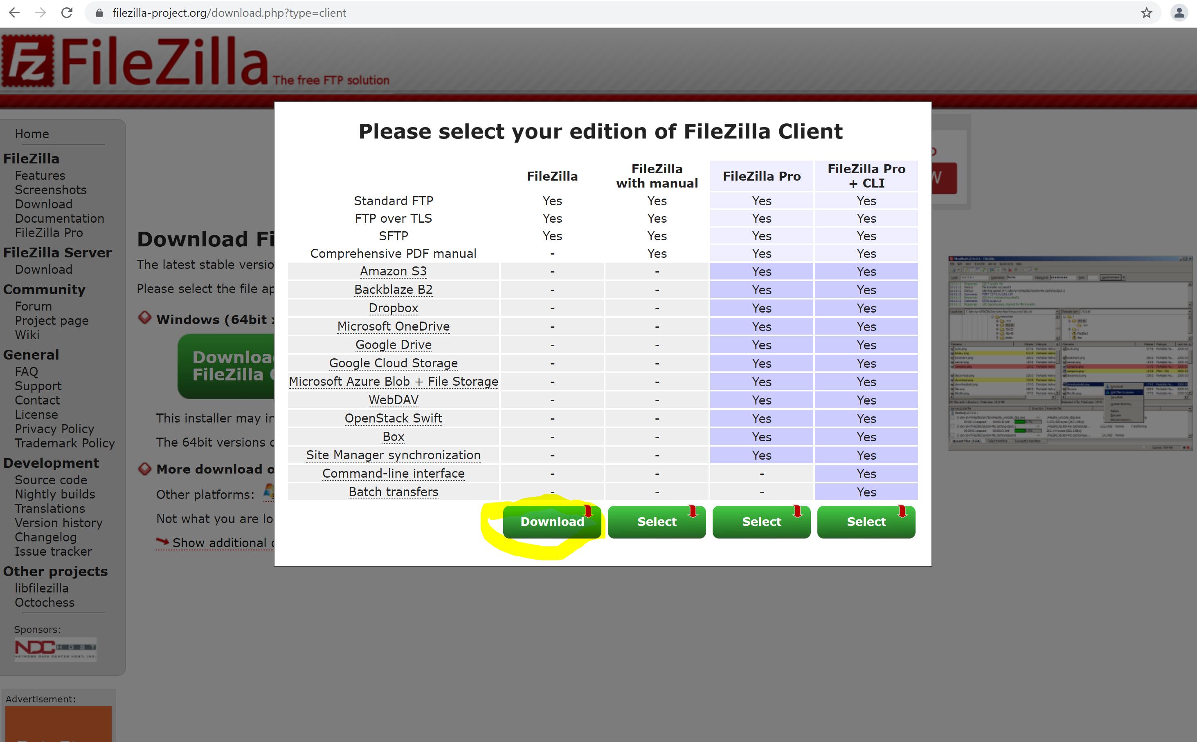

Click on download , will download the file (FileZilla_3.56.2_win64_sponsored-setup.exe)

Open the file ( FileZilla_3.56.2_win64_sponsored-setup.exe ) for installation steps, press next & finish
Click I Agree
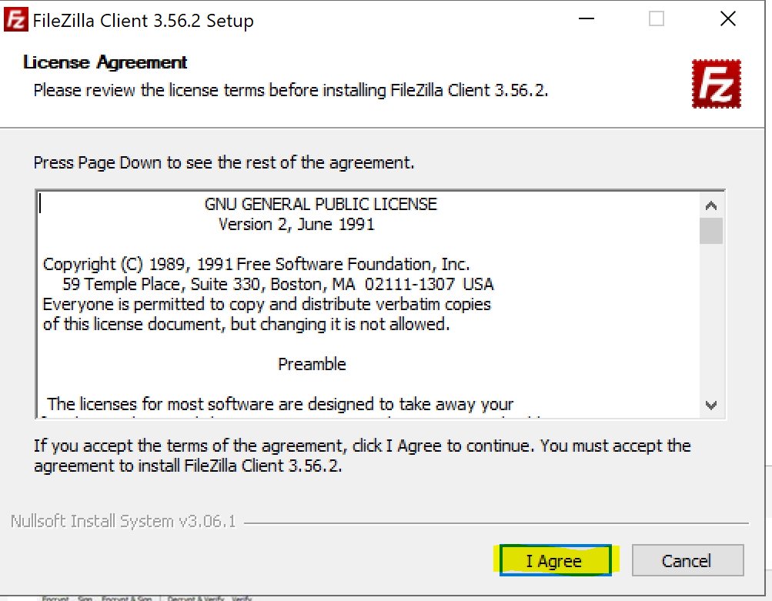

Click Next
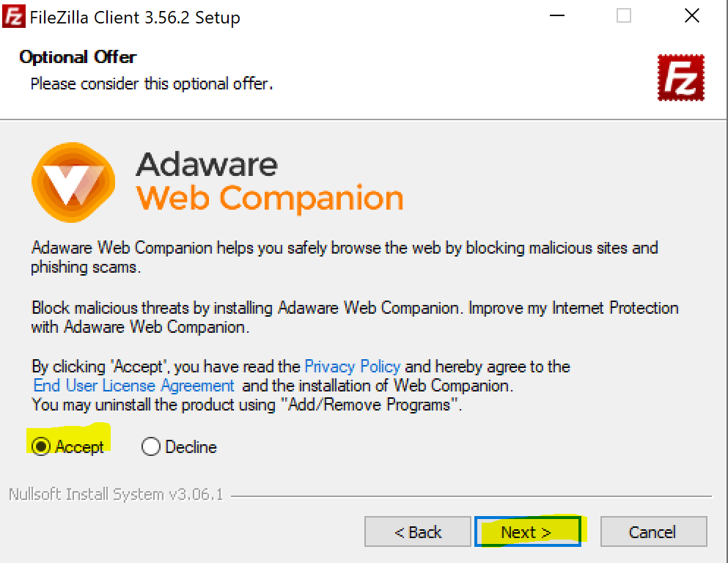
Click Next
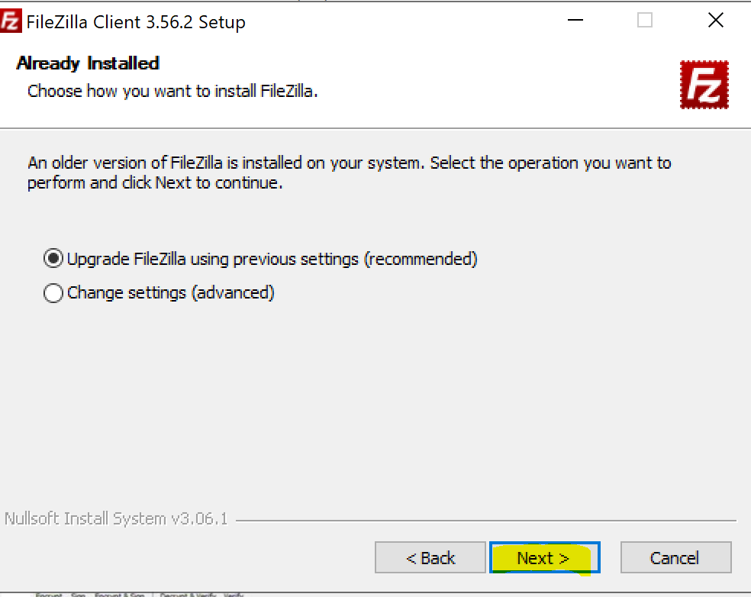
Installation in progress
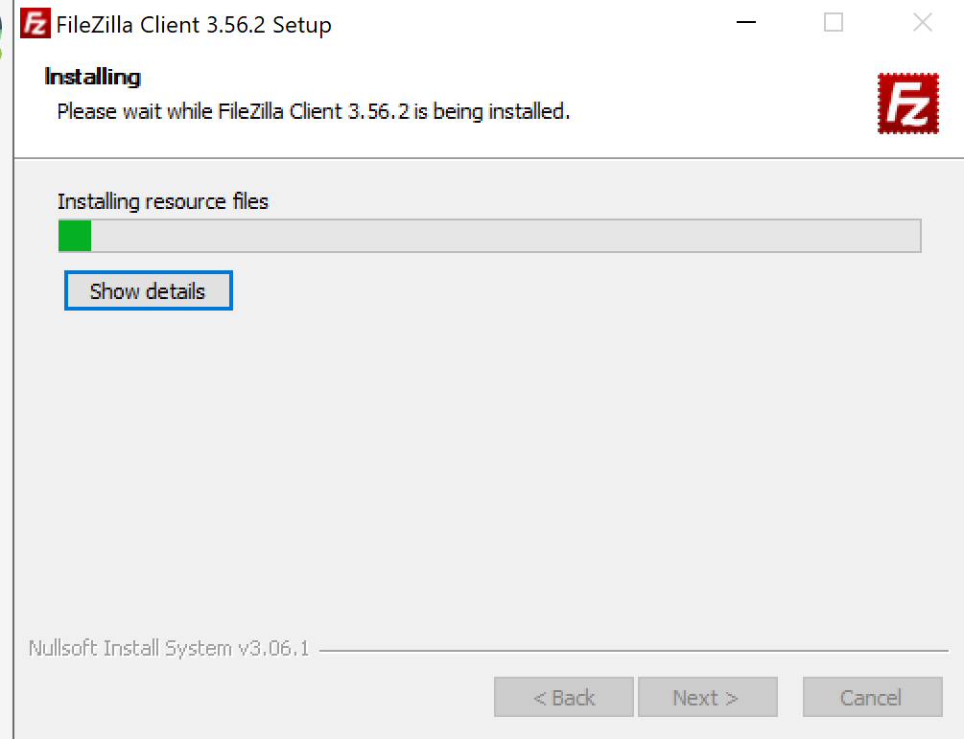
Click Finish
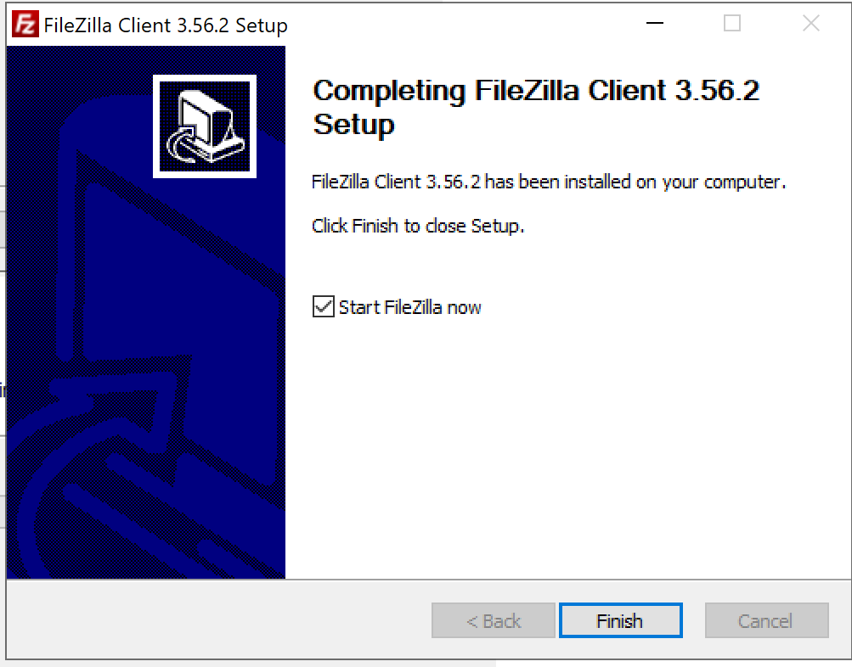

You will get below screen, once you open the File zila

Enter the given details
- Host Name
- User Name
- Password
- Port number
Click on Quick Connect button.

on successful connection below screen will show the path where you need to upload the encrypted csv file

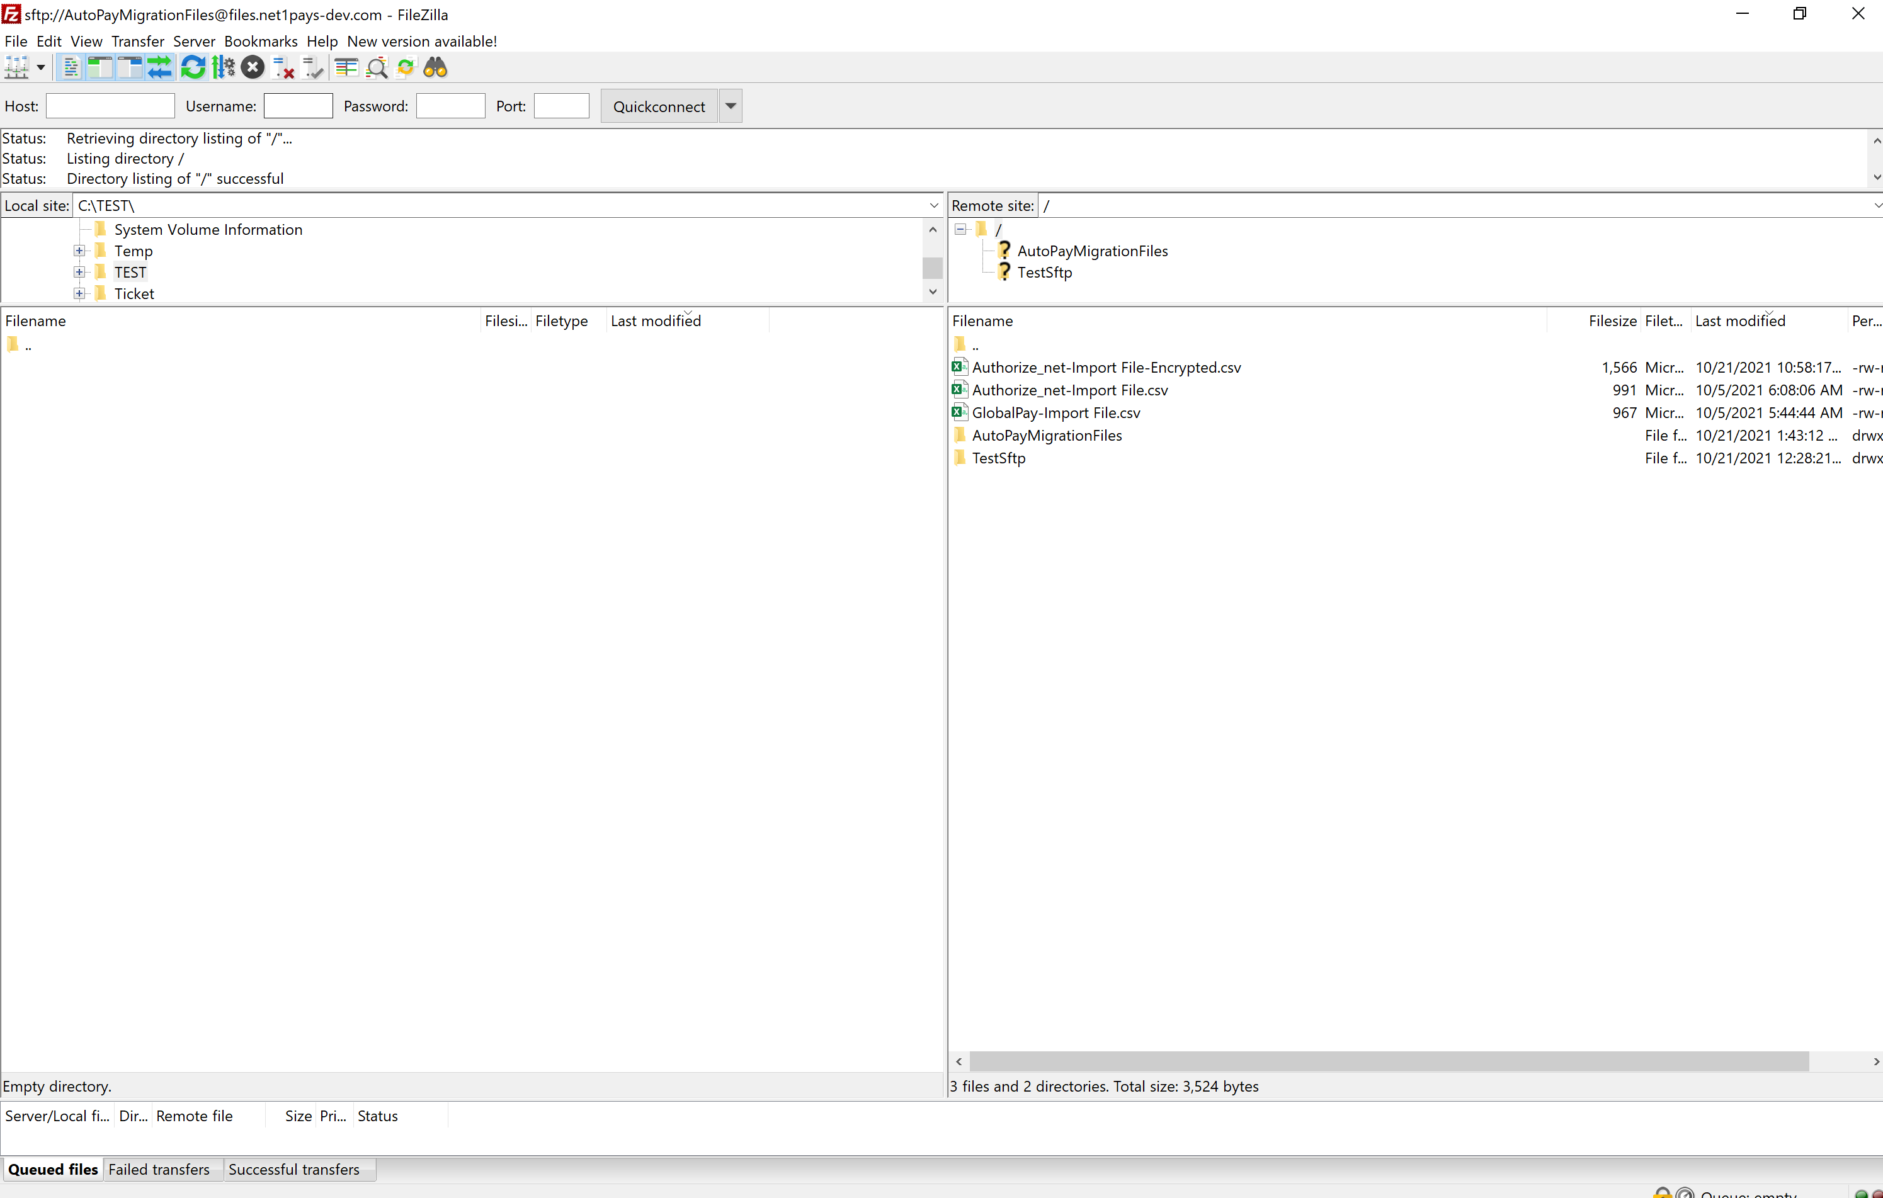

Open PGP Studio

Download PGP software ( https://www.goanywhere.com/openpgp-studio/download)
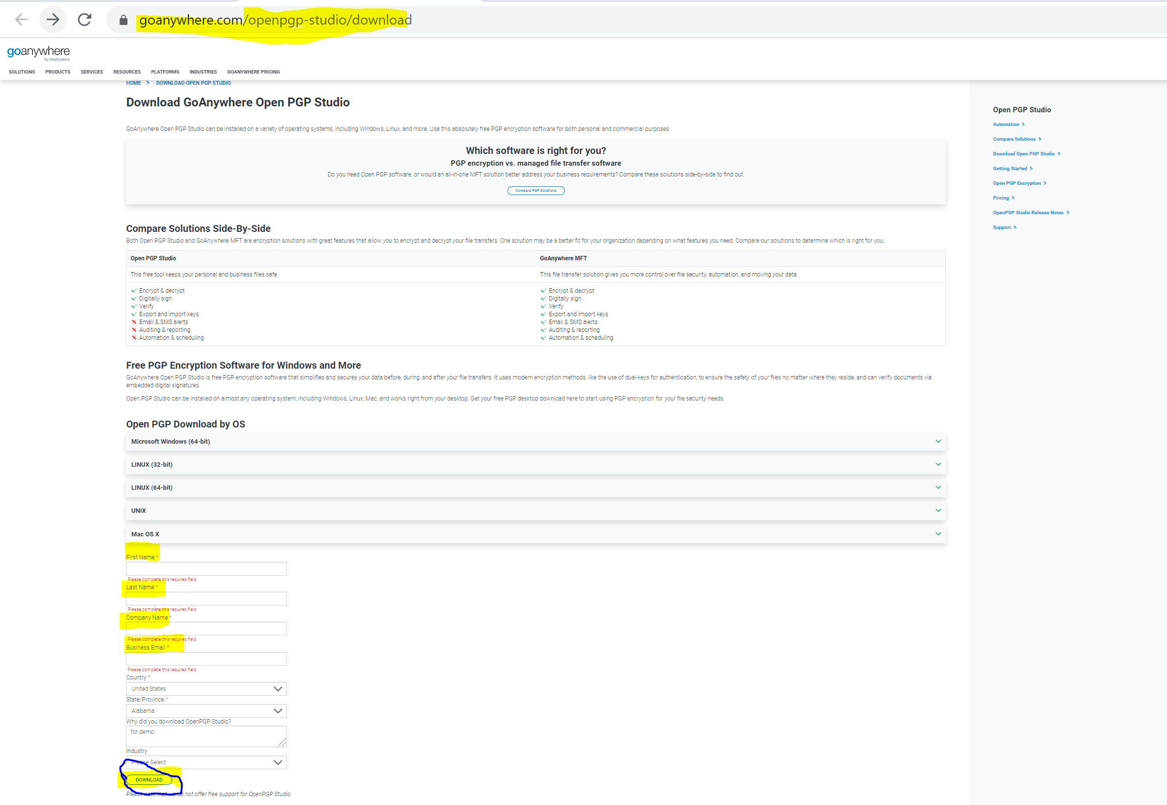

Click on Download button- to download file (gapgpstudio1_2_0_windows.exe)

Open the file (gapgpstudio1_2_0_windows.exe) to start installation

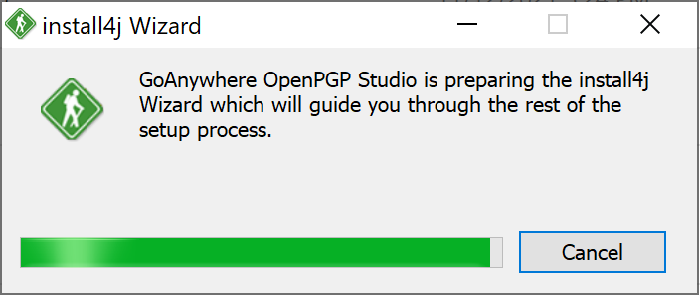

Click next

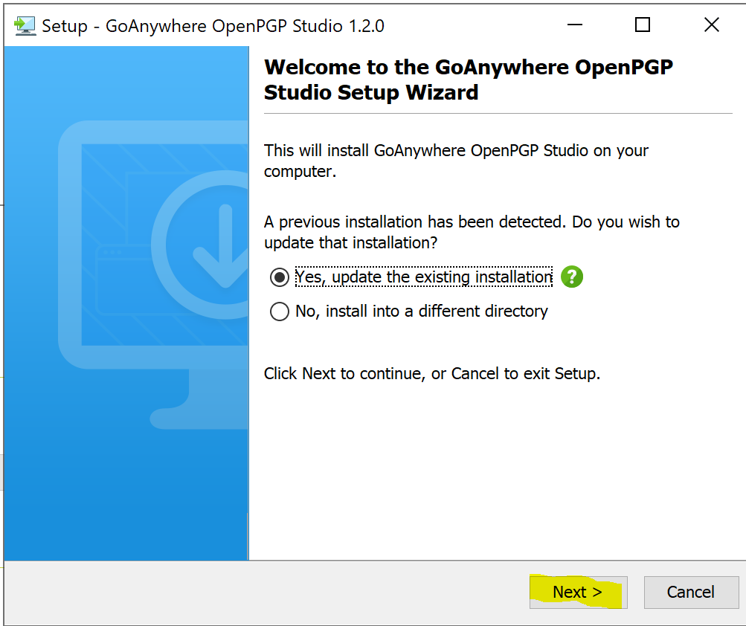

Click next

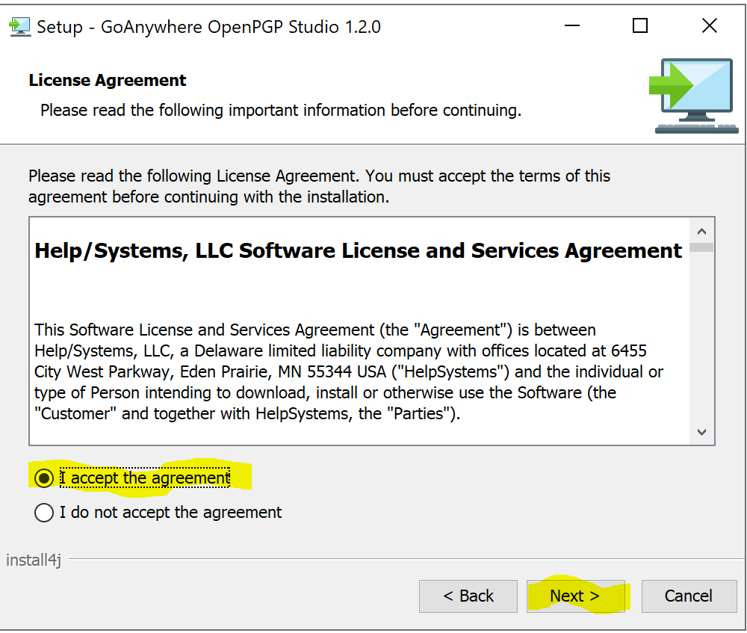

Click finish button

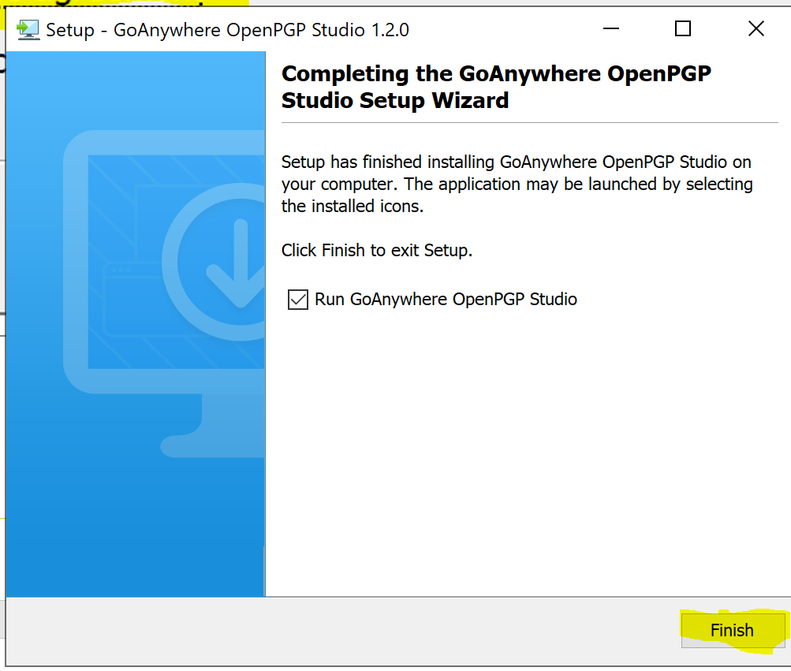

Once installation is done

Search for application OpenPGPStudio.exe – IF YOU OPEN THIS APPLICATION, BELOW SCREEN SHOULD OPEN
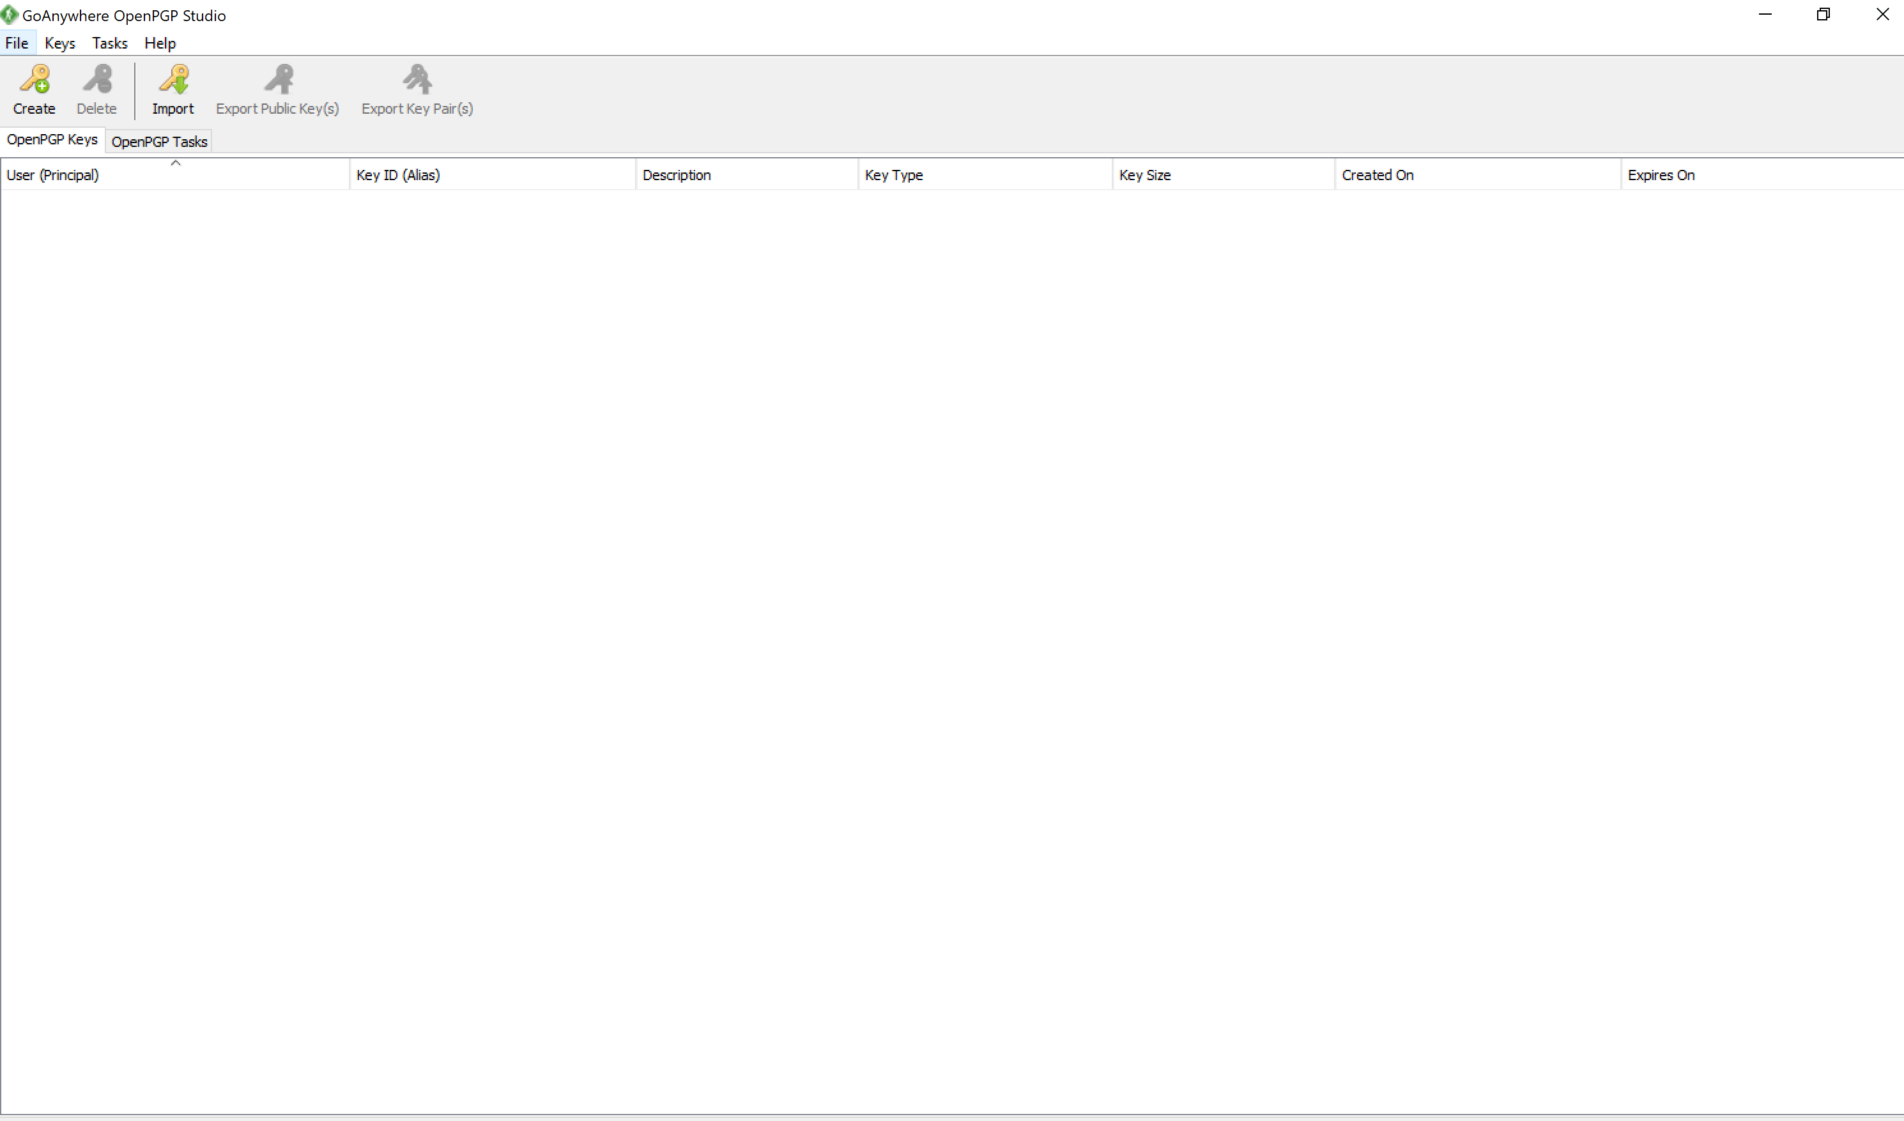

Click on Import button on the tab OPENPGP Keys
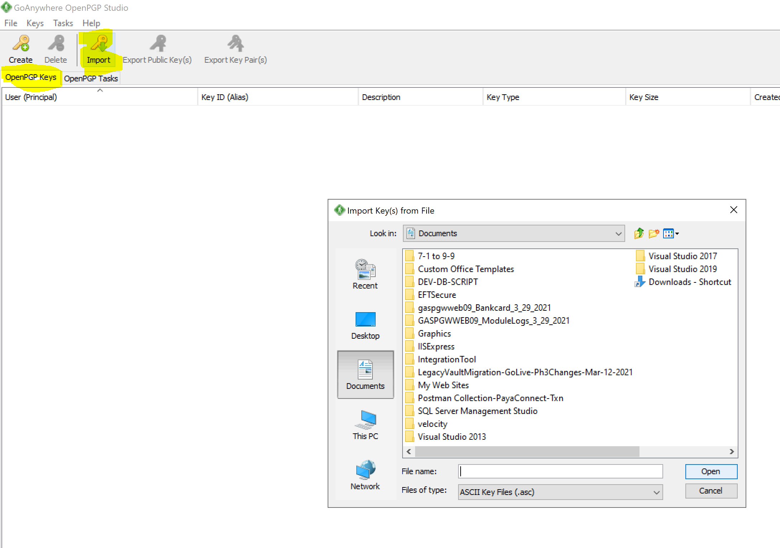

Select the given public key
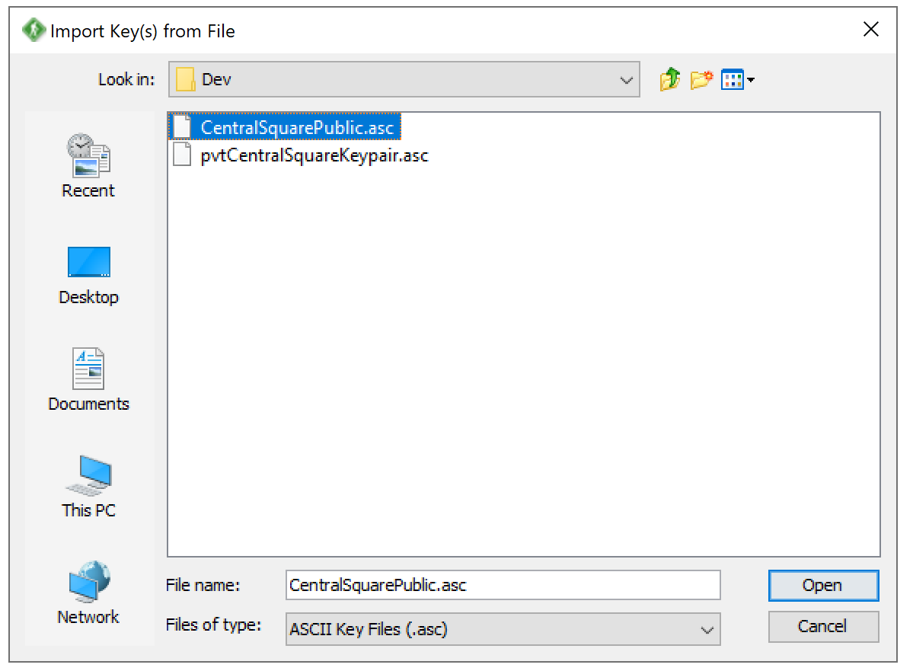

Select the file to be encrypted
        - select OpenPGP Task as shown below
        - left window- select the folder where the file is located
        - right window- select the file to be encrypted
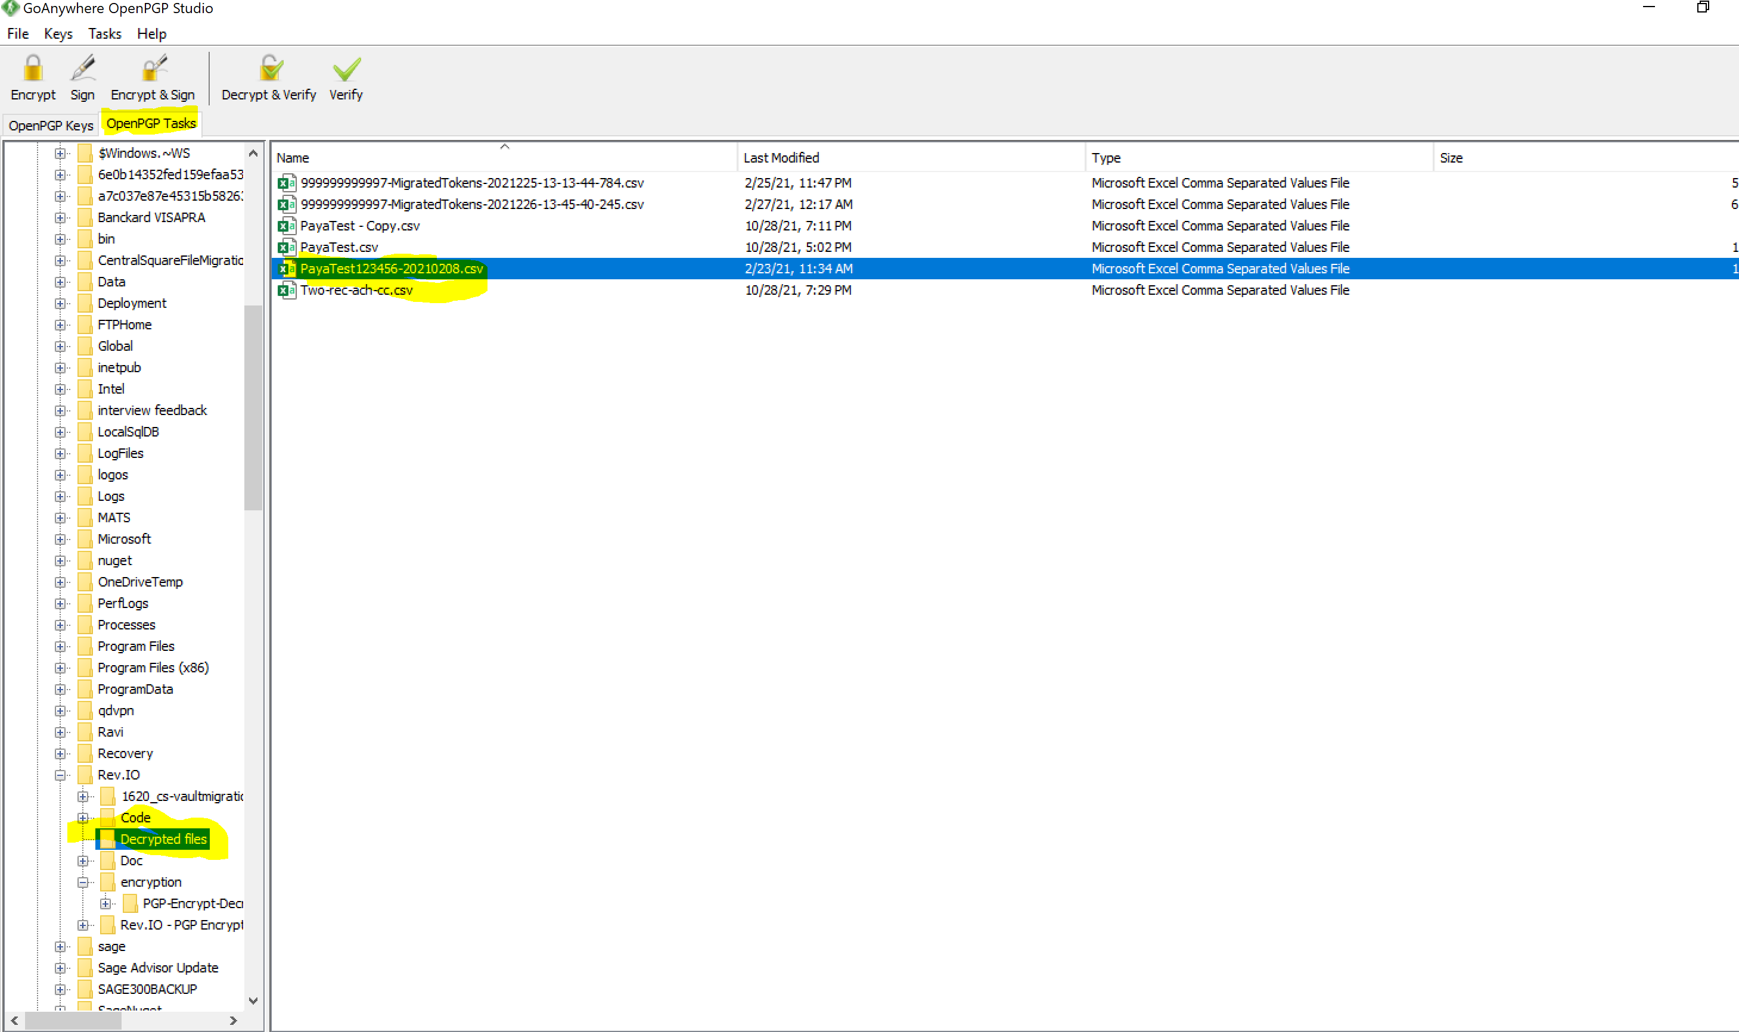

Right click the file that need to be encrypted
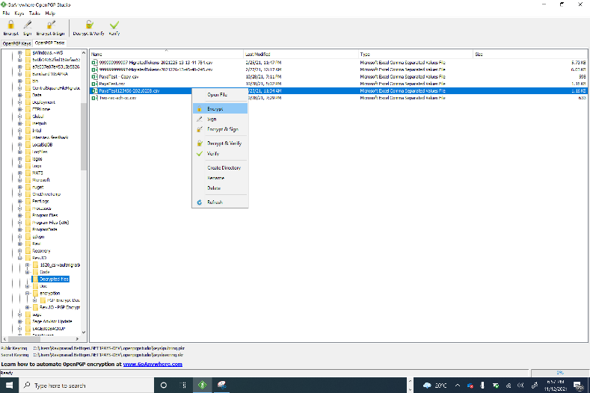

Click on Encrypt menu
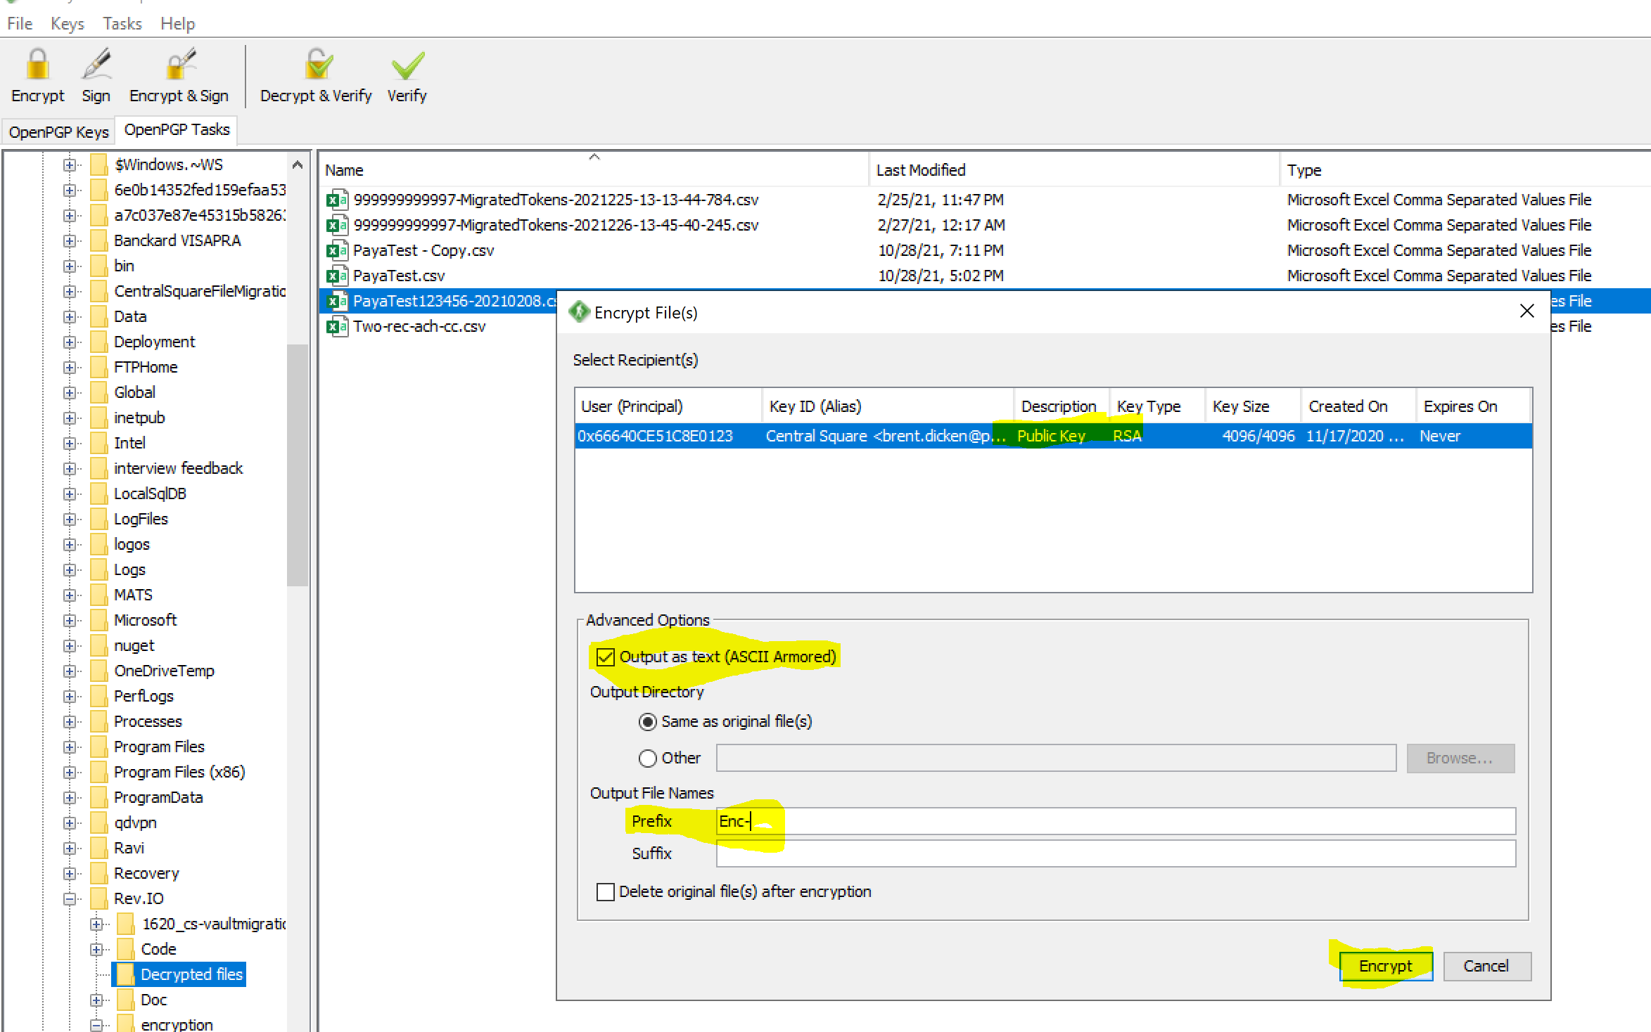

When above screen is open, make sure
- Remove suffix - .asc
- Add Prefix Enc-
- Check- check box Output as text(ASCII Armored)
- Finally press Encrypt button

Will get below screen
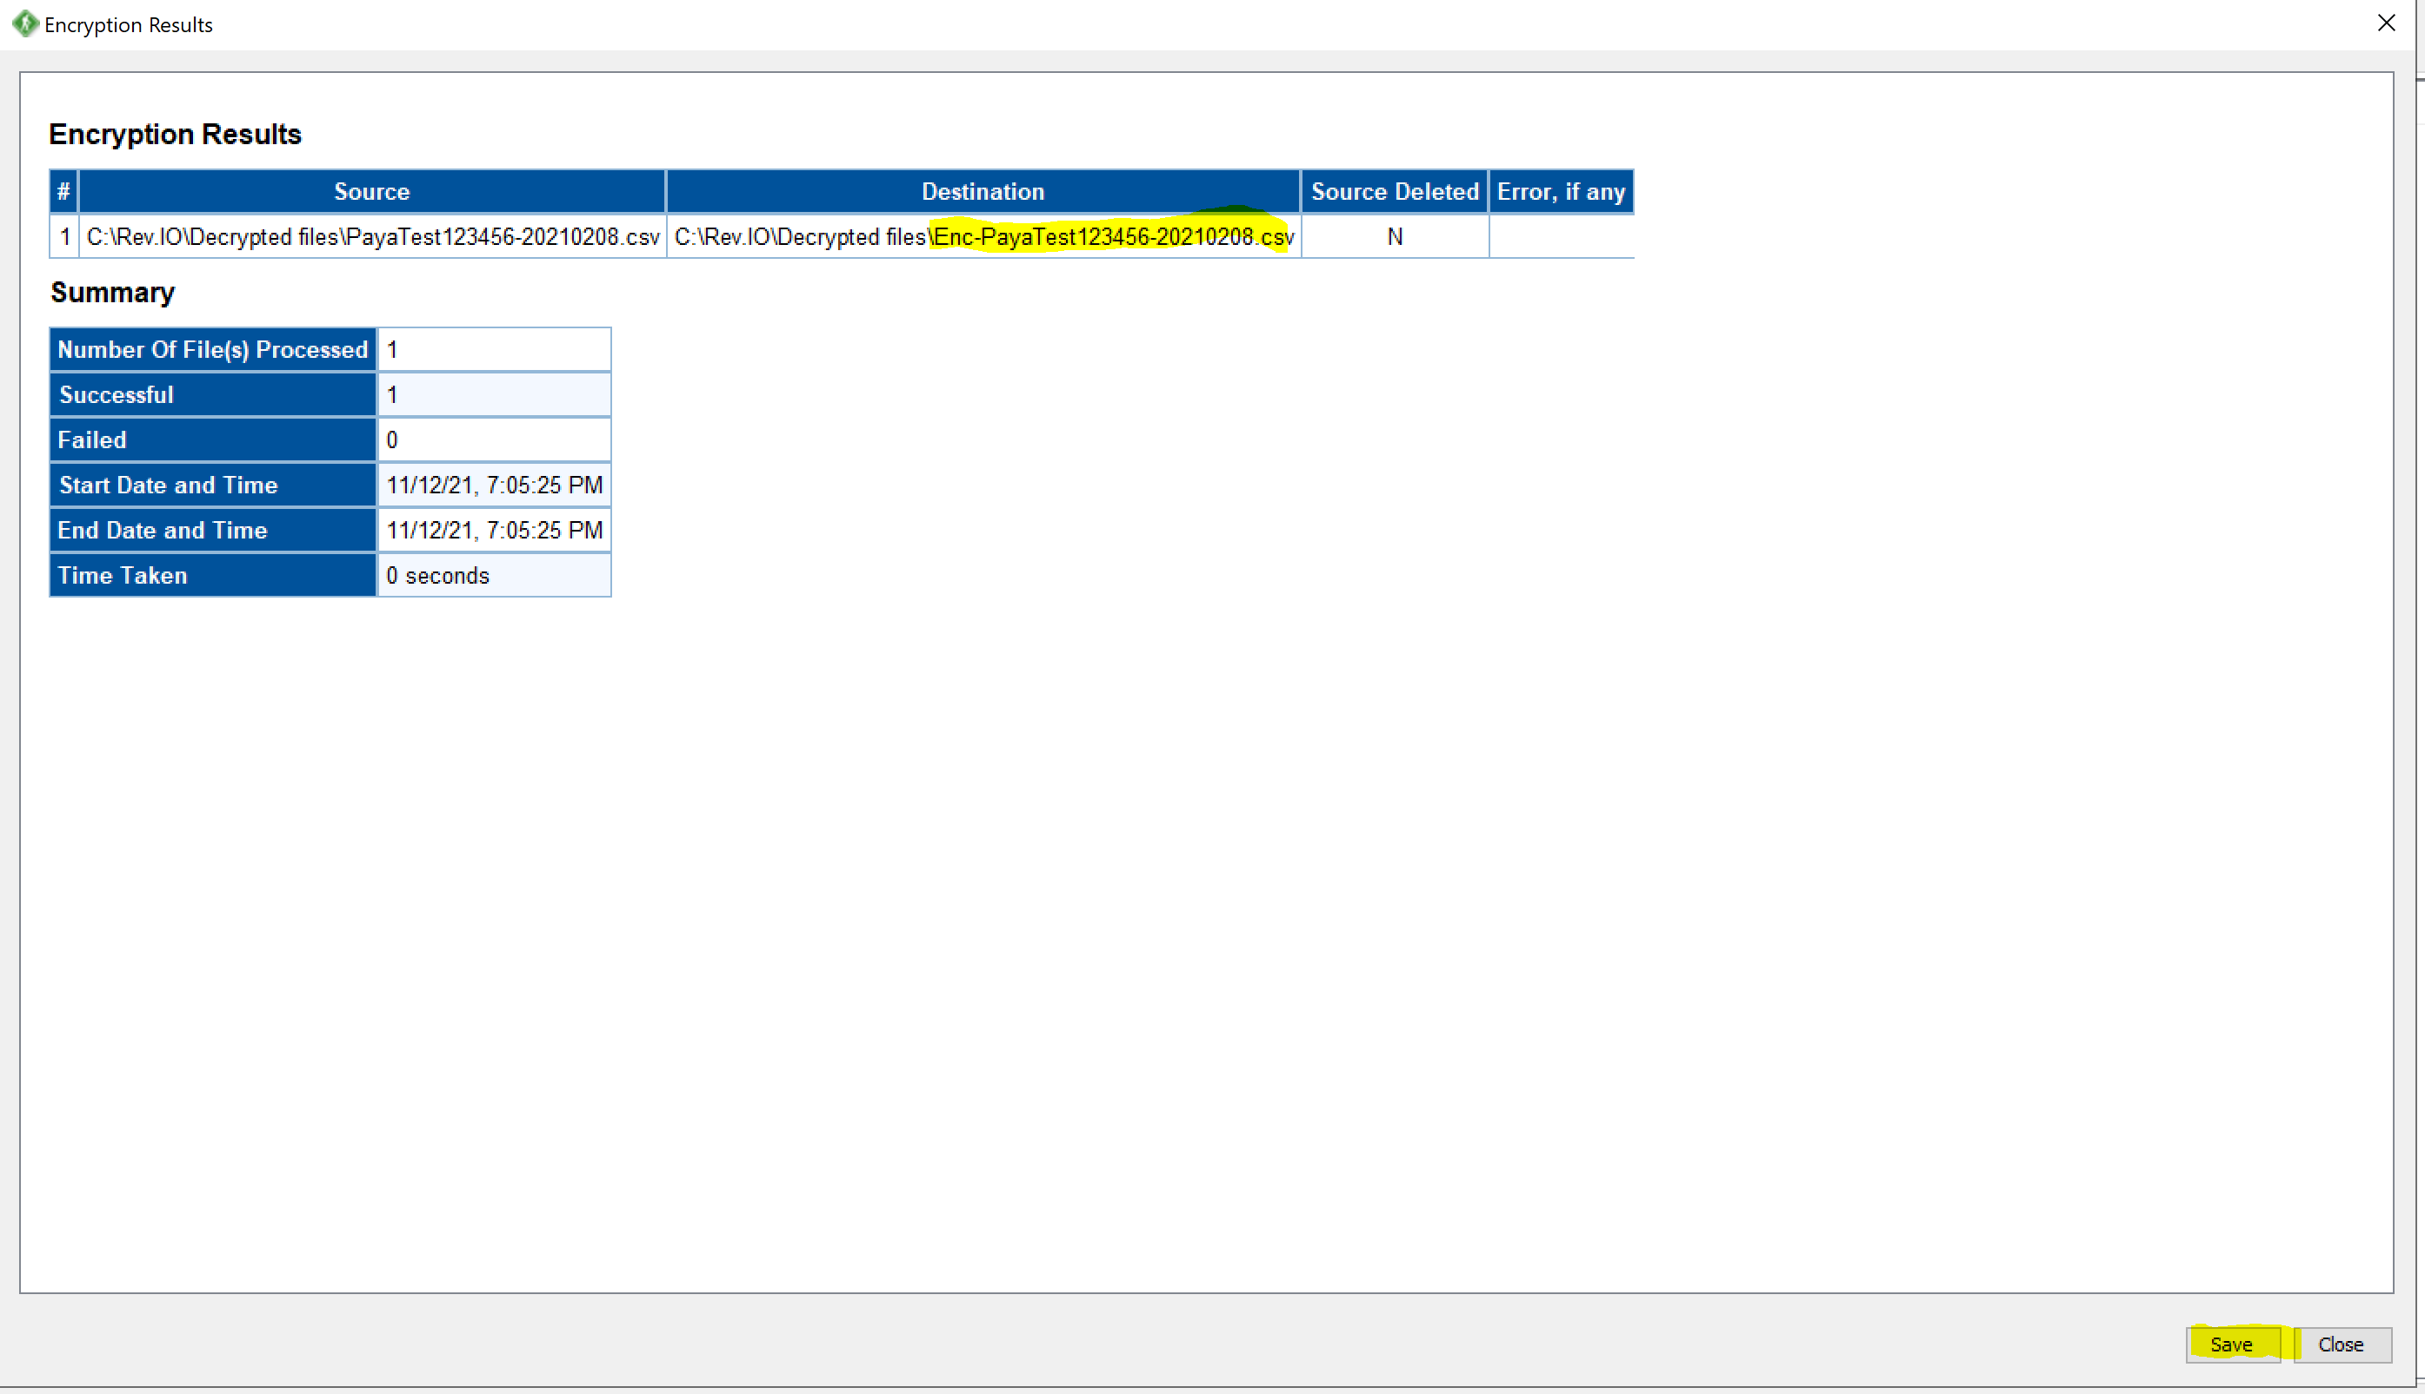

Click on – Save button- to save report in html format as below & click on close button

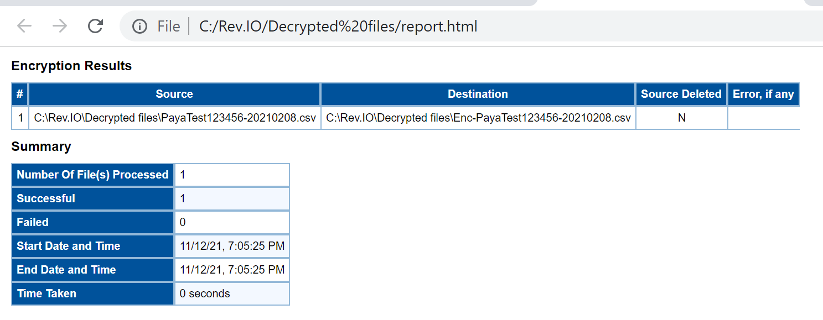

Verify the encrypted file is created
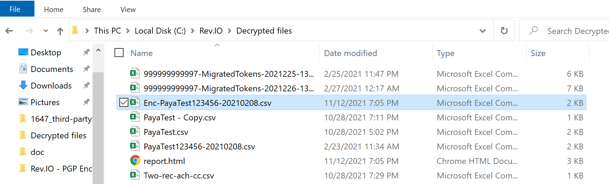

Once encrypted file is created

Connect to SFTP via File Zilla : Detailed in 2.8 section above, for how to connect

Upload to SFTP server via File zilla
Drag encrypted file from left window to right window.
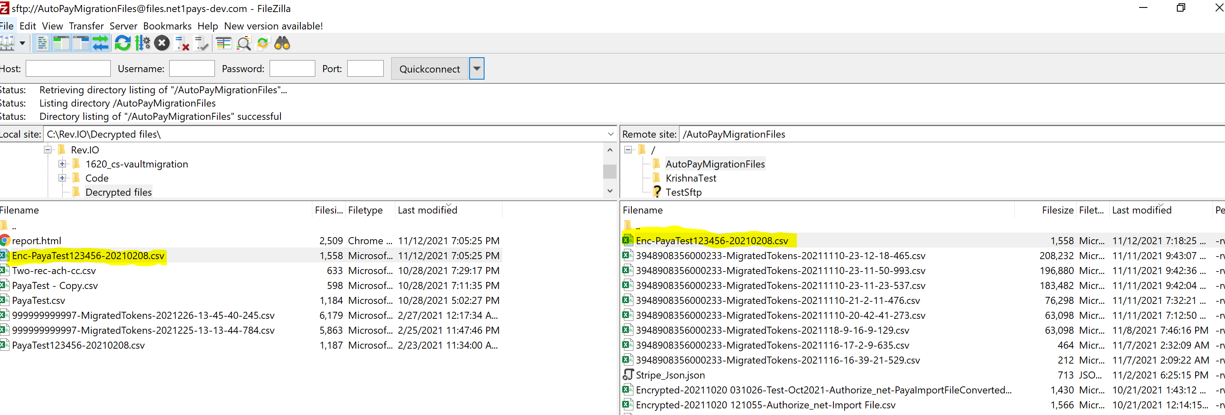

Upload file to SFTP server is completed

