Process Document for
CSV file upload to SFTP Site

Introduction

Purpose
This document captures the steps to be followed for uploading the csv file to SFTP Server.

Intended Audience
This document is intended for merchants that have auth.net tokens to upload to Paya.

Software required
- File zila (https://filezilla-project.org/)

File Zilla

Go to URL (https://filezilla-project.org/)

Download the installation file, i.e. click on Download File Zila Client.
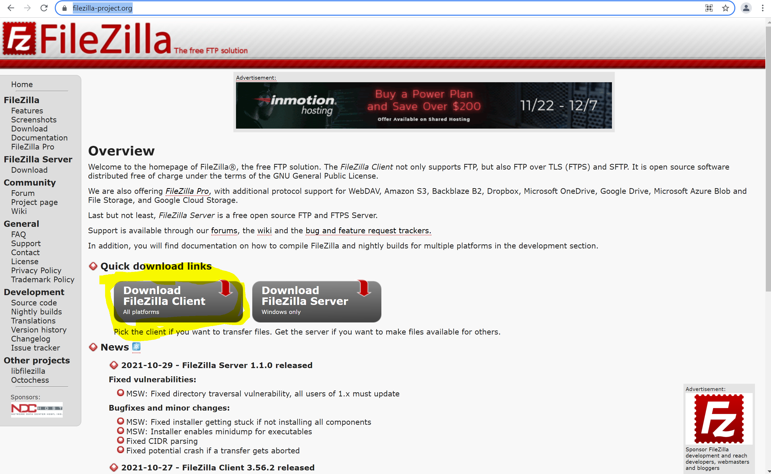

Will get below screen
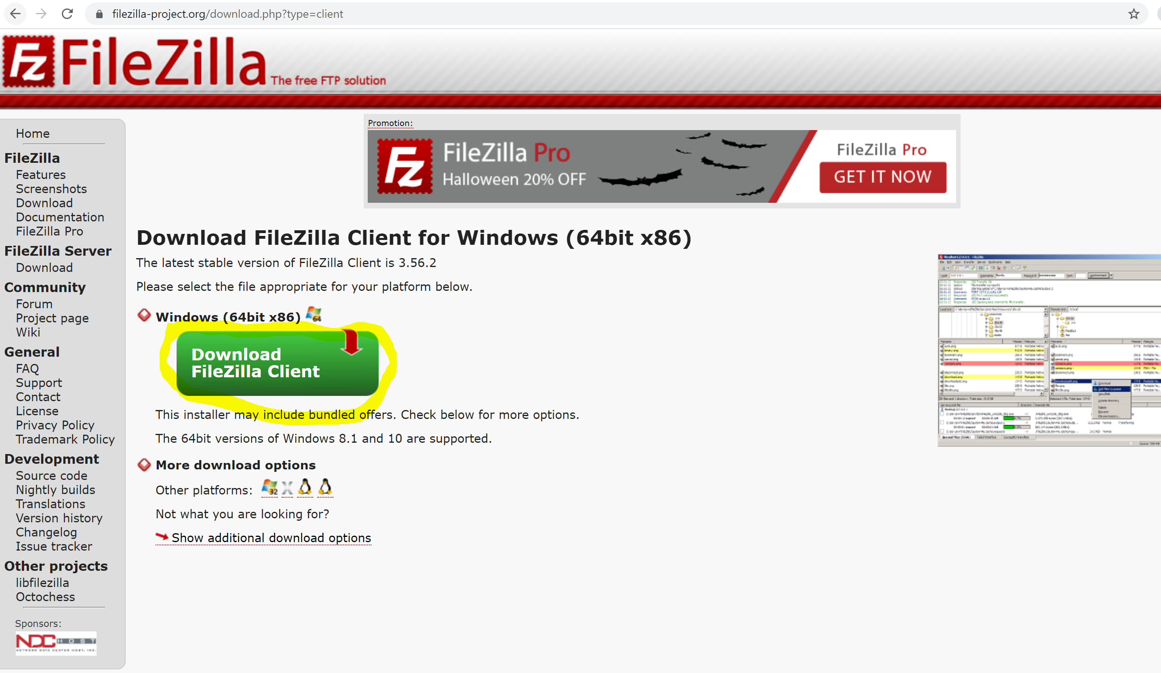

Click on Download File Zila Client, will get below screen
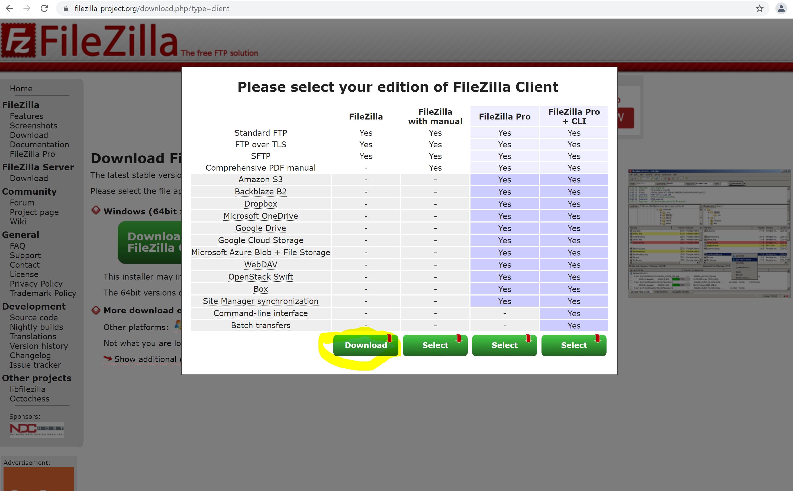

Click on download , will download the file (FileZilla_3.56.2_win64_sponsored-setup.exe)

Open the file ( FileZilla_3.56.2_win64_sponsored-setup.exe ) for installation steps, press next & finish
Click I Agree
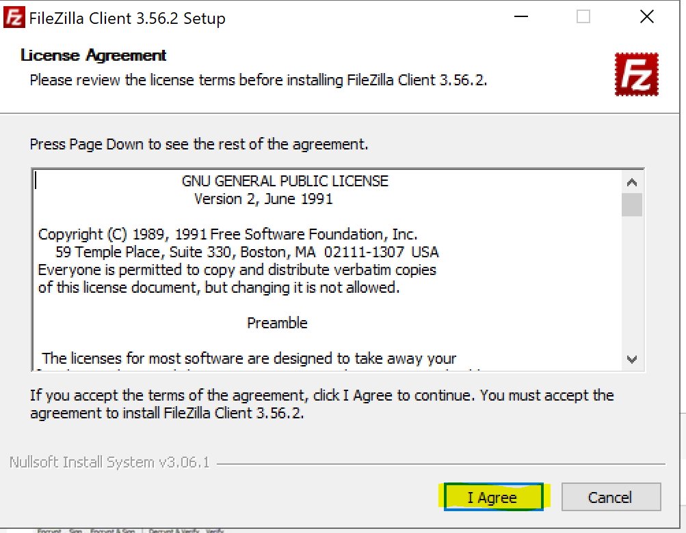

Click Next
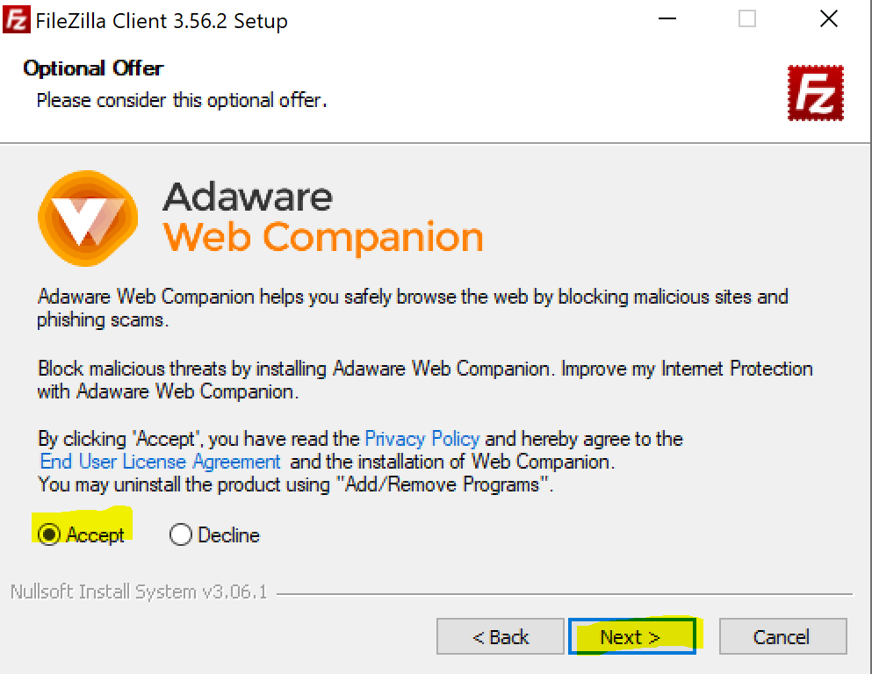
Click Next
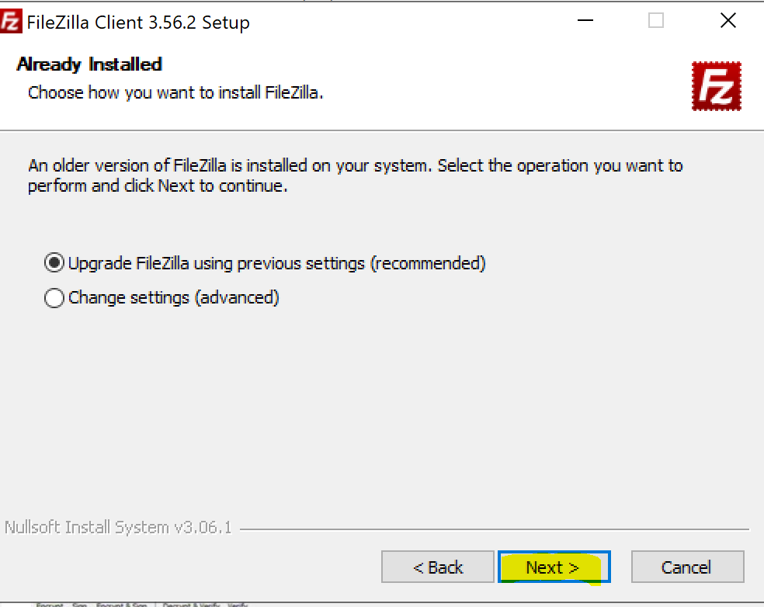
Installation in progress
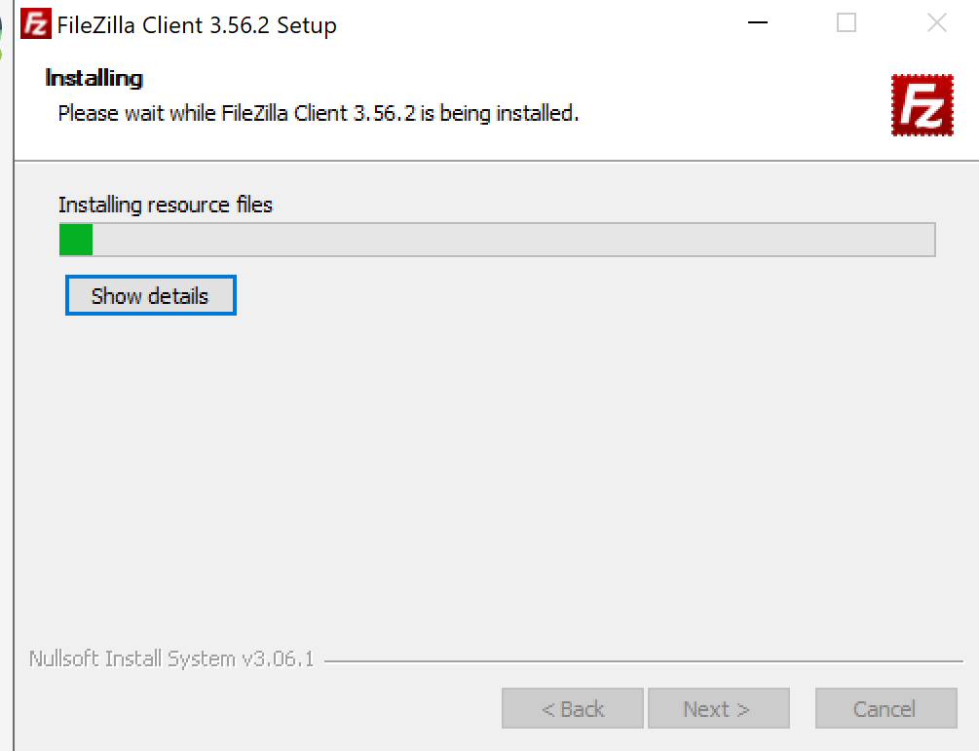
Click Finish
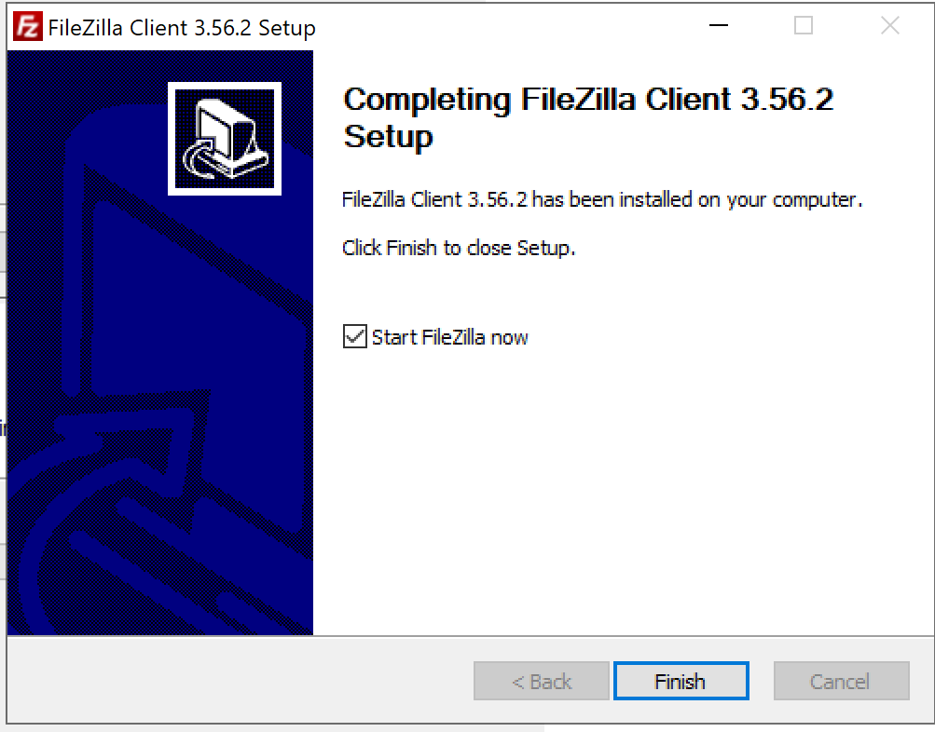

You will get below screen, once you open the File zila

Enter the given details
- Host Name
- User Name
- Password
- Port number
Click on Quick Connect button.

on successful connection below screen will show the path where you need to upload the encrypted csv file

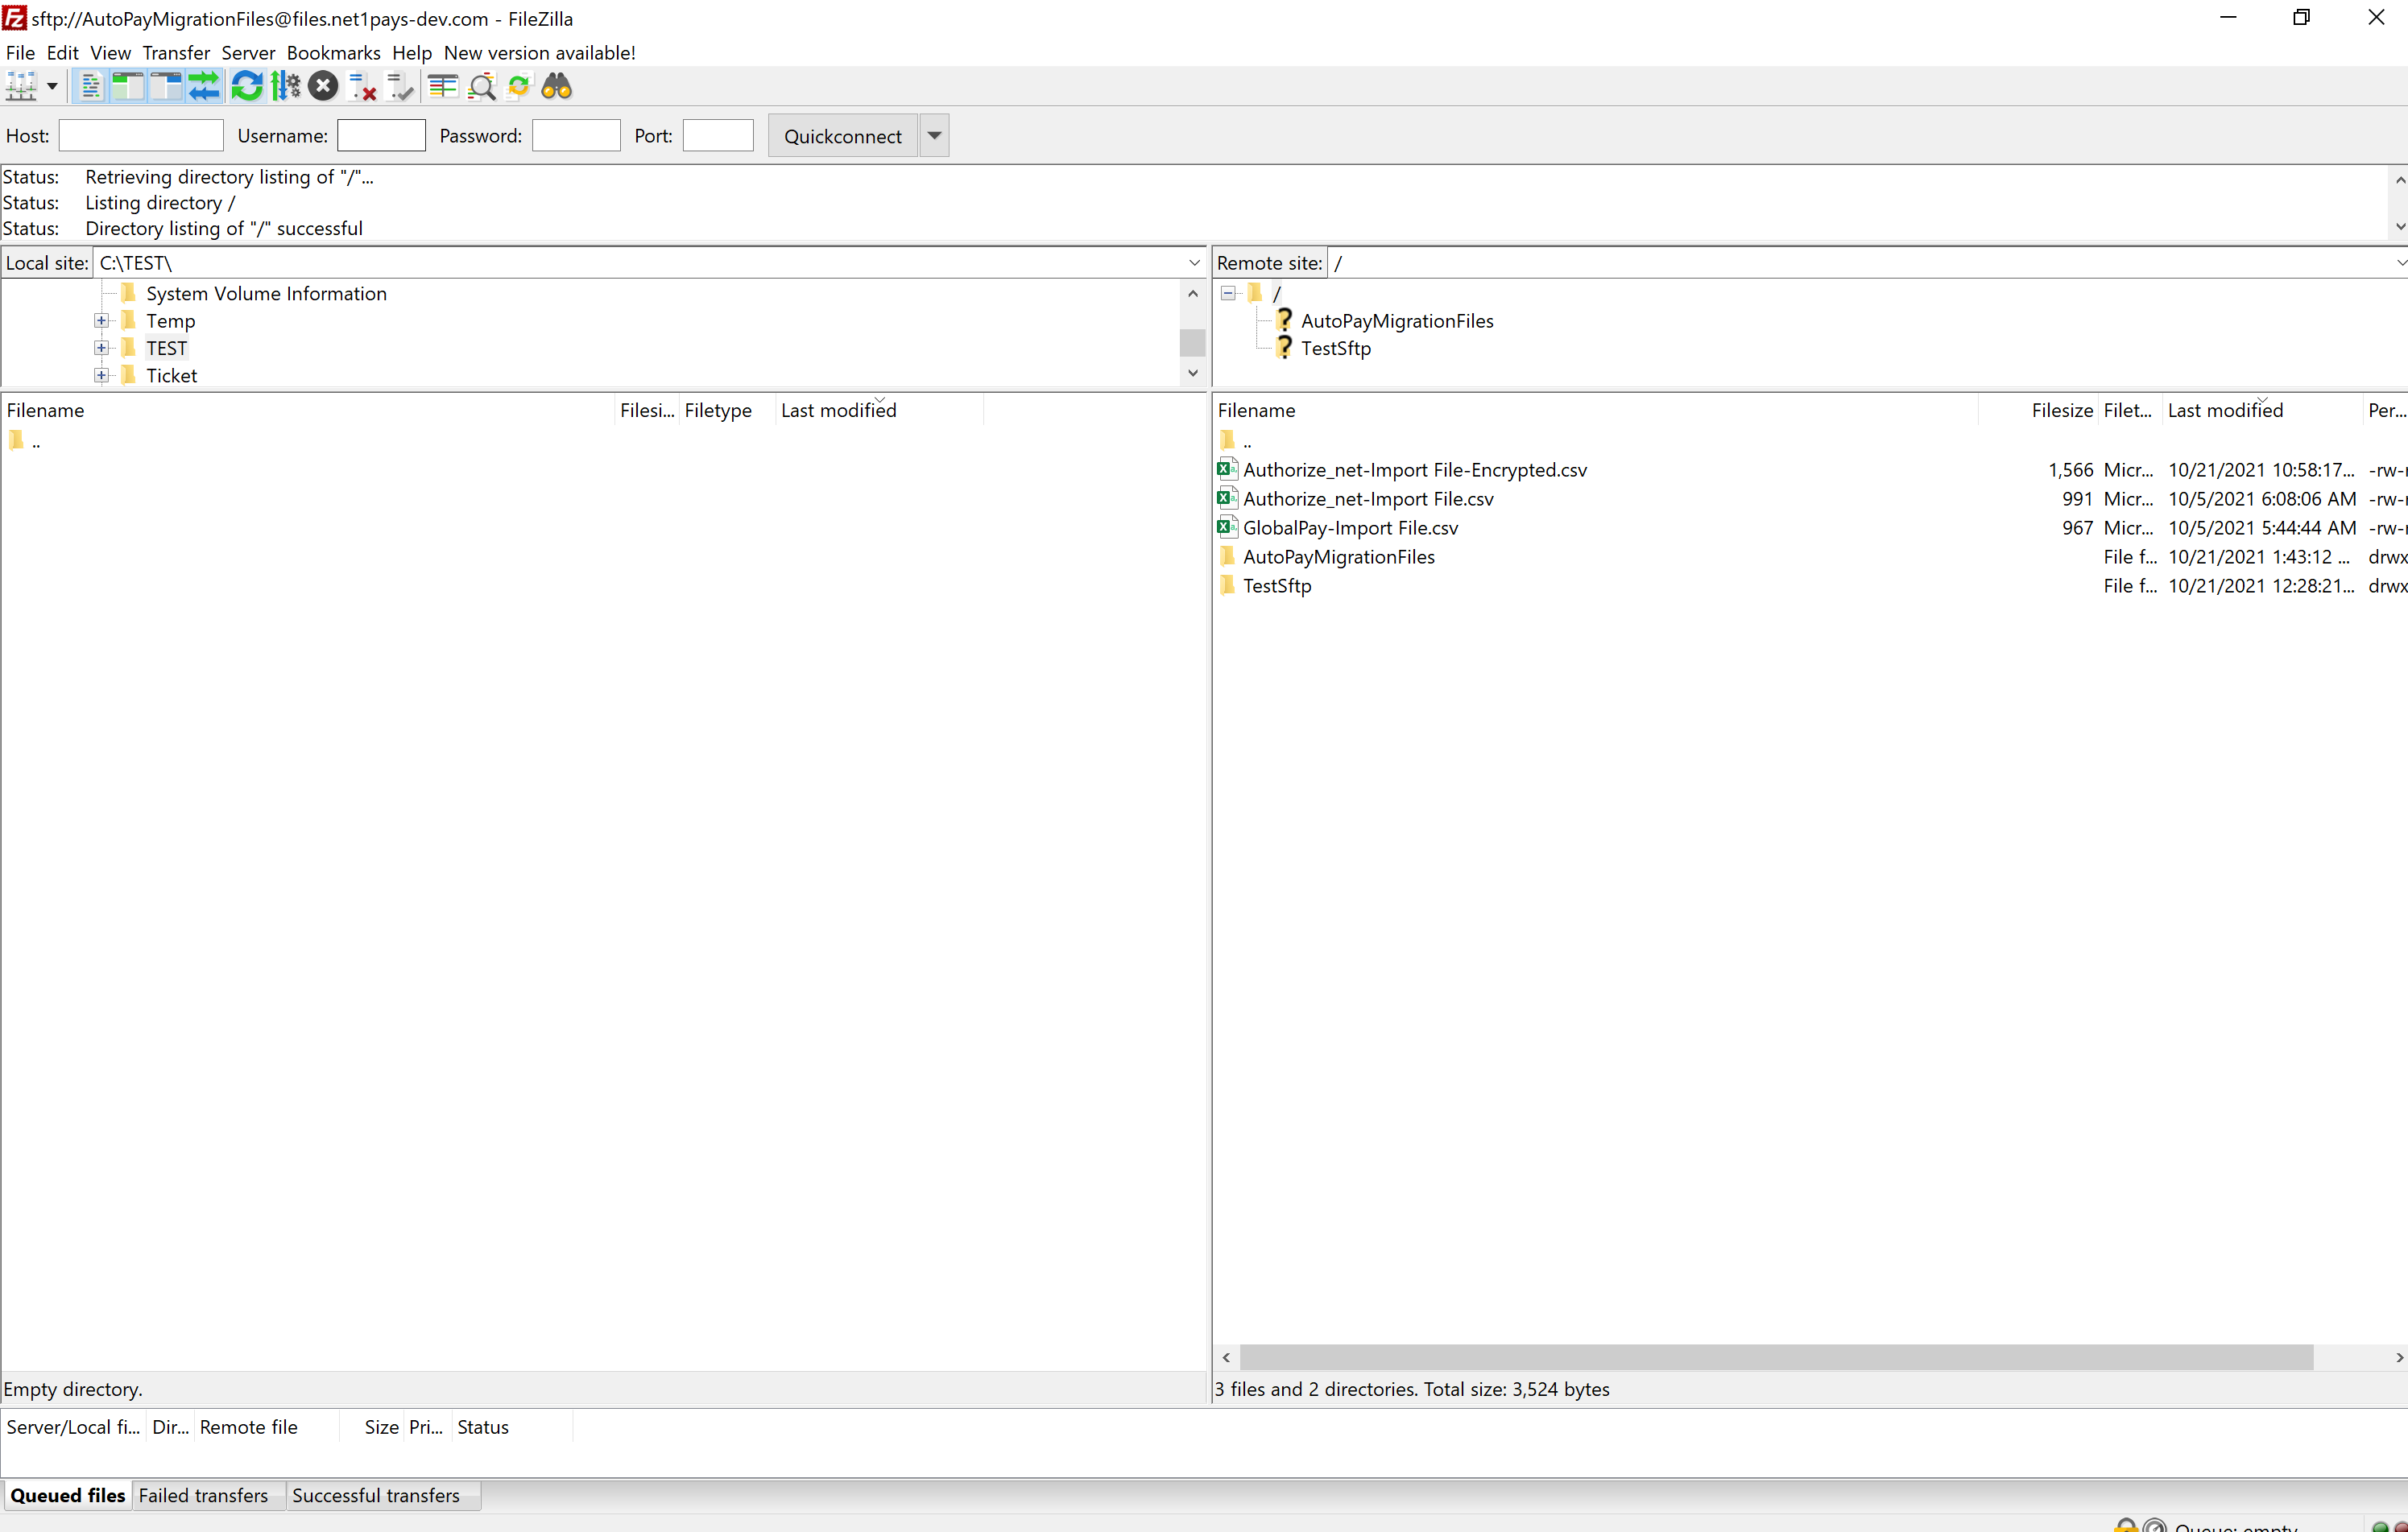

Upload to SFTP server via File zilla
Drag encrypted file from left window to right window.
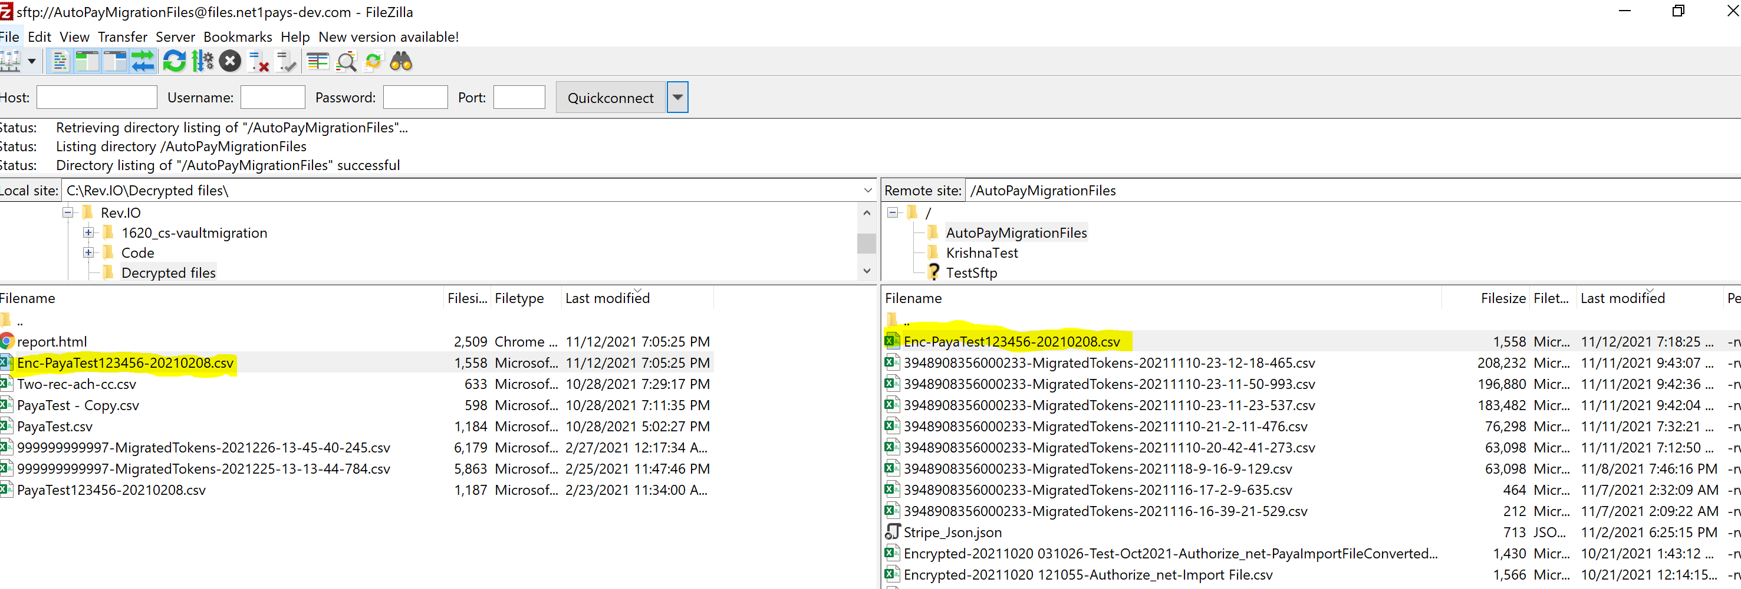

Upload file to SFTP server is completed

