Sage Intacct minI-uSER Guide
AR: Transaction

AR: Transactions
This guide includes instructions on how to process payments against an Accounts Receivable Transaction within Sage Intacct.
Navigate to "Dashboard" > "Accounts Receivable" > "Invoices"

Steps:
- Click on "Add" in the top right-hand side of the screen.
  - NOTE: If you want to work with an existing invoice, jump to Step 4.
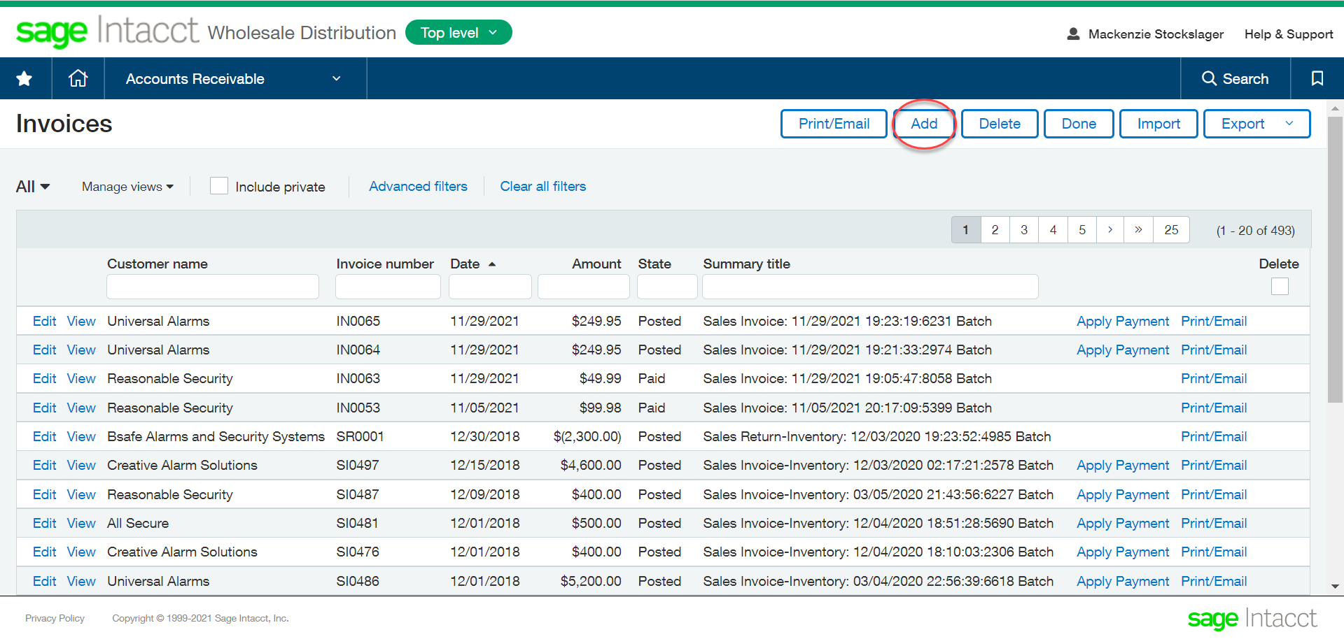

- Fill out the AR Invoice by selecting the Customer and Entries.
- Post the Invoice.
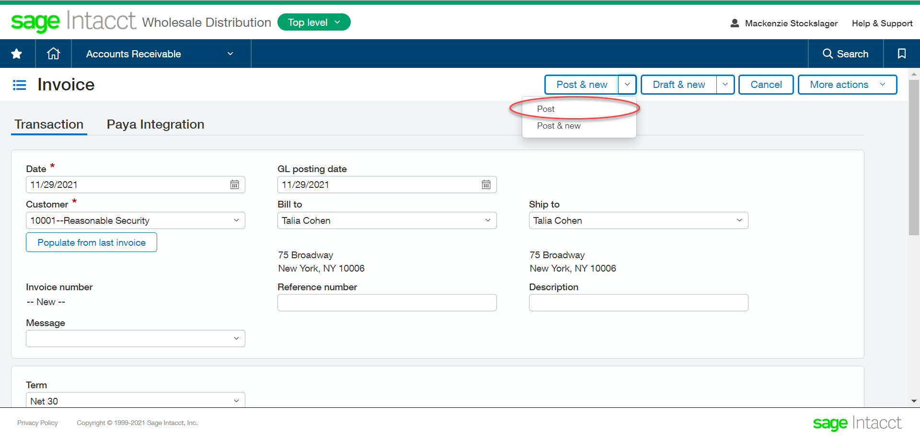

- From the main AR Invoice screen, select "View" on the invoice that you would like to look at.
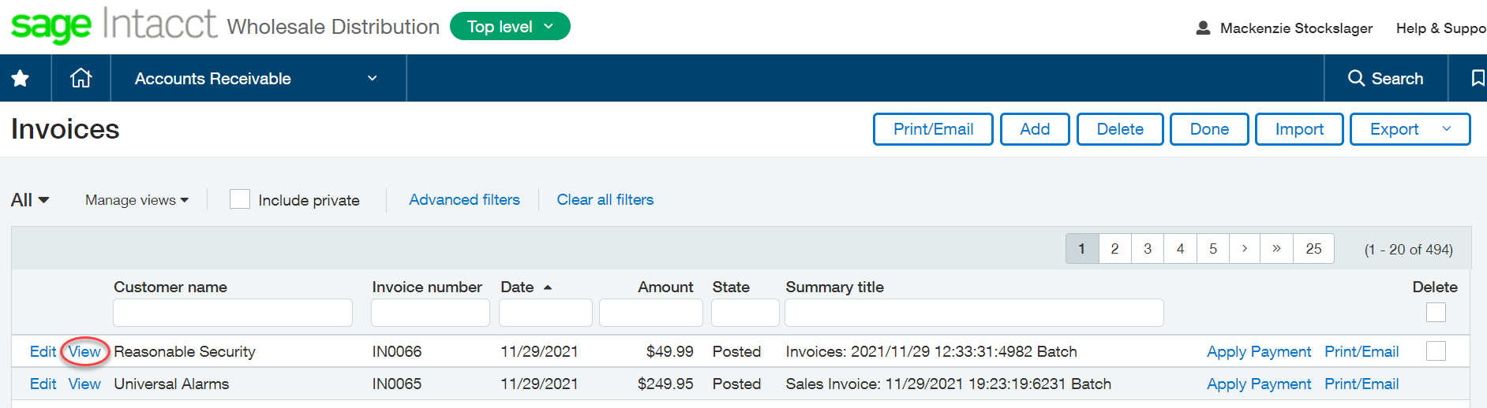

- Select "One Time Use Payment" dropdown from the "Pay with Paya" button on the top righthand side of the screen
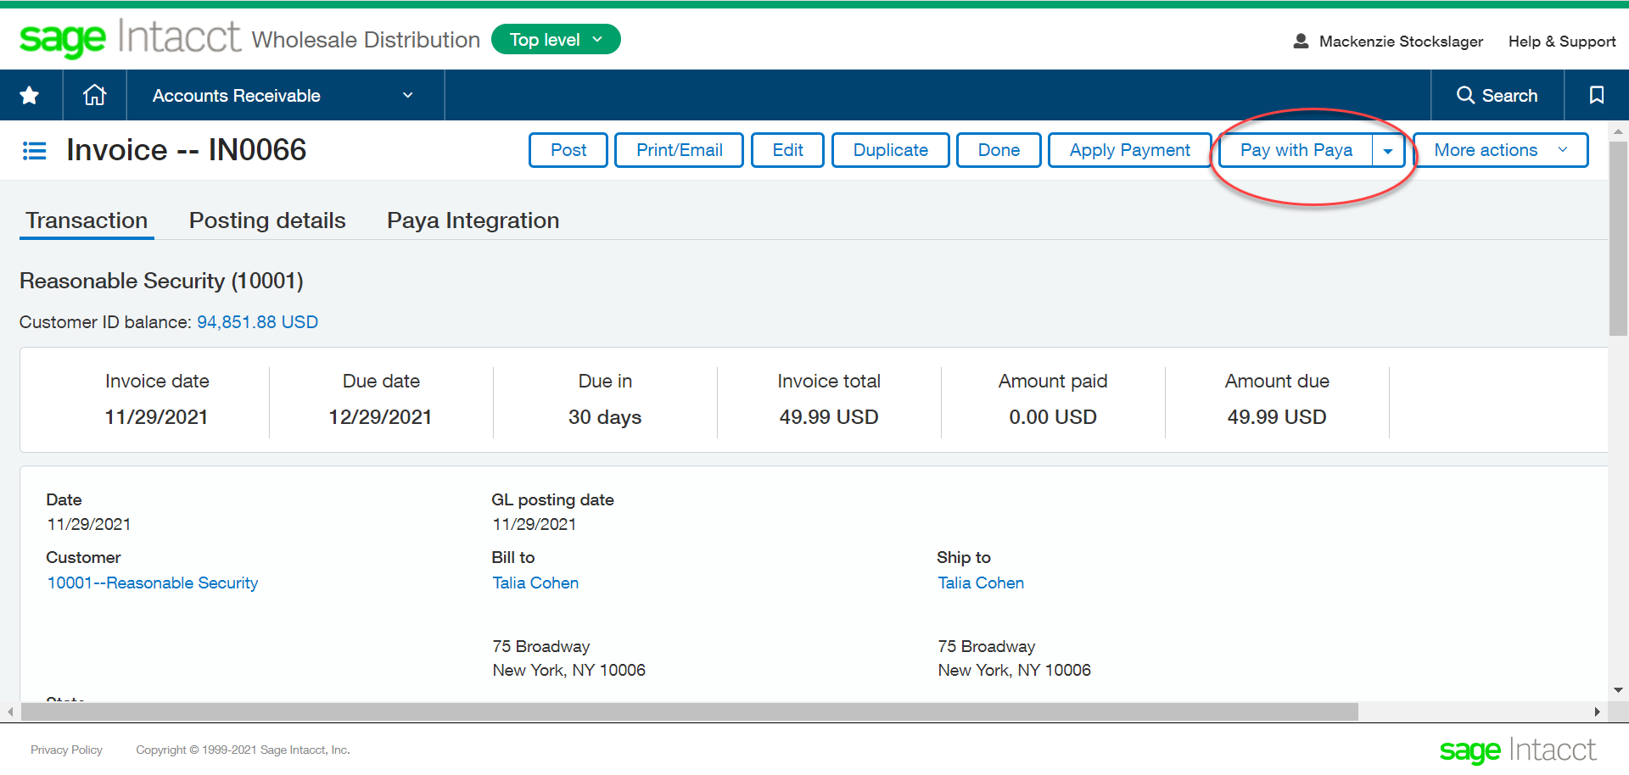

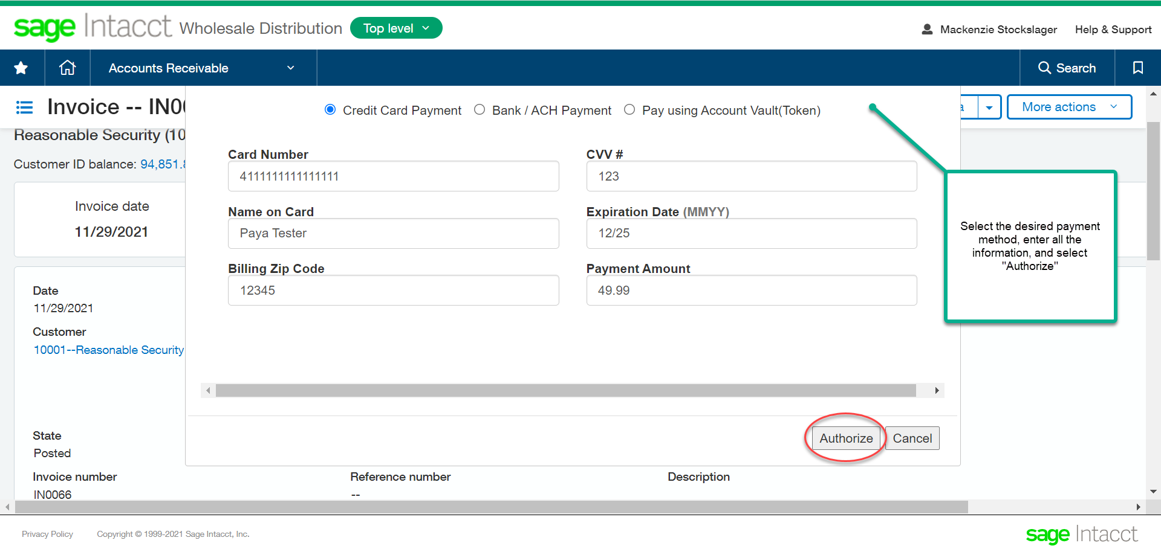
- “Authorize” that payment, then verify the payment was successful before closing out.

