Sage Intacct minI-uSER Guide
New Vault Payment

New Vault Payment
This guide includes instructions on how to set up a new Paya Account Vault for tokenized payments within Sage Intacct.

Navigate to "Dashboard" > "Paya Integration" > "Paya Account Vaults" > "Paya Account Vaults"

Steps:
- Click "New Account Vault" Hyperlink on the top left-hand side of the page
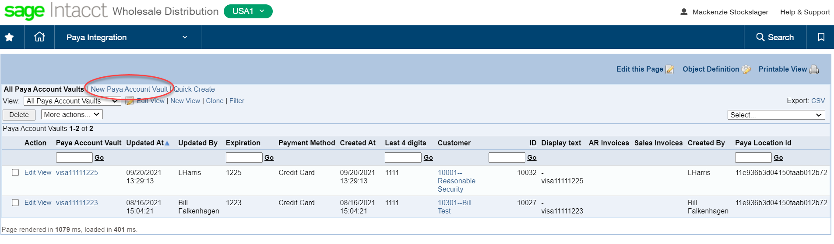

- Fill out all the required information and press "Save"

