Sage Intacct mini-uSER Guide
OE: Sales Invoice

OE: Sales Invoice
This guide includes instructions on how to process payments against a sales invoice within Sage Intacct.

Instructions:
Navigate to “Dashboards” > “Order Entry” > “Transactions” > “Sales Invoice”
- If you need to add a new sales invoice, click “Add” on the top right-hand side of the page.
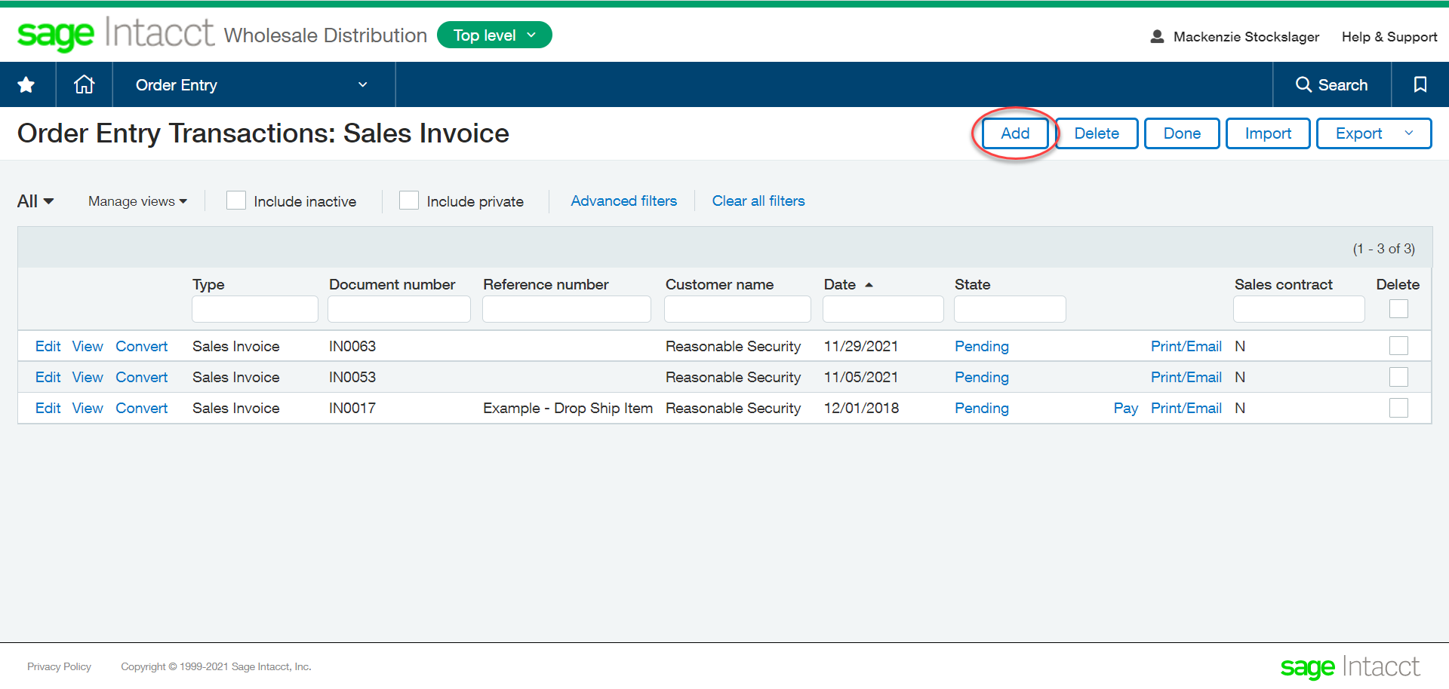
  - NOTE: If you want to work with an existing invoice, jump to Step 4.

- Fill out the invoice.
  - Select the Customer, Payment Terms, and Item ID.

- Select “Post & Pay”.
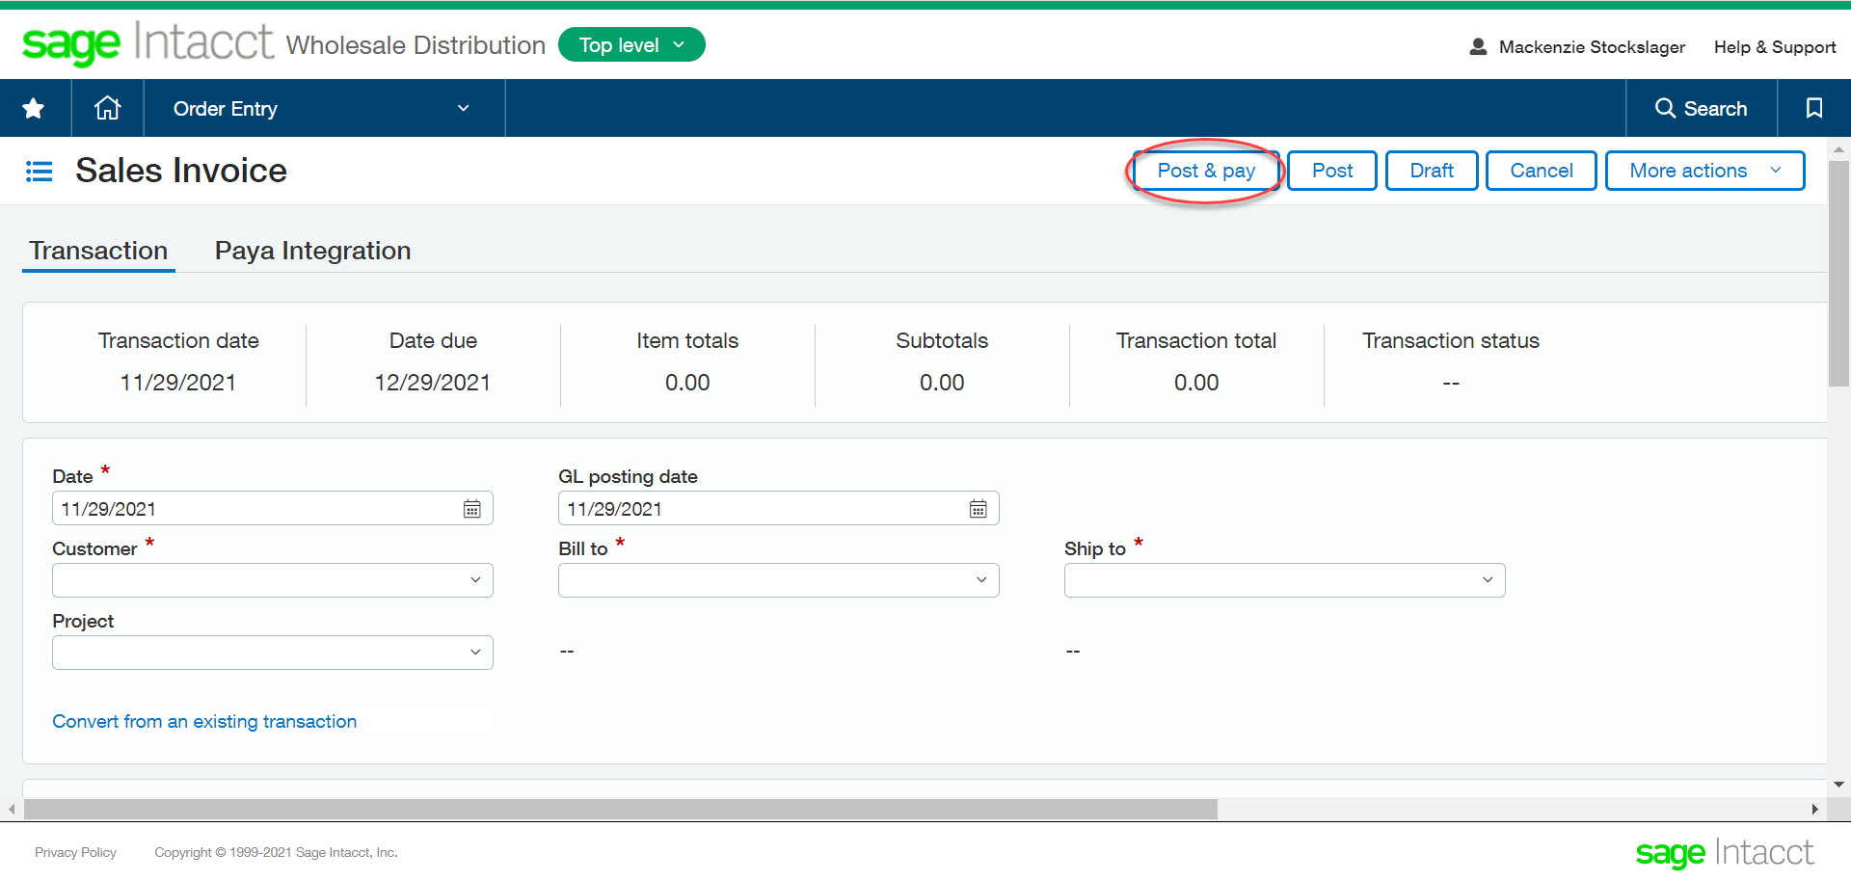

- Click “View” on the Sales Invoice line item like you would like to pay.
- Select “Pay with Paya” in the top right-hand of the screen.
  - You can select “One Time Use Payment” from the dropdown if you’d like to make a one-time payment.
- Enter the required payment information, then select “Authorize”
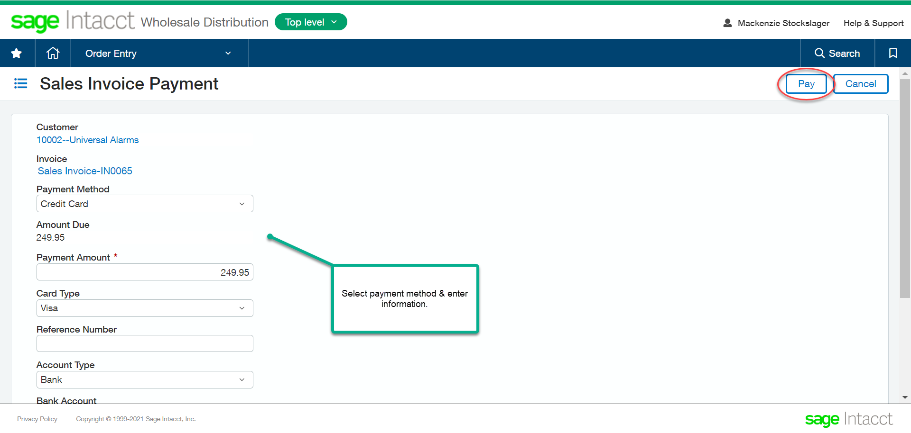

- Ensure the payment status has been updated to paid, then select “Done”

