Sage Intacct minI-uSER Guide
Transaction: Pre-Authorization

Pre-Authorizations
This guide includes instructions on how to process pre-authorized payment within Sage Intacct.

To begin:
Navigate to Accounts Receivable > Invoices > New Invoice

- Fill out all the required information to set up your new invoice. Once you are finished entering your data, click the “Draft” button in the top right hand of the screen.
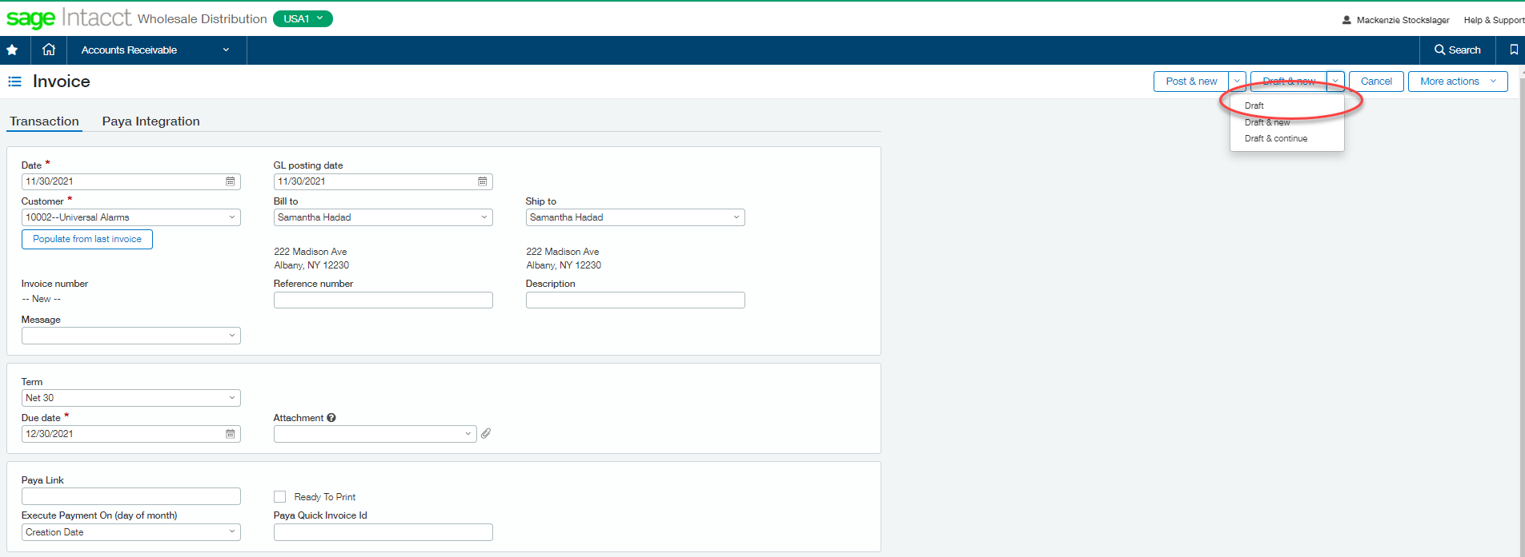

- On the main invoice page, you will be able to see the “State” of your invoice set to “Draft”. This means the pre-authorization was successful.

- When you are ready to accept the payment, click on “View” on the invoice line item, then “Post”
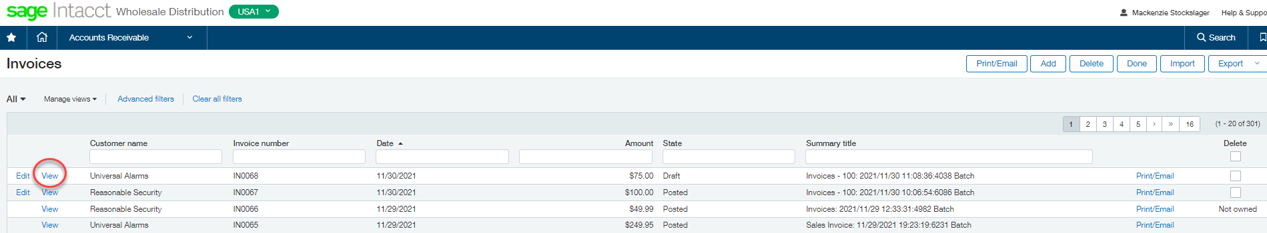

- Click on the “Pay with Paya” button on the top right-hand side of the screen and proceed with the payment process.
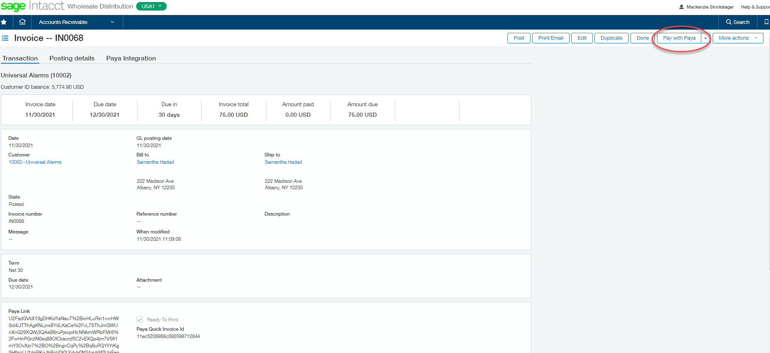

- Select your payment method, enter require data, and use the pre-authorization that was already created.
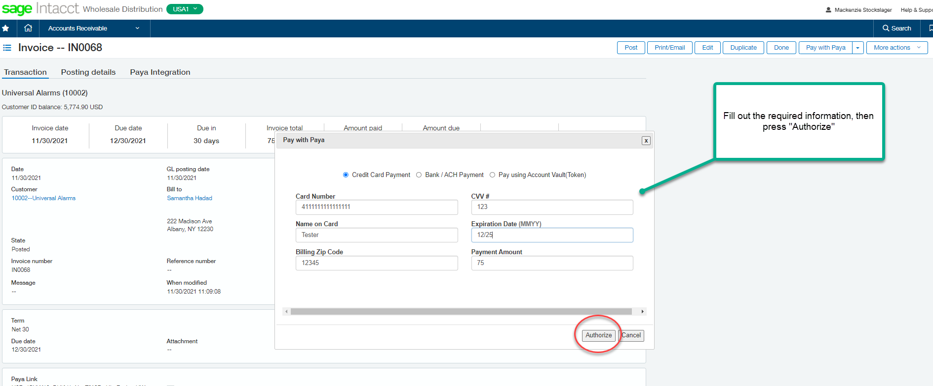

- Ensure a successful payment on the homepage and close out.

