Sage Intacct minI-uSER Guide
Recurring Payment Setup

Recurring Payment Setup
This guide includes instructions on how to setup a new recurring transaction well as processing payments against existing recurring transactions within Sage Intacct.

Navigate to "Dashboard" > "Order Entry” > "Other Transaction Activity" > "Recurring Transactions"

Steps:
- Add a new recurring transaction by selecting "Add" in the top right-hand corner of the page.

- For Document Type, select "Sales Invoice" and hit "Apply".
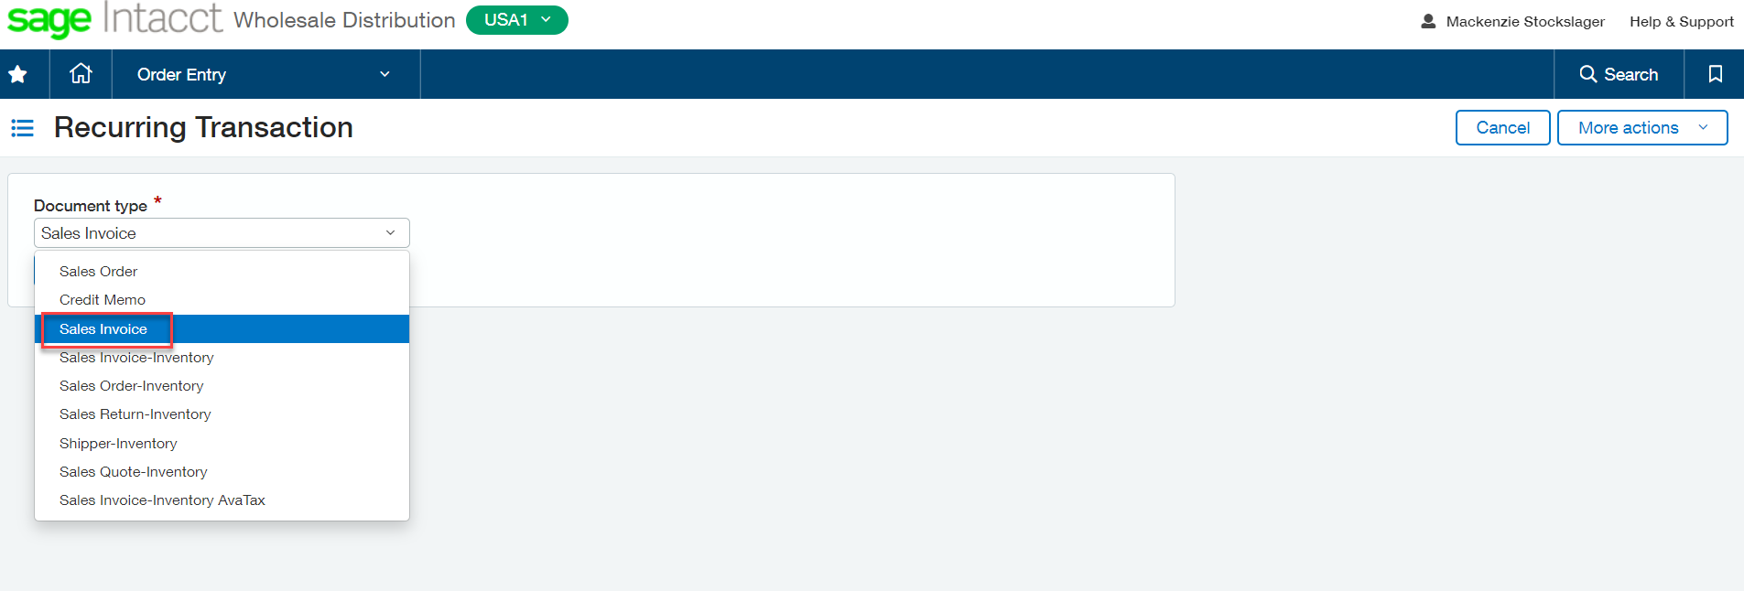

- Begin filling out the Sales Invoice as usual, selecting the Customer and Entries for the items.

- Then at the top of the page move to the "Payment Details" tab.
  - Select the Payment Method you would like to use.

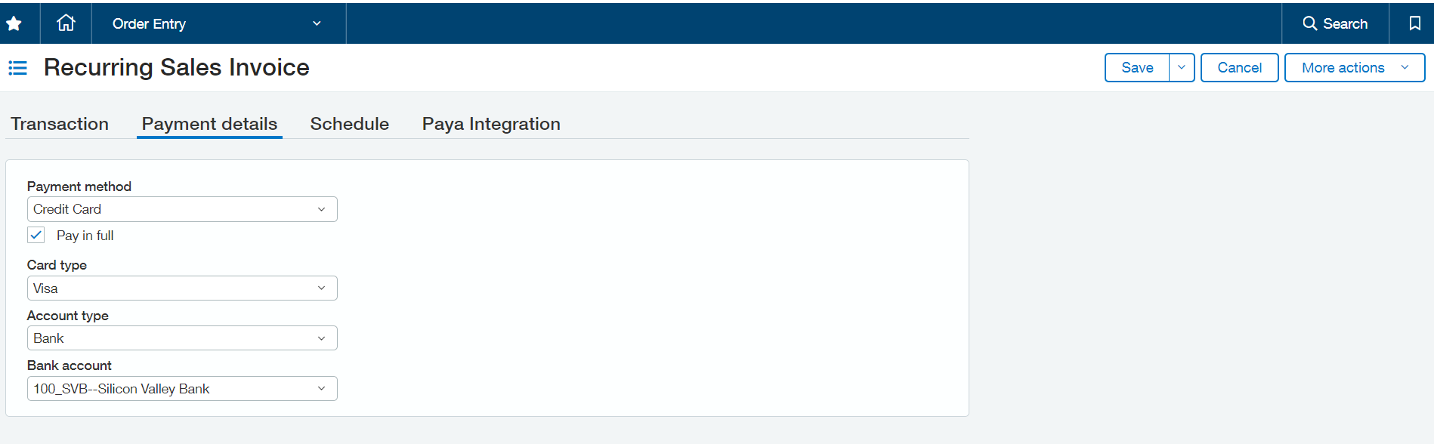

- Proceed to the next tab "Schedule".
  - Select the frequency and start date.

- Move to the "Paya Integration" tab and select "Paya Auto Pay" and choose your Account Vault from the drop down.
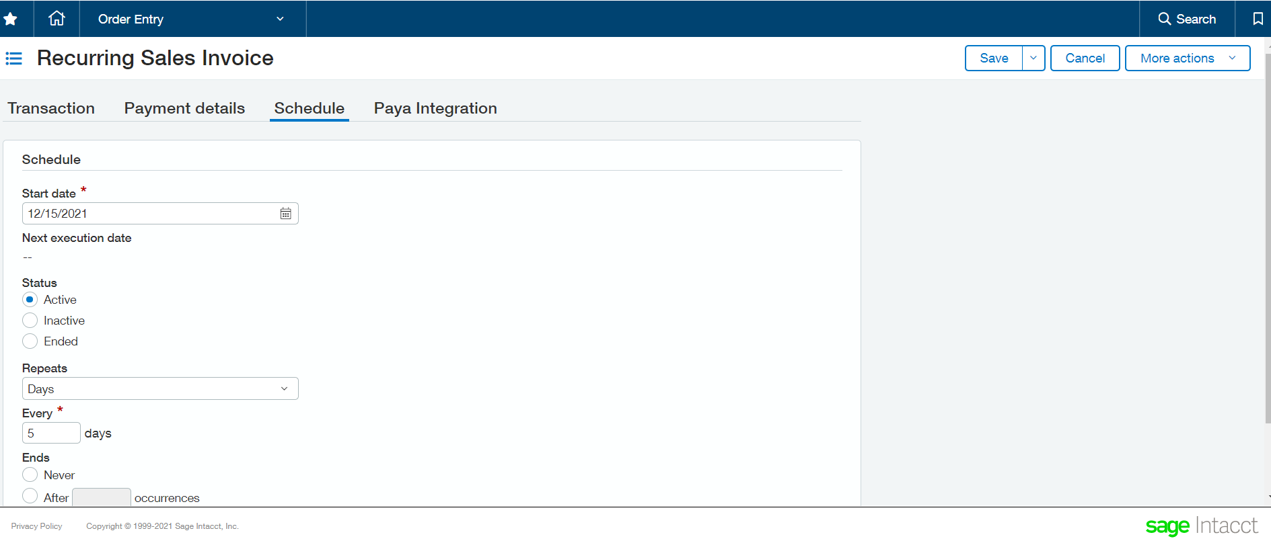

- After submitting, you can view the details of this invoice and see when the next execution date is set to occur.

