Sage Intacct minI-uSER Guide
Refund Transactions

Refunding Transactions
This guide includes instructions on how to refund payments within Sage Intacct using the Paya integration. Users can refund payments when the batch is closed.

Navigate to "Dashboard" > "Order Entry " > "Invoices"

Steps:
- Click "View" on a posted transaction line item that you are ready to void.
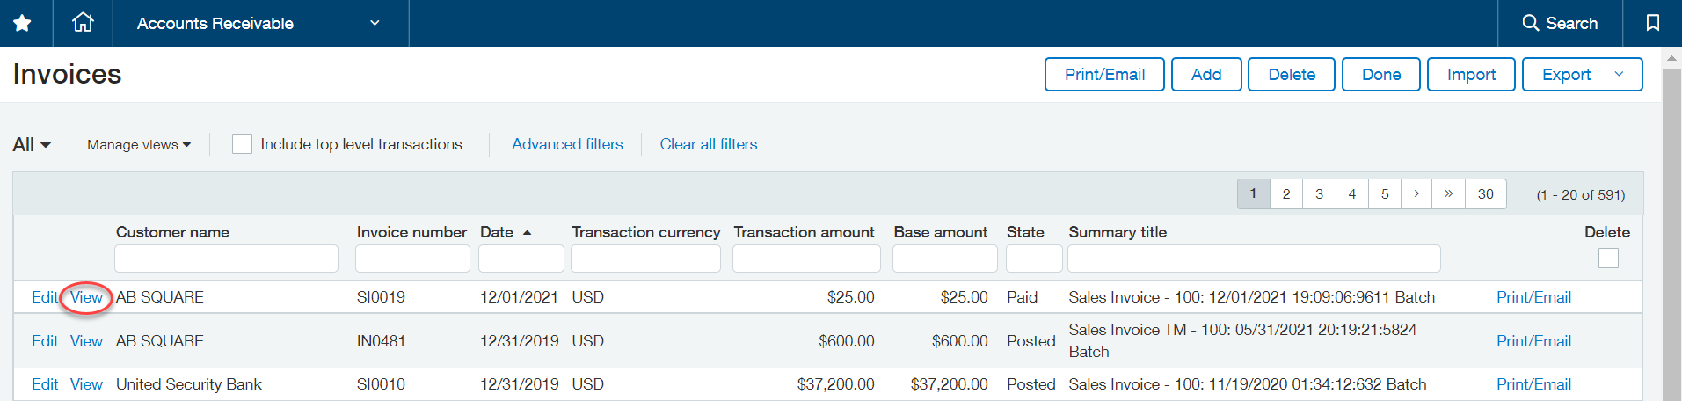

- Click "Refund Paya Payment" in the top right hand of the screen.
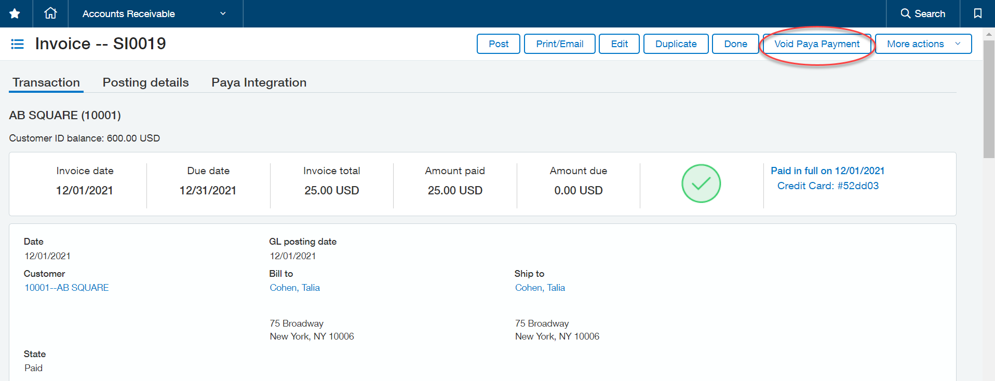

NOTE: The refund button will replace the void button after the batch closes.

- A popup window will appear asking for confirmation that you would like to refund the payment. Please confirm the refund amount and select “Yes”.

