Sage Intacct minI-uSER Guide
Paya Account Vault Payments

Paya Account Vault Payments
This guide includes instructions on how to process payments using a Paya Account Vault within Sage Intacct.

Navigate to "Dashboard" > "Accounts Receivable" > "Invoices"

Steps:
- Click "View" on a posted transaction line item that you are ready to pay.
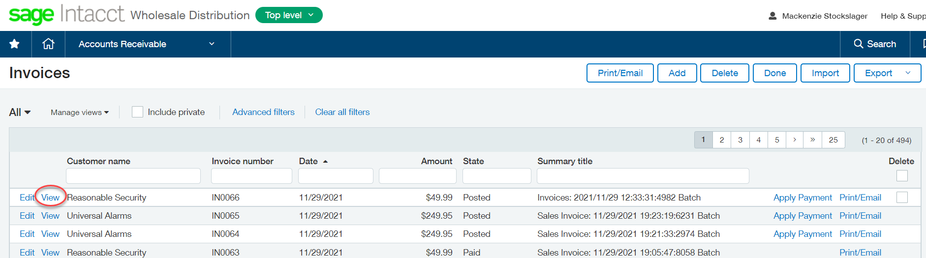

- Click "Pay with Paya" in the top right hand of the screen.
  - Make sure to then select the Pay using Account Vault (Token).
  - This option is located on the far right-hand side of the payment window.
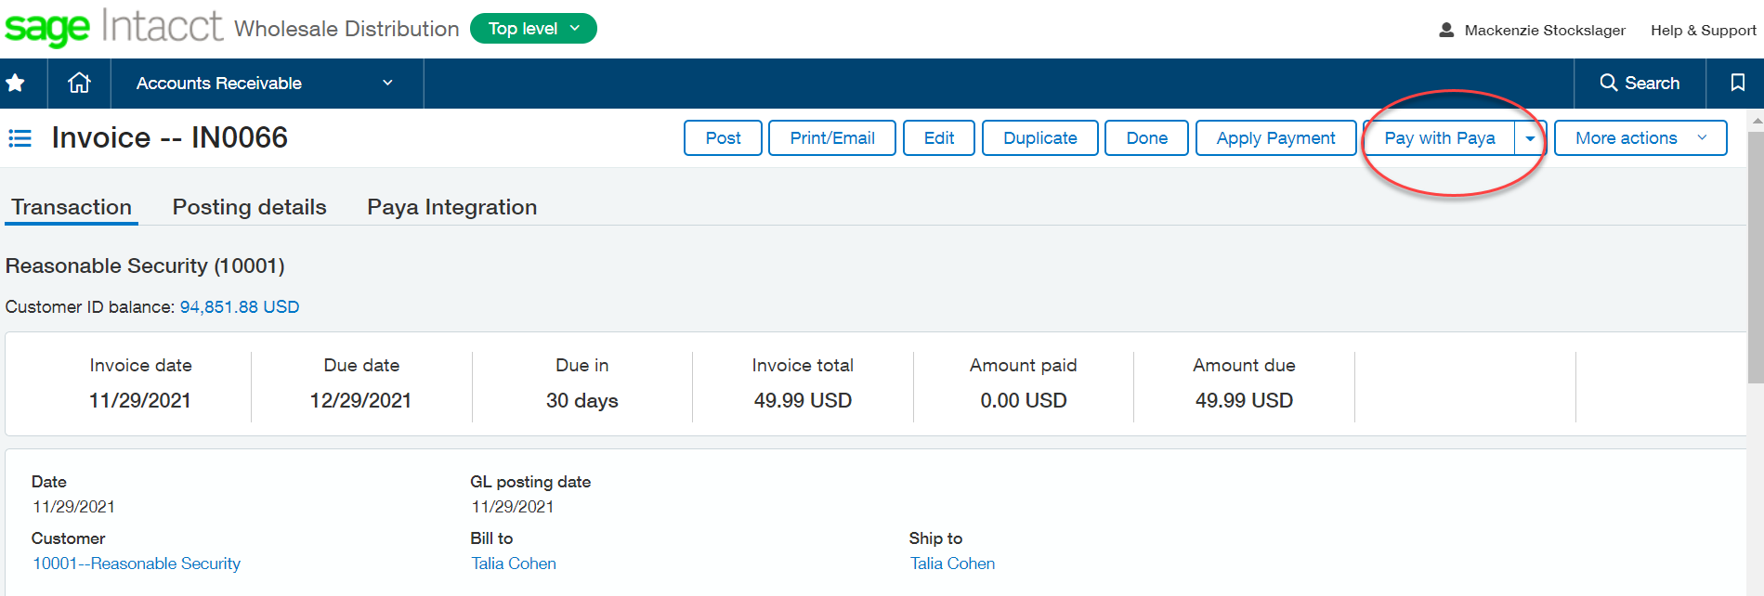

- Select which Account Vault you would like to use from the drop-down menu and then “Pay”.
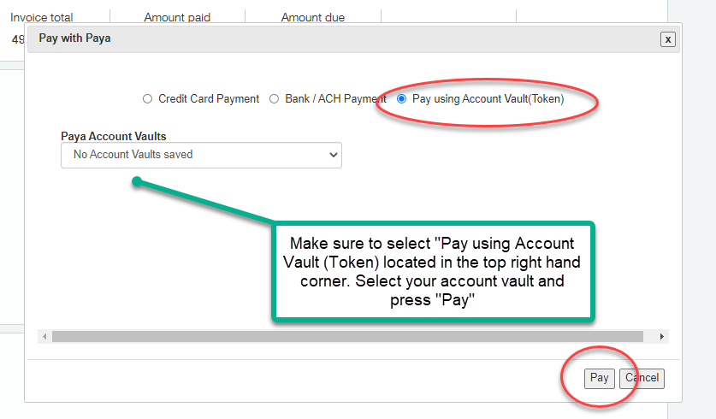

- Ensure the payment was successful from the Invoice screen before closing out.

