Sage Intacct minI-uSER Guide
Voiding Transactions

Voiding Transactions
This guide includes instructions on how to void payments within Sage Intacct using the Paya integration. Users can void payments when the batch is still open.

Navigate to "Dashboard" > "Accounts Receivable" > "Invoices"

Steps:
- Click "View" on a posted transaction line item that you are ready to void.
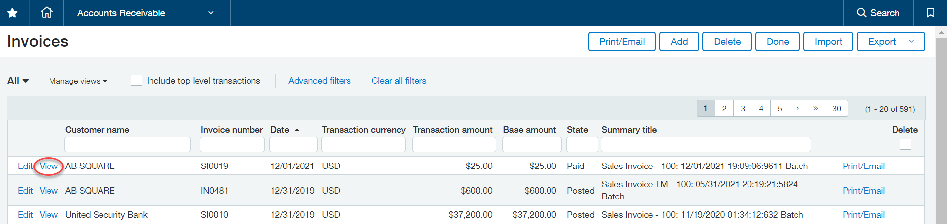

- Click "Void Paya Payment" in the top right hand of the screen.
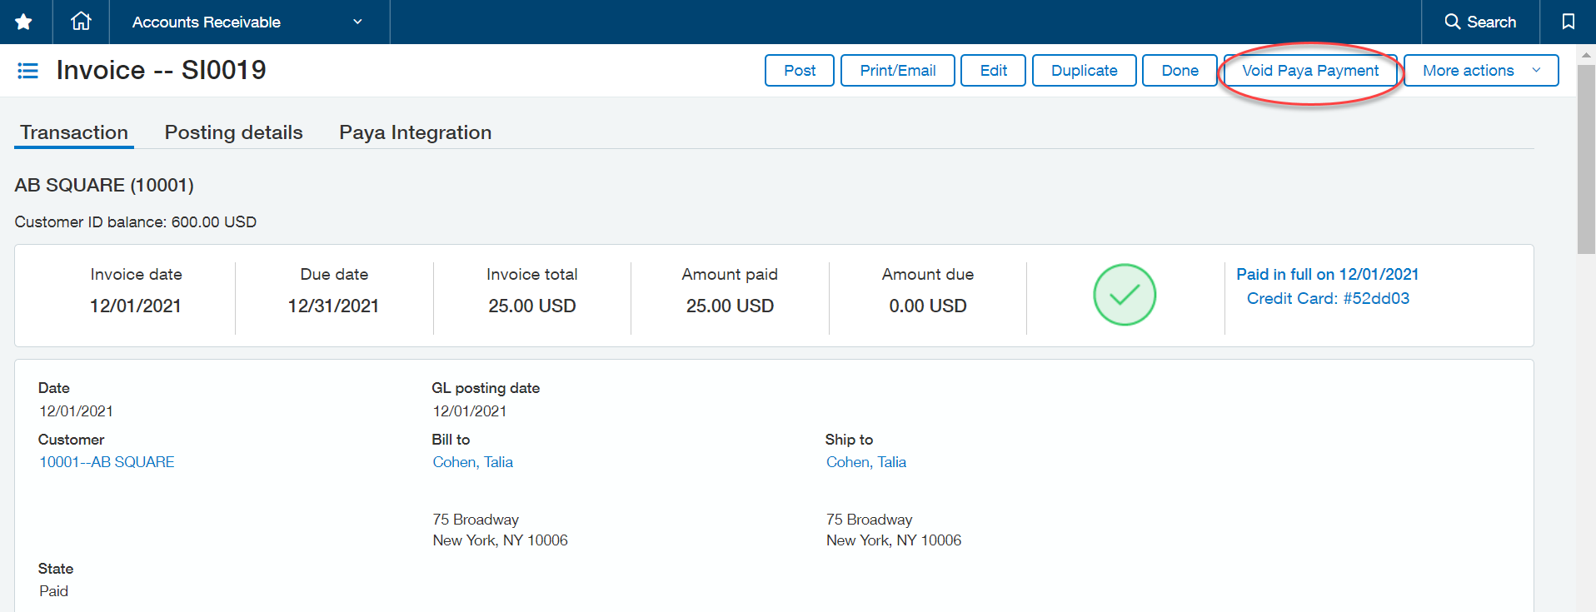

- A popup window will appear asking for confirmation that you would like to void the payment. Please confirm the void amount and select “Yes”.

