Secure File Transfer Protocol (SFTP) File Transfers – SEND files from File Share Location - 04.15.2022
We use Sentry One Task Factory’s Secure File Transfer Protocol Task to implement any SFTP SEND or GET process within the County. Native SSIS does not contain a Secure File Transfer Protocol Task. Below is the basic logic used for the SEND process for an SFTP task, Including user SharePoint PowerApp Form.
SFTP SEND BASIC Logical Flow
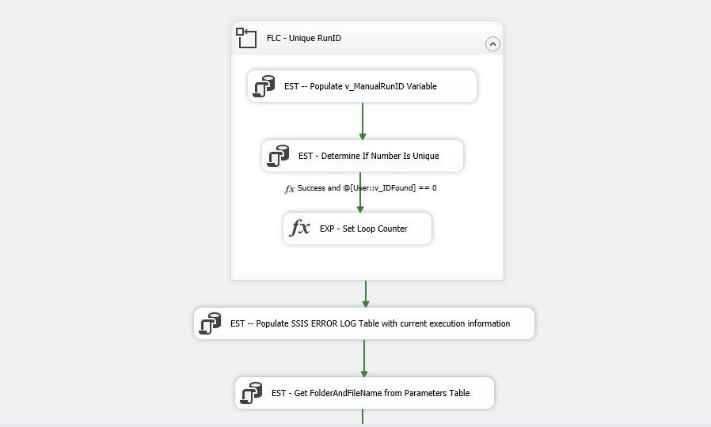
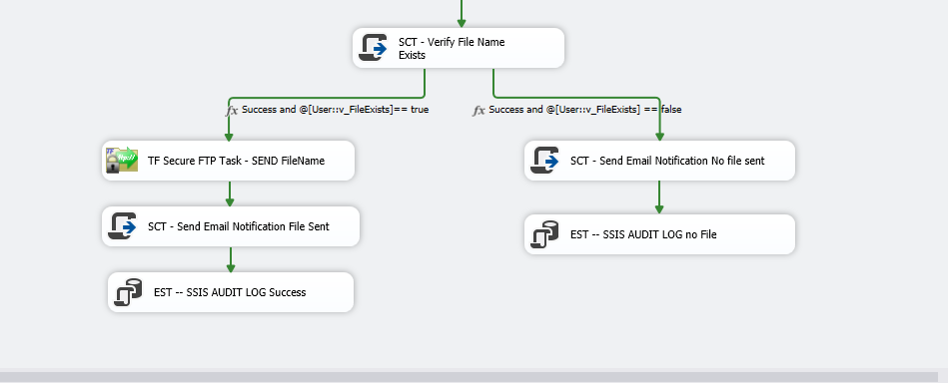

SCT – Creates email notification to users of not finding the file to send so they can troubleshoot
EST – SSIS Audit of successful package details BUT no file sent
SCT – Creates email notification to users of the download information
EST – SSIS Audit of successful package details
Conditional constraint. File exists True or False
SFTP task to send file to the SFTP Server. Variables passed in to identify the location of the file locally and where to place it on the SFTP Server
Variable value passed to SCT task to find the file or folder value saved in the SSIS Variable and verify it exists
When PowerApp form is used for user to enter the filename to send to the SFTP Server there must be a Power Automate Flow SQL Task that invokes a stored procedure created to insert the value the user entered in the SSIS_Parameters Table. This EST SSIS task is used to retrieve that value the user entered on the Power Automate Form. SSIS variable value assigned. IF NO POWER APP FORM IS USED – This task will not be needed as the value of where the file(s) are located to send to the SFTP Server is known and in an SSIS variable in the package
Auditing for all SSIS Packages Be sure to add Variables to package for these tasks

