Changes to the healthdirect Video Call sign-in procedure

On Day XX/YY/ZZ, the healthdirect Video Call (Telehealth) sign-in procedure will change

The healthdirect Video Call sign-in page will remain as vcc.healthdirect.org.au and will look the same as before, see image below.​​​​​​​

​​​​​​​​​​​​​​Enter your email address and when you click NEXT you will be asked to sign-in with your Health Organisation Microsoft credentials (your organisation email and password you use to access other work-related applications and websites). You will no longer need a separate password for Video Call. If you are already signed-in to other applications requiring your organisation password on your device, then you will not need to enter your password again.

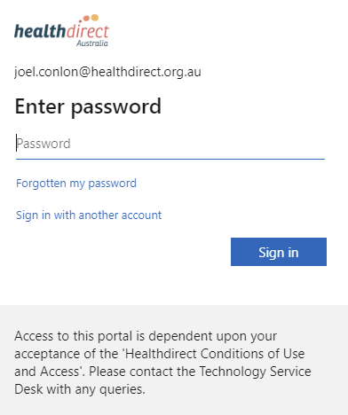

What if I encounter an issue?
If you encounter any issues, contact the Telehealth Coordinator, Name of Coordinator, Phone xxxxxx, or email yyyyyyyyyyy@xxxxx.org

