CoverMyMeds User Guide

CoverMyMeds Overview

The CoverMyMeds App (CMM App) is a standalone electronic prior authorization (ePA) solution that, when integrated into an electronic health record (EHR), creates a seamless experience between your EHR system and the tailored workflow of a specialized ePA application. CoverMyMeds can be launched directly from your EHR with user authentication provided via a Single Sign-On (SSO) implementation.

Prior Authorization (PA) Features and Definitions

Key - An 8-character alpha numeric code that identifies your request.

Required/ Important Tags – Identify information that must or should be completed before sending the request to the insurance plan for review.

Send to Prescriber - Share a request with a coworker or prescriber via email or fax.

Save - Save any information that is on the request at the time of saving.

Download/ Print - This feature allows a user to download and print a request at any point.

1 - Launching CoverMyMeds App

The first time CoverMyMeds is launched, you will be asked to accept CoverMyMeds Terms of Service. On subsequent launches, you will be taken directly to your dashboard, where you will find all prior authorization requests that you have access to view and complete.

2 - Dashboard Overview

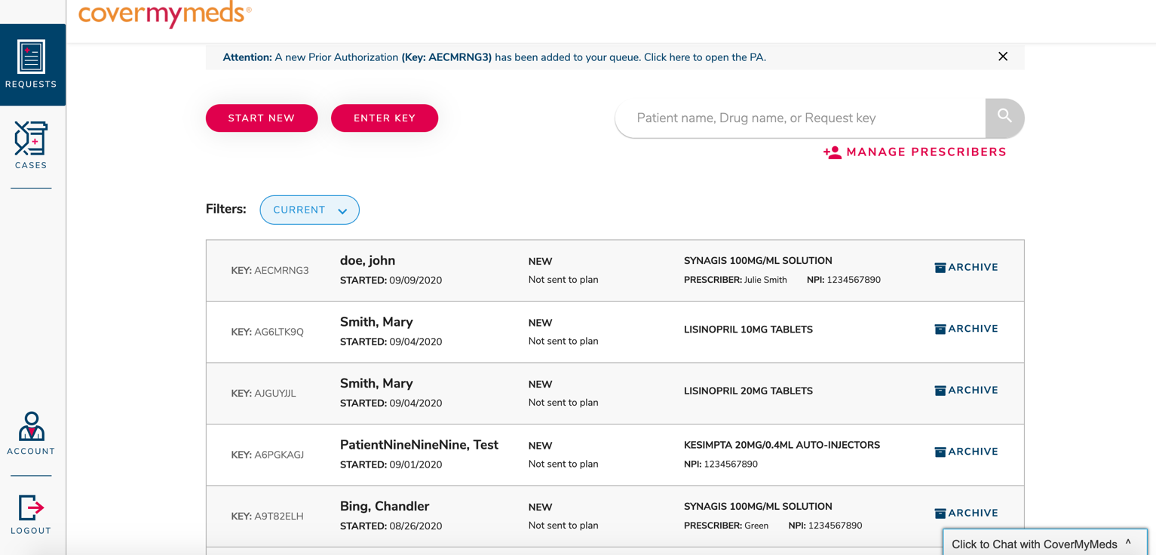

Request List

The request list will be a majority of what you see on your dashboard. This list will include all requests that you have access to view and complete. Requests are organized with the most recently created requests at the top of the list.

Filters

You can filter your request list to only show certain prior authorization requests.

Filter options include:
- Current – New prior authorizations and requests that are still being worked on; they have not been sent to the insurance plan for final review
- Sent – Prior authorization requests that have been sent to the insurance plan for final review
- Determined – Prior authorization requests that have received a determination from the insurance plan as a result of final review
- Archived – Prior authorization requests that have been removed from the previous 3 filters; these requests are still available to be viewed, but they are no longer able to be edited

Manage Prescribers

Select when to receive auto-shared PA requests:

- As soon as a prescriber sends a prescription to the pharmacy
- Once the claim is rejected at the pharmacy
- Do not auto-share any PA requests

Use select prescribers to choose which prescribers to automatically receive PA requests for.

- From your dashboard, click “Manage Prescribers”
- Check or uncheck the box next to prescribers you would like to add or remove from auto-share
- Click “Update” in the upper right corner of the page

Your changes will take place immediately.

Searching for a PA

A specific prior authorization request can be found using the “Search” bar on the dashboard. You can search for a request by following the steps below.

- In the search bar, type one of the following:
  - Key
  - Patient name
  - Medication name
- Press Enter or click the magnifying glass at the end of the search bar
- PA requests matching your criteria will appear in the request list

Enter Key – Accessing a Pharmacy Initiated PA

To access a PA that has been initiated by a pharmacy, follow the steps below.

- From your dashboard, click the “Enter Key” button on the left side of the page
- Enter the requested information that you received via fax from the pharmacy
- Click “View and submit PA”

Start New – Manually Create New PA

If a PA is needed but it has not been started by the pharmacy, you will need to start a new PA. To start a new request, follow the steps below.

- From the dashboard, click the “Start New” button on the left side of the page
- Enter the medication name, and click on the correct dosage and form of the medication you need
- Enter the patient’s prescription insurance information
  - Select the state that the patient has insurance coverage through
  - Enter either the insurance plan name or click to “search using BIN, PCN, and RxGroup”
- Click “Start PA” next to the form you would like to select for completing the patient’s prior authorization
- A prior authorization will be started on the form you have selected. You will be taken directly to this form, and it will remain on your dashboard when you return to your request list

3 - Returning to Your Dashboard

Be sure to save a prior authorization you are working on before navigating back to your dashboard. Return to your dashboard at any time by clicking the ‘CoverMyMeds’ logo in the upper left corner of the screen.

4 - Contacting Support

CoverMyMeds offers live support to all users. PA experts are available to help throughout the entire PA process, as well as help with any features/ functionality of using CoverMyMeds.

Our team is available at the following times:
  - Monday – Friday, 8am – 11pm EST
  - Saturday, 8m – 6pm EST

Contact us via:
  - Chat – available within the CoverMyMeds Platform
  - Phone call – 866-452-5017

