CoverMyMeds User Guide

Table of Contents
1 - Introduction 3
CoverMyMeds Overview 3
2 - Prior Authorization (PA) Features and Definitions 3
Key 3
Required/ Important Tags 3
Send to Prescriber 3
Save 3
Download/ Print 3
3 - Launching CoverMyMeds App 4
4 - Manage Your Prescribers 4
5 - Import Account 5
6 - Dashboard Overview 5
Request List 6
Filters 6
Searching for a PA 7
7 - Accessing a PA 7
Enter Key – Accessing a Pharmacy Initiated PA 7
Start New – Manually Create New PA 8
8 - Completing a PA 9
Patient Demographics 9
Physician/ Clinic Information 9
Medical Details 10
Attaching Documents 10
Send to Plan 10
9 - Renewing a PA 10
10 - Archiving a PA 11
11 - Returning to Your Dashboard 11
12 - Checking the Details of PA Status 12
13 - Shared PAs 12
14 - Contacting Support 12

1 - Introduction

CoverMyMeds Overview

The CoverMyMeds App (CMM App) is a standalone electronic prior authorization (ePA) solution that, when integrated into an electronic health record (EHR), creates a seamless experience between your EHR system and the tailored workflow of a specialized ePA application. CoverMyMeds can be launched directly from your EHR with user authentication provided via a Single Sign-On (SSO) implementation.

2 - Prior Authorization (PA) Features and Definitions

Key
Every CoverMyMeds PA request is assigned a “key.” This eight-character alpha numeric code identifies a specific request.

Required/ Important Tags
Every request on CoverMyMeds has “Required” and “Important” tags throughout the request. These tags identify information that must or should be completed before sending the request to the insurance plan for review.

Send to Prescriber
This feature allows a user to share a specific request with either the prescriber or another team member in the prescriber’s office. You can share a request via email or fax, and you can continue to follow up on the request once it has been shared.

Save
It is important to save your progress before navigating away from the request that you are working on. To save, simply click the blue “Save” button on the left side of the request. This will save any information that is on the request at the time of saving.

Download/Print
This feature allows a user to download and print a request at any point. This feature is for the purpose of putting a request into a patient’s file, but this downloaded version is not able to be sent to an insurance plan for review.

3 - Launching the CoverMyMeds App

The first time CoverMyMeds is launched, you will be asked to accept CoverMyMeds’ Terms of Service. On subsequent launches, you will be taken directly to your dashboard, where you will find all PA requests that you have access to view and complete.

4 - Manage Your Prescribers

The Manage Prescribers function allows you to access PA requests for authorized prescribers, and you can select which PA requests should auto-shared to your dashboard from the list of authorized prescribers.

There are 3 options for receiving auto-shared PA requests:

- As soon as a prescriber sends a prescription to the pharmacy
- Once the claim is rejected at the pharmacy
- Do not auto-share any PA requests

The first time you launch the CoverMyMeds App, you will have the option to select the prescribers for whom you would like to receive auto-shared PA requests. You can also edit your selections at any time. To make changes, follow these steps:

- Launch the CoverMyMeds App
- From your dashboard, click “Manage Prescribers”
- Check or uncheck the box next to prescribers you would like to add or remove from auto-share
- Click “Update” in the upper right corner of the page
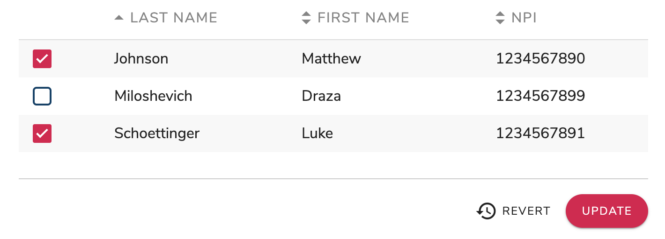

Your changes will take place immediately.

5 - Import Account

The Import Account feature allows you to add prior authorizations from a CoverMyMeds portal account into your integrated CoverMyMeds App account.

Prior authorization requests will be pulled into your CoverMyMeds App account. To import PA requests from your portal account, follow these steps.

- Launch your CoverMyMeds App account
- On your dashboard, click the “Import Account” button
- You will be prompted to enter your username and password from your CoverMyMeds portal account
- Click “Import”
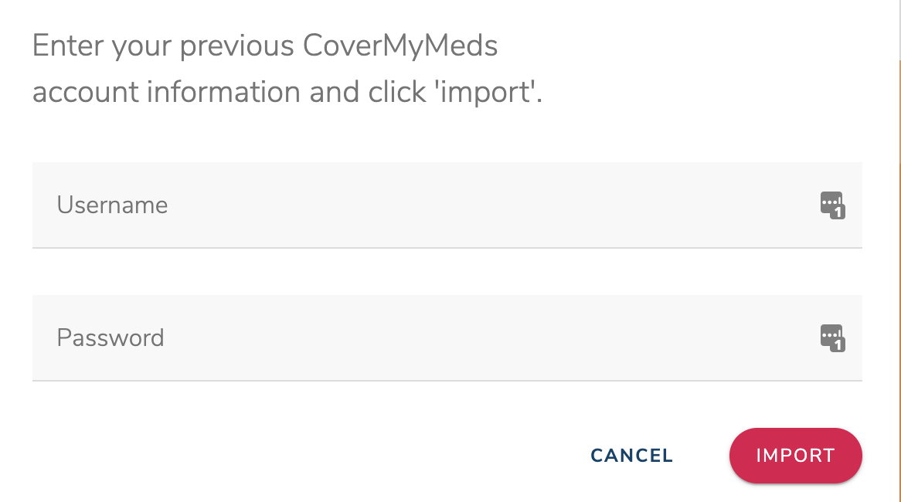
- Eligible prior authorizations from your portal account will automatically be imported into your CoverMyMeds App account.

Important Notes:
- Eligible PA requests include those for prescribers that you have access to within your EHR.
- Your CoverMyMeds portal account will not be affected by this action. All PA requests will still be in your CoverMyMeds portal account, and you can still access them there. Changes made to these requests will not be reflected in both accounts after the import has been completed.

6 - Dashboard Overview

Your dashboard will house all PA requests that you have access to view and complete. Your dashboard can be thought of as a “one stop shop” for navigating your CoverMyMeds App account.

Request List

The request list will be a majority of what you see on your dashboard. This list will include all requests that you have access to view and complete. Requests are organized with the most recently created requests at the top of the list.

Filters

You can filter your request list to only show certain PA requests.

Filter options include:
- Current – New PA requests and requests that are still being worked on; they have not been sent to the insurance plan for final review
- Sent – PA requests that have been sent to the insurance plan for final review
- Determined – PA requests that have received a determination from the insurance plan as a result of final review
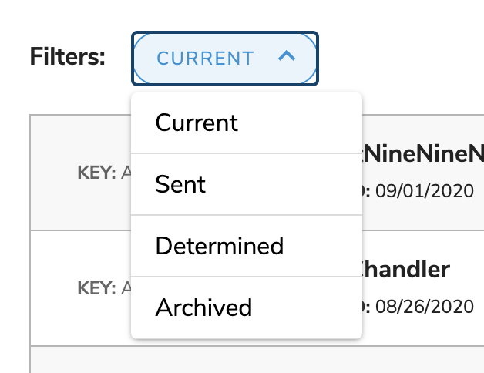
- Archived – PA requests that have been removed from the previous 3 filters; these requests are still available to be viewed, but they are no longer able to be edited

To view a certain filter, click the drop-down arrow and click the filter you would like to view.

Note: PA requests will automatically be moved to the applicable filter based on actions taken on the PA request.

Searching for a PA Request

A specific PA request can be found by using the “Search” bar on the dashboard. You can search for a request by following the steps below.

- In the search bar, type one of the following:
  - Key
  - Patient name
  - Medication name
- Press Enter or click the magnifying glass at the end of the search bar
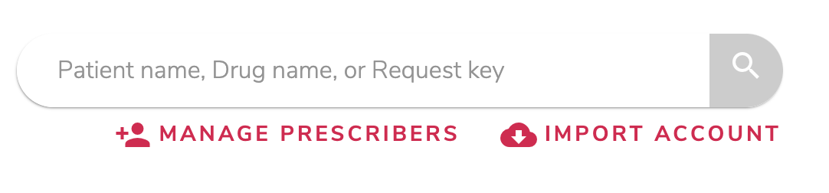
- PA requests matching your criteria will appear in the request list

7 - Accessing a PA

Enter Key – Accessing a Pharmacy Initiated PA Request

Often times, a pharmacy that is integrated with CoverMyMeds will automatically initiate a PA request for a medication that is being rejected due to a rejected claim. When this happens, the pharmacy will use the prescription and the patient’s prescription insurance information to select a PA form.

Once a form has been selected, the pharmacy will pre-populate any patient demographic information available, and the PA request will be shared with you via a fax. The fax will provide you with a key, patient last name, and patient date of birth. To access to the form that has been started for the patient’s PA, follow the steps below.

- Launch CoverMyMeds
- From your dashboard, click the “Enter Key” button on the left side of the page
- Enter the requested information that you received via fax from the pharmacy
- Click “View and submit PA”

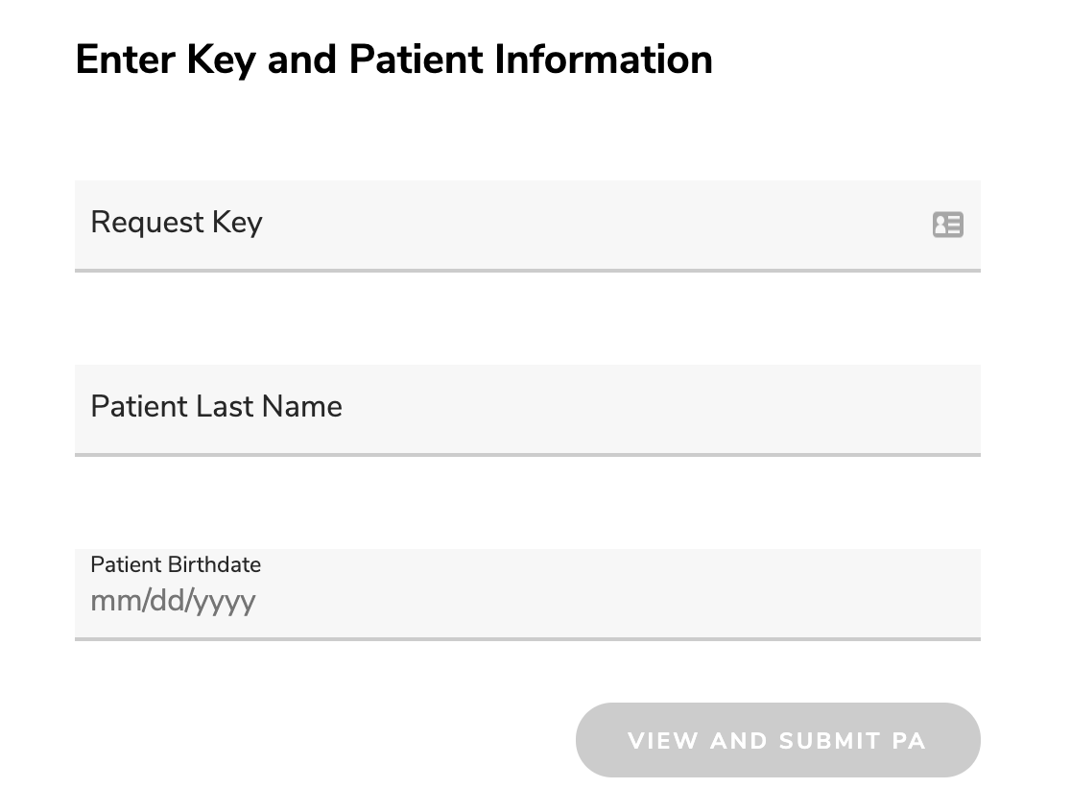

Start New – Manually Create New PA

If a PA request is needed but it has not been started by the pharmacy, you will need to start a new one. To start a new request, follow the steps below.

- Launch CoverMyMeds
- From the dashboard, click the “Start New” button on the left side of the page
- Enter the medication name, and click on the correct dosage and form of the medication you need
- Enter the patient’s prescription insurance information
  - Select the state that the patient has insurance coverage through
(Note: This may be a different state than where the patient lives)
  - Enter either the insurance plan name or click to “search using BIN, PCN and RxGroup”
(Note: We recommend searching using the BIN, PCN and RxGroup, as this will pull up the most accurate form. This information can be found on the patient’s prescription insurance card)
- Click “Start PA” next to the form you would like to select for completing the patient’s PA request
- A PA request will be started on the form you have selected. You will be taken directly to this form, and it will remain on your dashboard when you return to your request list

8 - Completing a PA

To complete a PA request, all required tags must be completed. You can send the request to the plan when all of the required tags are completed, but it is recommended that you complete as many questions as possible on the request form. To complete a PA request, follow these steps:

- Complete the required questions in Patient Demographics
  - Click “Check Eligibility” if applicable
- Complete the required questions in Physician/ Clinic Information
- Complete the required questions in Medical Details
  - Click “Send to Plan” to continue
- When Clinical Questions are available (usually within 24 hours), complete the required questions
- Click “Send to Plan” for final submission

If you would like more details about each section of the PA, read below.

Patient Demographics
Complete this section of the form with the patient’s demographic information. Most forms will perform an eligibility check before allowing you to continue to medical details. This is completed on the back end and often times requires no action from the user.

Note: If you experience issues with your patient’s demographic information matching the plan’s, please contact CoverMyMeds Support Team via online chat or by calling 866-452-5017.

Physician/ Clinic Information
Complete this section of the form with the prescribing physician’s clinic information.

Note: The fax number provided in this section will be the fax number that the insurance plan sends the determination to, if they do not provide an electronic determination. Please ensure this fax number is correct.

Medical Details
This is the bulk of the PA request. Please provide the insurance plan with as much information as you are able to.

Attaching Documents
Some insurance plans allow one or more files to be attached to a PA request. If this is the case for the form you are completing, you will be able to save a file to your computer and attach it to the request form. This will send the file to the insurance plan with the PA request.

- Save PA
- Combine all documents to be attached in one file
- Click “Upload Document”
- Search for document on your computer
- Click “Upload”

Send to Plan
Once all “required” tags have been completed, you will be able to send the request to the insurance plan for review. To send to plan, click the orange “Send to Plan” button at the end of the form, or in the upper left corner of the page.

9 - Renewing a PA

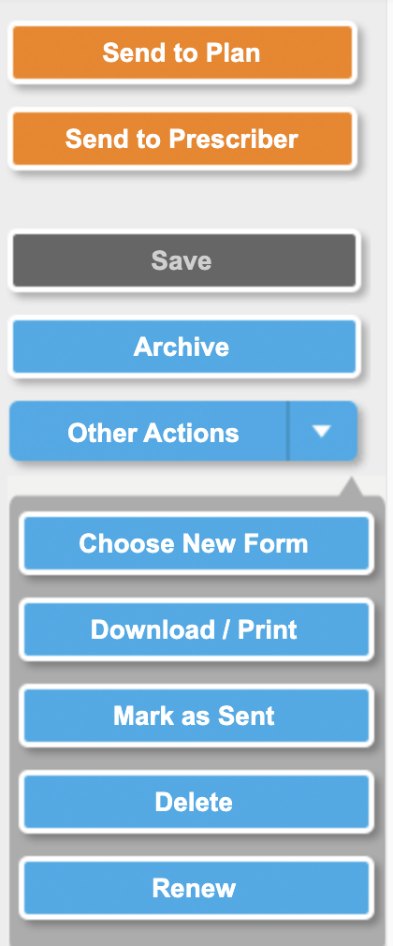
This feature allows a user to create a new request for a patient and medication that they have already completed a previous request for. To renew a request, follow these steps:

- Locate the request that you would like to renew
- Open the request
- On the left side of the screen, click the blue “Renew” button
- Confirm that the information is correct and click “Create Renewal”
- Confirm that all information transferred from the previous request is correct by clicking the blue check boxes in the upper right corner of each section of the request
- Continue the request as any other request

10 - Archiving a PA

This feature allows a user to remove a request from their request list by “filing” it away. This is a great way to remove requests that are no longer actively needed, but it does not remove the request from the account completely, in the event that the request needs to be referenced in the future.
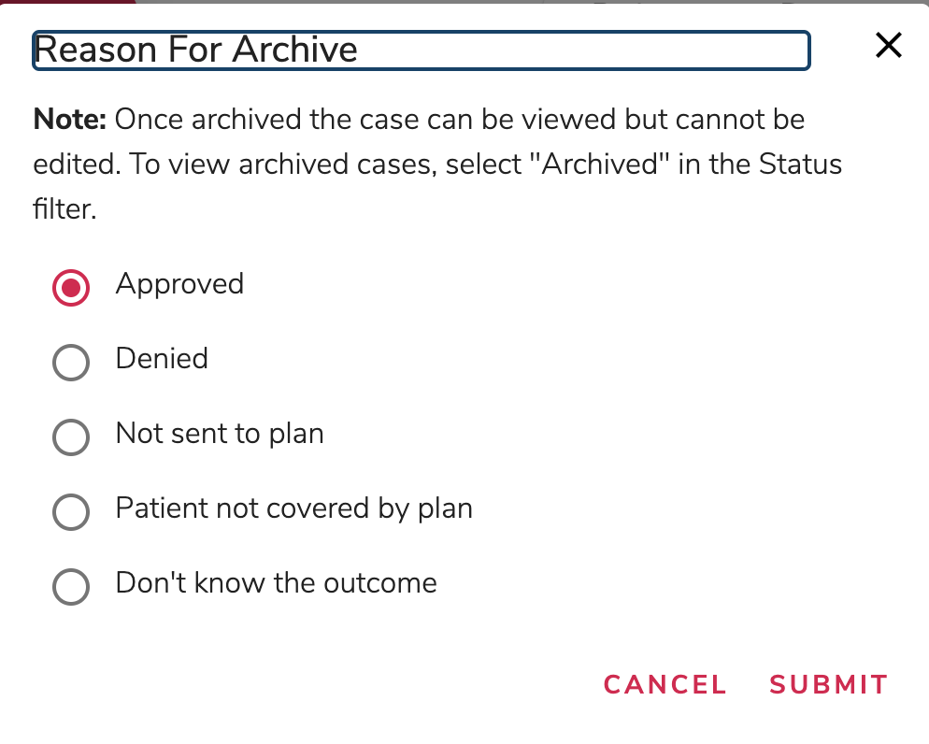

11 - Returning to Your Dashboard

Be sure to save the PA request you are working on before navigating back to your dashboard. Return to your dashboard at any time by clicking the ‘CoverMyMeds’ logo in the upper left corner of the screen.

12 - Checking the Details of PA Status

CoverMyMeds will update the status of a PA request as soon as we receive a status update from the insurance plan. Once a determination is received from the insurance plan, the request will automatically be moved to your “Determined” filter. The PA request status can be found by following the steps below.

- Locate the PA request in your account
- Open the PA request
- Details of the status will be displayed at the top of the request

If the status is not displayed, or you have questions about the status, please reach out to the CoverMyMeds support team via chat or by calling 866-452-5017.

13 - Shared PAs

There may be multiple CoverMyMeds users that have the same prescribers managed to their account that you do. If this is the case, you will be prompted to “Confirm your patient” before accessing the PA request that was shared to your account.

Confirming your patient ensures that you are accessing information for a patient that you should have access to. Check the patient’s name and date of birth that are provided to make sure you should be completing the correct patient’s PA request.

14 - Contacting Support

CoverMyMeds offers live support to all users. Prior authorization experts are available to help throughout the entire PA process, as well as help with any features or functionality of using CoverMyMeds.
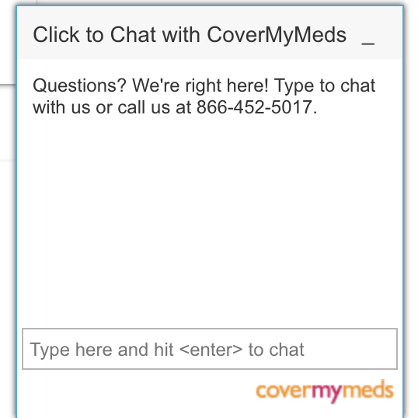
Our team is available at the following times:
  - Monday – Friday, 8am – 11pm EST
  - Saturday, 8am – 6pm EST

Contact us via:
  - Chat – available within the CoverMyMeds App
  - Phone call – 866-452-5017

