Materialise Magics

  - 26.02 – Release Notes
January 2023

Contents

1 What’s new 3
2 Bug fixes 3
3 Known issues 3
4 Compatibility 5
4.1 Bundled components and their licensing components 5
4.2 Compatibility with other Materialise product releases 5
4.3 Compatibility with other CAD packages 5
5 System Requirements 7
6 Contact Information 8

This document lists the main changes and fixes compared to the Magics 26.01 release.

What’s new
There are no changes compared to Magics 26.01 release

Bug fixes
- An issue causing Magics to not launch in a rare case of insufficient permissions was resolved
- An issue causing redundant part revisions in Streamics has been resolved

Known issues
- An update to Win11 (version 22H2 or higher) can potentially block the ability to run the simulation module (the progress stays at 0%). If using Win10 (version 21H1 or later) or Win11 (version 22H1 or lower) is not an option, a work around for this would be to ensure that the Simulation process has a higher priority than the Magics process. This can be adapted in the Task Manager:
  - Option 1 (=preferred): increase the priority of the simulation module (Agent.exe) from Normal to Above normal
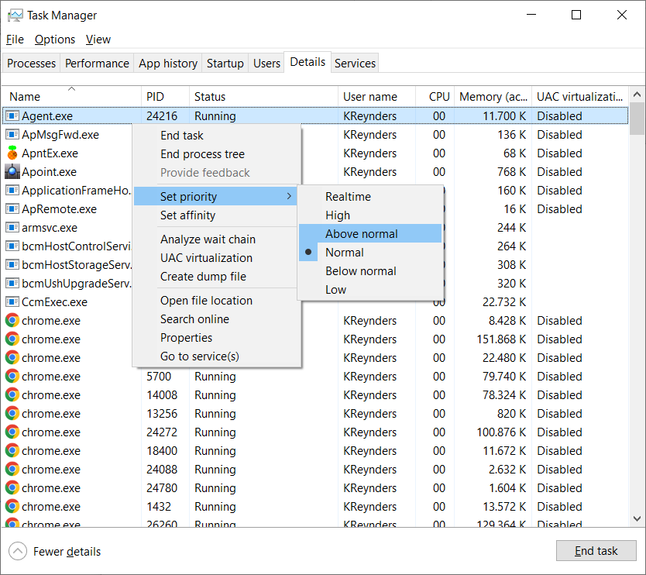

  - Option 2: decrease the priority of Magics (Magics.exe) from Normal to Below normal
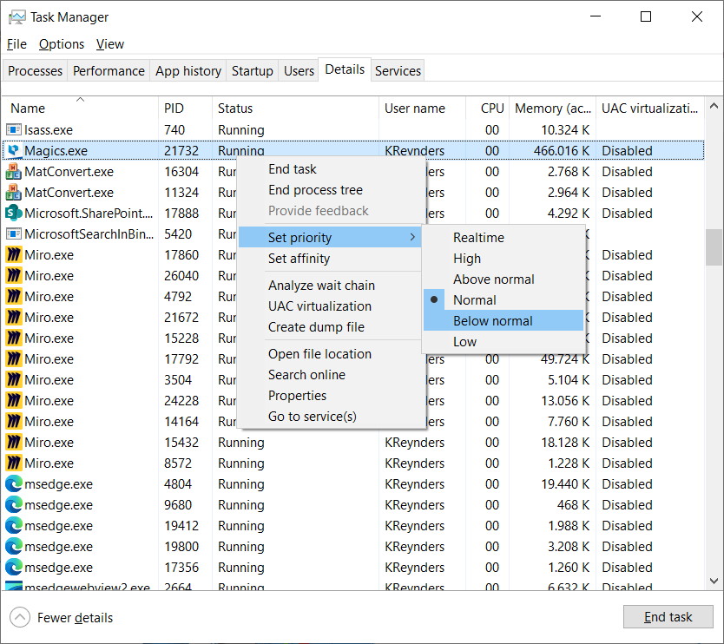

For all other known issues, please refer to the Magics 26.0 and 26.01 release notes as reference.

Compatibility

Bundled components and their licensing components
Product | Licensing component | Versions
Magics 26.0.2.2 | MatLicense | 7.3.6.0
 | Local License Server | 7.3.1.9
RegWizard 1.1.0.21 | MatLicense | 7.3.1.9
MatConvert 10.1.0.28 | MatLicense | 7.0.6.0
 | Local License Server | 7.3.2.2

Compatibility with other Materialise product releases
Product |  | Versions
Streamics |  | 9.0 (future release)
Robot |  | 8.3
3-matic |  | 17.0
Simulation module |  | 3.0
e-Stage |  | 7.3.0.176
Build Processor System |  | 3.2
Build processors | SLM BP | 3.2.7
 | HP | 2.2.1
 | Renishaw | 1.3.1
 | DLP | 2.0
 | SLx | 5.1.40.0
 | EOS | 3.1
 | Arcam | 2.4.5.0
 | Trumpf | 7.0
 | Concept Laser | 1.2.2

Compatibility with other CAD packages
Magics 26.02 comes with MatConvert 10.1, which supports the below CAD formats. The highlighted formats have been updated compared to MatConvert 10.0.
Please note that the ‘all imports’ license is needed for all these CAD formats, except for importing STEP files.
Via ‘Magics RP’ base license
STEP | *.stp, *.step | AP203 (E1, E2), AP214 (up to E3), AP242 (E1,E2)
VRML | *.wrl, *.vrml, *.x3dv | 1.0 and VRML 97, X3D 3.3
Via ‘all imports’ module
IGES | *.igs, *.iges | Version 5.3
ACIS SAT | *.sat | Up to 2021 1.0
JT | *.jt | 6.4 to 10.7
Rhino | *.3dm | Rhino 6.0
CATIA 4 | NO LONGER SUPPORTED | NO LONGER SUPPORTED
CATIA 5 | *.CATPart, *.CATProduct | R10 to V5-6R2021 (R31)
CATIA 6 | *.3dxml | R2010x to R2021x
Pro/Engineer | *.prt, *.asm | 2000i to Creo 8.0
Siemens NX | *.prt | 15 to NX 1980 Series until 2000
Parasolid | *.x_t, *.x_b | V7 to V34
SketchUp | *.skp | SketchUp 2021
Autodesk Inventor | *.ipt | 9 to 2022
Revit | *.rvt | 2011 to 2022
Solidworks | *.sldprt, *.sldasm | 2006 to 2022
Solid Edge | *.par | 10 to 2022

System Requirements

Hardware* | Software
CP​U  - Intel Core i7  - AMD Phenom II X4/ X6 at 3.0 GHz or higher with SSE2 technology  Memory  - 16 GB RAM or higher  Free Disk Space  - Win 64-bit system  - 2GB of free disk space  Display  - 1920 x 1080 resolution or higher  - 32-bit color depth (True color)  - 4K monitors are not actively supported  Video Card  - NVIDIA GeForce GTX 1060’ or AMD Radeon RX 480 or better  - DirectX 11 compatible video card  - At least 4 GB of memory  - At least a memory interface width of 192-bit (256-bit is recommended) | Materialise Magics 26 is only supported on Windows 64-bit**:  - Windows 11  - Windows 10 version 21H1 or later  Materialise Magics 26 is recommended on:  - Windows Pro edition  - Windows Enterprise edition  Materialise Magics 26 is not supported on:  - Windows 8.1 or earlier  - Windows Server Editions  - Virtualization systems such as VMWare  Materialise Magics does not run natively on Mac OS X, Linux, or any other operating system not listed above.  .NET 4.6 or later or a working internet connection during the installation is required.

*These hardware requirements are considered minimal for professional usage, but depending on the expected use cases (mainly influenced by project size, amount of triangles and number of parts) it is recommended to invest in appropriate hardware (more memory, larger disk size, ... ). More info can also be found on: https://help.materialise.com/93151-tips-and-tricks/magics:-performance
** Materialise Software will discontinue supporting an operating system, or a specific version of an operating system, from the moment that the OS vendor discontinues support.

Contact Information
For more information, check out our website: materialise.com/software/magics/
For technical support, please check http://help.materialise.com/ or contact one of our Customer Support teams:

Europe (Headquarters)  Technologielaan 15  3001 Leuven  Belgium  Phone +32 16 39 66 11  software.support@materialise.be | USA & Canada  44650 Helm Court  Plymouth, MI 48170  USA  Phone: +1 734 259 6445  Phone (toll-free): +1 888 662 5057  software.support@materialise.com
United Kingdom  AMP Technology Centre  Advanced Manufacturing Park  Brunel Way, Catcliffe  Sheffield, S60 5WG  Phone +44 1143 997 845  software.support@materialise.co.uk | Germany  Friedrichshafener Str. 3  82205 Gilching  Germany  Phone: + 49 8105 77 859 20  software.support@materialise.de
China  Baoshan District  Hutai Road 2999  1F Building no 1  Shanghai 200444  P.R.China  Phone +86 21 583 124 06  software.support@materialise.com.cn | Japan  Yokohama Portside Bldg. 2F  Sakae-cho 8-1  Kanagawa-ku, Yokohama  Phone +81 45 440 4591  support@materialise.co.jp
Asia – Pacific
Unit 5-01, Menara OBYU
No. 4, Jalan PJU 8/8A, Damansara Perdana
47820 Petaling Jaya
Selangor Darul Ehsan - Malaysia
Phone: +603 7724 1415
software.support@materialise.com.my

