<Client first name> <Client last name>
<Company>
<Postal address 1>
<Postal address 2>
<City> <Postcode>

<Date>

Dear <Client first name>,

As you're aware, (your firm) acts as the registered office for (client company). One of the requirements of this is that someone from your company checks that the information to be filed to the Companies Office annually is correct.
We've started using a software product called Connectworks to help with the governance and record-keeping of companies and trusts. It includes an easy process for you to verify annual return information and change any details if necessary.
So in future, we'll be sending an email via Connectworks to start this process. Please keep an eye out for an email from (your firm) via Connectworks with the subject line: "Company Annual Return for (client company)"
If you haven't seen this email by the end of the week please check your spam folder, and if its not there, then get in touch with us.
The email will look similar to this:

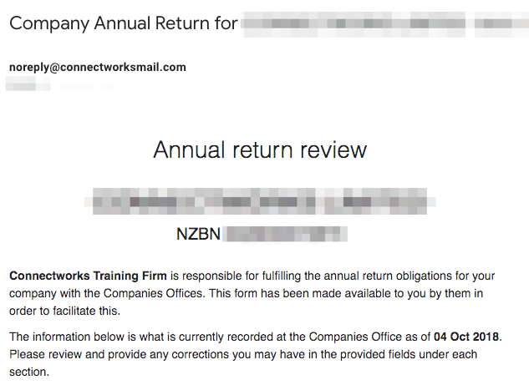

Please open the email, read it, and review the information contained in it. There is a deadline for the Companies Companies Office to receive the filing for your company each year, so please act promptly when the email arrives.
If the information in the email is correct, then please click the green "No changes are required" button at the bottom. It will ask you to verify this, and after that you've completed the process.
If the information is not correct, please press the red "I want to make changes" button at the bottom of the email. This will open a web form where you can enter any changes to be made in the appropriate section. Once you've done this, click the 'Confirm and Send' button. We will retrieve the changes and make sure the Companies Office and our systems are correct.
~OPTIONAL~
Connectworks also comes with a client portal that allows us to distribute documents for you to sign electronically on-screen, or to print, sign, scan, and upload. It is legal and secure and enables you to sign from anywhere at any time. It can store your signed documents and also act as a secure, convenient and free 'vault' for your important digital documents.
If you are interested in signing this way, then get in touch with ____________.
If you have any questions or concerns please contact _______ on ________.

Regards,

